VPS data integrity manual – Overview
In recent times the management of data, including data integrity, has taken on even greater significance within the Victorian Public Sector (VPS). The volume of data being managed, and reporting produced, across the VPS continues to increase. As the volume of data and reliance on it increases, so too does the need for data integrity – the need to provide data users with a level of assurance that the data they are using is trustworthy and can be relied upon.
Data integrity
Data integrity forms part of a wider set of data-related practices that are designed to help ensure the effective and efficient management of data.
Although data quality is generally understood as a concept, the term is not well defined in practice. The general consensus is that, for any set of data, regardless of its content or structure, the definition of the “quality” of the data has to be determined by the people and the systems that use it. For the purposes of the explanation, the quality of data can be defined as:
The existence of the right data in the right format at the right place and time to meet the needs of the people and systems that use it.
This definition is a multidimensional concept embracing both:
- Characteristics (e.g. accuracy, completeness etc) of the presented data itself that affect the integrity of the data for potential use - existence of the right data in the right format at the right place and time. i.e. whether it is trustworthy and can be relied upon.
- The relevance of many sets of data to potentially multiple users’ needs (any one piece of data may have many different uses and users, each of which will have their own “quality” requirement) - meet the needs of the people and systems that use it.
The VPS Data Integrity Manual focuses on the first aspect noted above and covers measures to support management of characteristics that affect data integrity. Managing data integrity and informing users about the integrity of data presented allows those users to determine if the data is fit for their intended use.
Purpose of the manual
The VPS Data Integrity Manual is intended to provide users across the VPS with guidance on managing data to ensure data integrity. It is not intended to transfer responsibility for VPS entity oversight or management of data integrity, nor replace or supersede any existing applicable legislative or policy requirements in relation to information or data management. Instead it aims to assist with increasing capability and awareness of data integrity across the public sector, to assist VPS entities to better manage their data. The manual aims to achieve this through the definition and explanation of a systematic approach (framework) that VPS entities may consider adopting to manage and improve data integrity across the VPS.
The data integrity framework that is outlined in the VPS Data Integrity Manual (and depicted in the diagram on the following page) is risk-based and involves the identification, assessment and management of relevant risks that underpin the ‘fitness-for-purpose’ of key data used and produced by the entity to fulfil the organisation’s plan and associated operational goals, objectives and outcomes.

Data integrity framework overview
Create/update data inventory  1 | - Assessment of data dependencies in line with key goals, targets and intended outcomes of the entity  - Objective is to define key data dependencies  - Key output is Data Inventory containing details of key data dependencies for the entity  Tools  - Data integrity manual  - Data inventory template
Assess key data dependencies  2 | - Periodic assessment of key data dependencies defined in data inventory  - Assessment based on Data Integrity Impact Assessment Questionnaire in Data Integrity Manual.  - Key output is high / moderate / low classification for key data dependencies in Data Inventory.  Tools  - Data integrity manual  - Data Integrity Impact Assessment Questionnaire
Establish and maintain data integrity controls  3 | - Application of controls guidance in line with assessment Differential requirements based on assigned classification of importance.  - Data Integrity Controls Guidance supported by detailed guidance materials  Tools  - Data integrity manual  - Data Integrity Controls Guidance  - Detailed guidance materials
Monitor and assess data integrity controls  4 | - Periodic assessment of the effectiveness of the key controls over data integrity for the key data dependency  Tools  - Data integrity manual

Data integrity controls guidance – Checklist
The table below defines the specific guidance recommendations that entities should consider applying at both the entity-wide environment level and key data dependency level (dependent on the classifications of importance – high, moderate or low – assigned to the entities key data dependencies).
# | Data Integrity Controls Guidance – Checklist | Classification |  |  | Applied
Entity level
A | The entity has assigned a senior manager to have explicit executive level accountabilities for data integrity – an accountable person. | H | M | L
B | The entity has defined and documented a Data Integrity Charter outlining its perspective and approach to the management of data integrity across the organisation. | H | M
Key data dependency level
1 | The entity has defined and documented a Data Integrity Plan for the data dependency outlining the entity’s requirements for data integrity for the key data dependency. | H
2 | The entity has assigned a dedicated owner for the defined data dependency. | H | M | L
3 | The entity has incorporated data integrity responsibility as a component of staff performance plans and measures to provide incentives. | H
4 | The entity has established and documented integrity standards and procedures for the key data dependency. | H | M | L
5 | Information security management – Refer to the Whole of Victorian Government ICT Policy on Information Security Management issued by the Department of Treasury and Finance for guidance on requirements for information security management.
6 | The entity understands and has documented the full range of data integrity risks in relation to the defined data dependency in a risk register. | H | M | L
7 | Changes to business processes or systems that impact on the defined data dependency are subject to a controlled implementation process, | H | M
8 | The entity has identified and implemented the key controls required to ensure data integrity for the data dependency over data acquisition, maintenance and distribution. | H | M | L
9 | The entity has identified and implemented validation controls to detect errors or anomalies in data submitted or used in the key data dependency. | H | M
10 | The entity has implemented IT controls to manage the IT environment that supports the data dependency. | H | M
11 | The entity has defined data integrity requirements for data that is submitted or managed by an external party and subsequently used in the defined data dependency. | H | M
12 | The entity provides data integrity training to the data dependency owner and any other relevant management and staff. | H | M
13 | The entity has defined and documented a formal process for managing data integrity issues, starting with conducting root cause analysis through to resolution. | H | M
14 | The entity has defined metrics and a way to measure and report on data integrity for the data dependency. Data integrity is regularly measured and reported. | H
15 | The entity actively monitors and assesses the effectiveness of its key data integrity controls for the data dependency on an ongoing basis. | H
16 | The entity has mechanisms to detect anomalies in all its key data. | H

Data integrity framework – Process overview
Activities | Create/update data inventory  1  Manual – Page 11  1.1 Identify key business objectives  1.2 Identify key data dependencies  1.3 Assign ownership for key data dependencies | Assess key data dependencies  2  Manual – Page 14  2.1 Assess key data dependencies using questionnaire  2.2 Update data inventory register  2.3 (optional) Create entity profile of data dependencies | Establish and maintain data integrity controls  3  Manual – Page 16  Apply appropriate control frameworks and processes to manage the data integrity risks relevant to the key data dependency | Monitor and assess data integrity controls  4  Manual – Page 17  4.1 Perform regular controls assessment  4.2 Remediate identified gaps or issues
Tools | Appendix A – Data inventory register  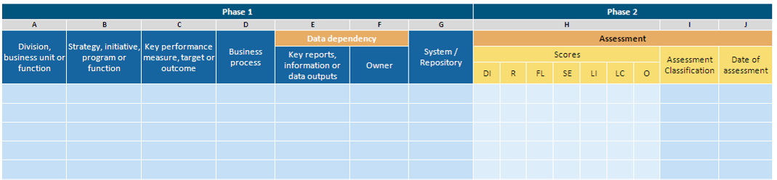 |  | Appendix D – Data integrity controls guidance  Entity level  The table below defines the specific guidance recommendations that entities should consider applying at the entity-wide environment level.  Key data dependency level  The table below defines the specific guidance recommendations that entities should consider applying for each key data dependency by individual classification of importance (high, moderate or low).  Appendix E – Detailed guidance materials  Entity level  These guidance materials are intended for application at the entity-wide environment level.  Appendix F –Detailed limitations and factors that can lead to a loss of data integrity  The table below (and continued on the following pages) provides further detail of specific limitations within each of the twelve defined limitation categories. | Appendix D – Data integrity controls guidance  Entity level  The table below defines the specific guidance recommendations that entities should consider applying at the entity-wide environment level.  Key data dependency level  The table below defines the specific guidance recommendations that entities should consider applying for each key data dependency by individual classification of importance (high, moderate or low).
  # | Guidance – Entity level | Differentiation
  A | Data integrity charter | Dependent on highest individual data dependency class
  B | Entity-wide ownership | Dependent on highest individual data dependency class
  # | Guidance – Key data dependency level | Data dependency classification
  # | Guidance – Key data dependency level | High | Moderate | Low
  Environment
  1 | Data integrity plan | X
  2 | Data dependency ownership | X | X | X
  3 | Performance measurement | X
  A | Data integrity governance
   |  | Data integrity impact
   |  | Completeness | Consistency | Validity | Accuracy | Timeliness
  Limitation Characteristic Description
  1 | Coverage
  1.1 | The population of reference differs from the population of interest | X | X
  1.2 | The population of reference is not explicitly stated in presented data |  |  |  | X
  # | Guidance – Entity level | Differentiation
  A | Data integrity charter | Dependent on highest individual data dependency class
  B | Entity-wide ownership | Dependent on highest individual data dependency class
  # | Guidance – Key data dependency level | Data dependency classification
  # | Guidance – Key data dependency level | High | Moderate | Low
  Environment
  1 | Data integrity plan | X
  2 | Data dependency ownership | X | X | X
  3 | Performance measurement | X
Appendix B – Data integrity impact assessment questionnaire
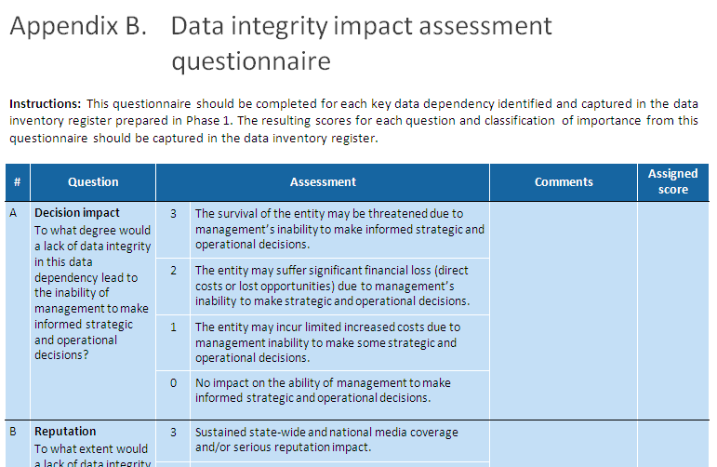
Appendix C – Data integrity environment profile
