Investment Management Standard
A guide for Victorian government departments and agencies

The Secretary
Department of Treasury and Finance
1 Treasury Place
Melbourne Victoria 3002
Australia
Telephone: +61 3 9651 5111
Facsimile: +61 3 9651 5298
www.dtf.vic.gov.au

Authorised by the Victorian Government
1 Treasury Place, Melbourne, 3002

© Copyright State of Victoria 2012
This book is copyright. No part may be reproduced by any
process except in accordance with the provisions of the Copyright Act 1968.
ISBN 978-1-922045-92-8
Published May 2013.

If you would like to receive this publication in an accessible format please telephone 9651 0909
or email mailto:information@dtf.vic.gov.au

This document is also available in PDF format at www.dtf.vic.gov.au

Contents
About this document iii
1. Investment management standard – an introduction 1
1.1 The theory behind the Investment Management Standard 1
1.2 History of the Investment Management Standard 2
1.3 What’s next? 2
2. Concepts that underpin the standard 3
2.1 Making sound investment decisions – the 16 questions 3
2.2 The logical journey – from problem to solution 3
2.3 Pooling our knowledge – the informed discussion 4
2.4 Telling the investment story – Investment Logic Maps 4
2.5 Benefits shape solutions – the need for an early benefit management plan 5
2.6 Every investment is accountable – the benefit framework 6
2.7 Clever interventions – robust strategic options 7
2.8 Project management and investment management – not the same thing 7
2.9 Engaging the key player – the investor 8
2.10 Piecing it all together – a systems view of the Investment Management Standard 8
2.11 What’s next? 10
3. Shape a new investment 11
3.1 Intent 11
3.2 Business context 11
3.3 Benefits of using this practice 11
3.4 General approach 11
3.5 The steps in shaping a new investment 12
3.6 Documents produced through these discussions 13
3.7 Workshops 13
3.8 What’s next? 14
4. Prioritise investment proposals 15
4.1 Intent 15
4.2 Business context 15
4.3 Benefits of using this practice 15
4.4 General approach 15
4.5 What’s next? 17
5. Develop new policy 18
5.1 Intent 18
5.2 Business context 18
5.3 Benefits of using this practice 18
5.4 General approach 18
5.5 The steps in developing new policy 18
5.6 What’s next? 18
6. Monitor and measure the delivery of benefits 19
6.1 Intent 19
6.2 Business context 19
6.3 Benefits of using this practice 19
6.4 General approach 19
6.5 The steps in monitoring and measuring the delivery of benefits 19
6.6 What’s next? 20
7. Evaluate a program of investment 21
7.1 Intent 21
7.2 Business context 21
7.3 Benefits of using this practice 21
7.4 General approach 21
7.5 The steps in evaluating a program of investment 22
7.6 What’s next? 22
8. Refocus an organisation to improve its effectiveness 23
8.1 Intent 23
8.2 Business context 23
8.3 Benefits of using this practice 23
8.4 General approach 23
8.5 What’s next? 25
9. Monitor organisational outcomes 26
9.1 Intent 26
9.2 Business context 26
9.3 Benefits of using this practice 26
9.4 General approach 26
9.5 The steps in monitoring organisational outcomes 26
9.6 What’s next? 27
10. Support in adopting the practices 28
10.1 Getting started 28
10.2 Do we need to train in-house facilitators? 29
10.3 Engaging an accredited facilitator 29
10.4 What’s next? 29
11. Support for facilitators 30
11.1 How to become an accredited facilitator 30
11.2 Ongoing support for facilitators 30
12. Templates, examples and case studies 31
Appendix 1: Sample 16 questions checklist 32
Appendix 2: Benefit framework 33
Glossary 34
Further information 38

About this document
The Victorian Government’s Investment Management Standard is encapsulated in the functionality of the Department of Treasury and Finance’s website (www.dtf.vic.gov.au/investmentmanagement). All of the current practices, definitions and templates can be obtained at that site and they are supported by a wide selection of examples and video clips.
This document is intended to provide an aggregation of the contents of the website in context for those people who require or prefer a hard copy. It does not contain all of the information available on the website. It does not provide the links to all of the referenced material (which can only be obtained from the website), although many of the definitions referenced are in the glossary of this document. This document will be updated from time to time to reflect any significant changes to the standard. The date of the current update is shown on the front cover.

Investment management standard – an introduction
The ability to select those investments that will provide the most benefit to a community is fundamental to good government. Over the past decade the practices that have been adopted by governments and businesses to shape their investments and support investment decision making have become increasingly complex but failed to focus on the real need for an investment or the benefits expected to be delivered. The Victorian Government has therefore restructured and simplified its practices with the aim of providing decision-makers with more certainty that any investment they are considering will succeed. In other words, is it the right thing to be investing in and it will be implemented as planned?
The Department of Treasury and Finance (DTF) has developed this brief Investment Management summary document for Victorian government departments and agencies to use as part of its investment decision-making process. It is intended to provide users with a basic summary of some of the key steps and practices that need to be undertaken when embarking on an investment decision.
The Investment Management Standard (IMS) is a collection of simple, commonsense ideas and practices that help organisations to direct resources to deliver the best outcomes.
When first developed the IMS was used to help shape individual investments. Today, its uses have broadened to the point where it can now support all the primary investment decision-making functions of an organisation.
Investment Management can be used to undertake the following 7 practices:
- shape a new investment;
- prioritise investment proposals;
- develop new policy;
- monitor and measure the delivery of benefits;
- evaluate a program of investment;
- refocus an organisation to improve its effectiveness; and
- monitor an organisation’s outcomes.
This document will describe each of these practices in more detail.

The theory behind the Investment Management Standard
In the place of complex processes the IMS is centred on three key concepts:
- The best way to aggregate knowledge is through an informed discussion that brings together those people with most knowledge of a subject.
- The logic underpinning any investment (the ‘investment story’) should be able to be depicted on a single page using language and concepts that can be understood by a lay person.
- Every investment should be able to describe how it is contributing to the benefits the organisation is seeking.
The Investment Management practices are skewed towards the early stages of shaping investments and focus heavily on the evidence to support the need, the benefits that will be delivered and the best strategic solution. The practices also track the delivery of benefits and support evaluation of the effectiveness of the investment.
For the sake of this standard, investment is defined as ‘the commitment of the resources of an organisation with the expectation of receiving a benefit’.

History of the Investment Management Standard
The IMS practices have been evolving within the Victorian Government since 2004. They were motivated by the recognition that, on a global basis, segmented manufacturing-style processes had been introduced into knowledge workplaces. The introduction of these processes had the unintended consequence of disengaging the key decision-makers and made solutions the major focus of investments rather than the benefits they were expected to deliver.
The standard has now been used to help shape thousands of individual initiatives and has been instrumental in creating better investments. The approach has since been adapted and used to shape the design and management of major programs of new investments and is also now being used to refocus entire organisations.
While adhering to the basic principles of simplicity and driving maximum value for minimal effort, the practices continue to evolve and improve through the lessons of their practical use.

What’s next?
The next chapter examines the concepts that underpin the IMS.

Concepts that underpin the standard

Making sound investment decisions – the 16 questions
Depending upon the nature of the investment, this is often a complex exercise that requires the contribution of many people who each bring their specialist skills and perspectives. But what are the prime questions that any decision-maker should have considered before making a decision to fund an investment?
In applying the rigour of the IMS to thousands of potential investments, 16 questions have been identified that, together, can provide decision-makers with confidence that:
- there is a real problem and it needs to be addressed at this time;
- the benefits that would be provided by successfully addressing the problem are of high value to the organisation;
- the way the problem will be addressed is both strategic and innovative; and
- the solution is likely to be delivered within the time and cost expectations.
The 16 questions address four areas – problem, benefits, strategic response and solution. These questions are relevant to any type of investment but the areas of focus and depth of information required for a decision-maker will vary based on the type of investment and the business environment.
The Victorian Government has aligned its investment shaping and decision-making processes to the ‘16 questions’. This includes the structure of the business case guidelines.
In shaping new investments the role of the IMS is to extract the information needed to address many of these questions.
The 16 questions provide a view of how the 16 questions can be used as a checklist for investment decision-makers and their advisers.
Visit the DTF website and search ‘16 questions’ to download a template. An example of how the ‘16 questions’ are applied can be found in the appendix.

The logical journey – from problem to solution
The logic expressed in business cases is often fragmented. Some business cases strongly articulate the need to invest but can’t explain how they arrived at the proposed solution. Others are not able to describe the benefits they are likely to deliver. Many business cases describe the solution in detail but fail to identify any real problem.
The IMS has established a structure that identifies the four primary entities of an investment proposal (problem, benefit, strategic response and solution) and connects them in a stream of logic. This structure is the foundation of the Investment Management practices that aim to address each entity in sequence and logically connect one to the next to form the completed ‘investment story’ (Figure 2.1).
Figure 2.1: The primary entities of an investment proposal
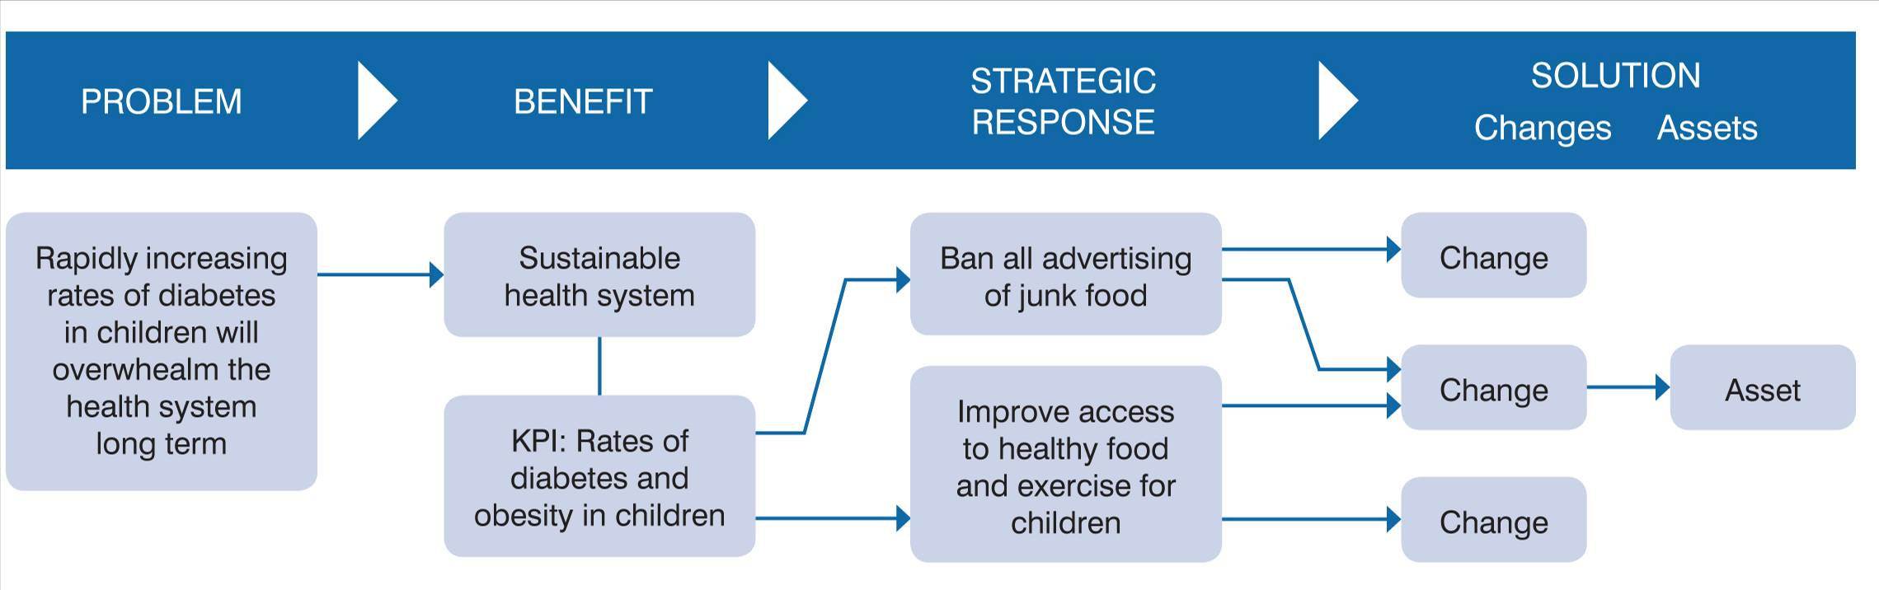

Pooling our knowledge – the informed discussion
Many organisations have introduced complex and compliant processes that aim to standardise the way they work and increase their rigour in shaping new investments. These processes have often failed to properly harness the knowledge available to the organisation.
Central to the success of the IMS is the ‘informed discussion’. These have evolved through their use on many thousands of investments since 2004 and are now a highly efficient decision-making forum that can shape and deliver effective investments.
‘Informed discussions’ have the following characteristics:
- Informed – they require the participation of the investor (the person who has the business problem and will be responsible for delivering the benefits) and those people with the most knowledge of the subject.
- Decision making – the practices are structured to address a sequence of decisions that are central to the potential investment.
- Plain English – the story of the investment is told in simple language and concepts that can be understood by a layperson.
- Evidence-based – each statement of the story must be able to be supported by evidence.
- Two-hour limit – discussions do not exceed two-hours in duration, which has been found to be short enough time to obtain the time commitment of senior people, and long enough to extract an agreed investment story.
- 48 hours following – the 48 hours following the discussion is used to conclude it. During this period the decisions made are circulated and any outstanding matters are electronically discussed and resolved.
- Facilitated – the facilitator is responsible for
  - extracting and telling the investment story in a way that will maximise its value to the organisation and expresses the concepts in plain language;
  - obtaining the agreement of all participants to the investment story; and
  - ensuring that each statement can be supported by evidence.

Telling the investment story – Investment Logic Maps
Transparency of intent is a prerequisite to good decision making and is critical to the successful delivery of most investments. This is difficult to achieve for any investment, particularly those that are large and complex.
The IMS has developed what’s called an Investment Logic Map, which aims to communicate the investment story on a single page using language and concepts that are understandable to a layperson. This is the printed equivalent to the 30-second lift discussion when you are asked, ‘Tell me about your investment’.
There are three versions of the Investment Logic Map, with each one communicating the story at a different level – for an individual investment, for a program of investment and for an entire organisation.

Benefits shape solutions – the need for an early benefit management plan
People regularly question, ‘How can you develop a benefit management plan when you don’t even know what the solution will be?’
In previous practices, by some means, people would decide that something might be worth investing in (such as building some infrastructure or introducing a new program). To validate the idea and to make the case for investing they would then set about defining the benefits the planned investment could deliver.
The IMS starts at the other end. Having clearly defined the problem, the benefits that will result in successfully addressing the problem are identified. Next comes the critical step of identifying the key performance indicators (KPIs) that will provide the evidence that the benefits were ultimately delivered and the problem has been adequately addressed. It’s not enough just to identify the KPI (e.g. rates of childhood obesity). It is necessary to specify, for example, to what degree childhood obesity needs to be reduced. Figure 2.2 provides an example.
Figure 2.2: Defining benefits using specific KPIs
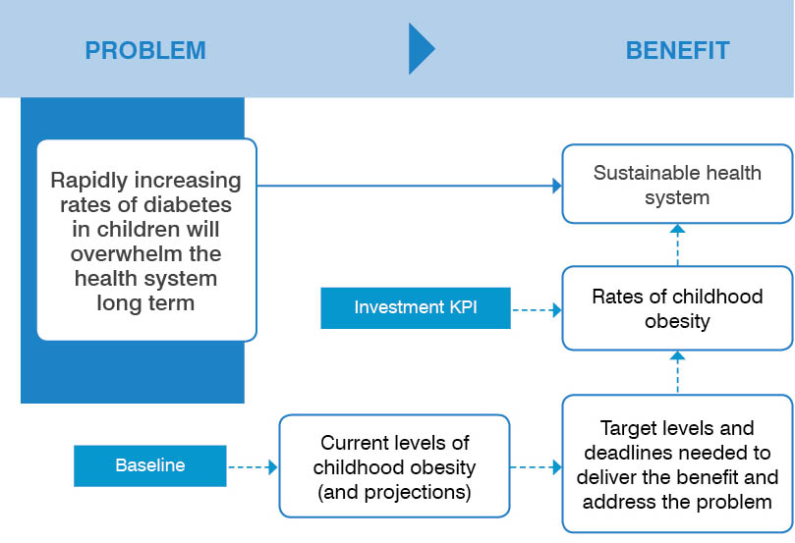

Clearly defining the KPIs and their associated measures that must be delivered is a necessary precursor to identifying the types of interventions needed to deliver them. Without these targets, interventions might be selected that can reduce childhood obesity but to a degree that is ineffective in addressing the problem.
A benefit definition workshop is used to identify the KPIs, measures and targets that must be met to mitigate the effect of the problem. This workshop produces the first iteration of the benefit management plan that, like the Investment Logic Map, evolves as the investment is shaped.

Every investment is accountable – the benefit framework
The only reason an organisation makes an investment is to obtain some form of benefit. It is therefore critical that organisations can select and shape investments that provide maximum benefit and can confirm that the expected benefits were actually delivered.
Why is it then that very few investments are able to articulate the benefit they will provide or to demonstrate what benefits were delivered?
It is typical (and appropriate) that everyone within the police force believes their individual investment will reduce crime and everyone in the education field will claim theirs will result in better learning outcomes. But until now there has been limited ability to describe the contribution of an individual investment to reducing crime or to achieving better learning outcomes.
The benefit framework (see appendix X) has been tried and found to be effective in addressing this longstanding problem. It is a three-level structure that links the contribution of an individual investment to the outcomes the enterprise is seeking.

Clever interventions – robust strategic options
Each time there is a need to consider a new investment there is also an opportunity to substantially improve the way things will be done in the future. Instead of just solving problems the way they have always been solved, innovative approaches that are better and cheaper can be explored.
Most business case templates contain a section titled ‘Options analysis’, which is intended to show what strategic options were explored in arriving at the proposed solution. However, in the past, few proposals have used it for this purpose. More often it is used for project options (‘Should the hospital have 350 or 500 beds?’) or procurement options (‘What acquisition model should be adopted?’). The business cases that are weakest in this area often propose just three options: do nothing, do something that is clearly irrational or do what the business case is proposing.
The first two discussions of the IMS establish the problem that needs to be addressed and specifies the benefits (with KPIs, measures and targets) that any investment aiming to address the problem must deliver. It then uses the third discussion to decide the strategic response. There are three steps in doing this:
- Step 1 identifies a range of strategic interventions that might be taken to deliver the identified benefits.
- Step 2 decides how these interventions could be packaged into a number of sensible strategic options.
- Step 3 evaluates the strategic options to determine their relative merit and decides the preferred option.
Merit is based on a balance of five factors: benefits, cost, timelines, risks and dis-benefits.
The strategic response workshop produces the two-page strategic options analysis, which documents the output of these three steps and allows investment decision-makers to confidently respond to the strategic response questions of the 16 questions checklist.

Project management and investment management – not the same thing
Over the past few decades project management has been introduced into knowledge workplaces to enable increased discipline to the way investments are shaped and managed. Project management methodologies were originally developed to increase the certainty that a defined solution would be implemented as planned (whether it is a piece of infrastructure or a program of some sort). In doing this, project management enables the following questions to be answered:
- Will the project complete within budget?
- Will it deliver to its planned schedule?
- Were the expected products delivered?
From the perspective of the investor, what is missing are answers to the following:
Before an investment decision is made
- Is the logic for the planned investment clear?
- Is there a sound case to invest?
After the project is delivered
- Were the expected benefits delivered?
The IMS enables investors to shape potential investments and define the preferred solution. Project management then assists the investor to implement the defined solution on time and to budget. The IMS then validates whether or not the investment delivered the expected benefits.
Investment management and project management are complementary disciplines that, together, enable an investor to shape and implement good investments.

Engaging the key player – the investor
Investments often fail when the key person (the investor) is not actively engaged in its management. Additionally, many potentially good investments are never funded because the investor just doesn’t understand what they are all about.
- The IMS addresses both of these issues by engaging the investor early and retaining their involvement over the entire investment lifecycle.
- The language used within the standard is that of business and economics as distinct from project management – problems, benefits and business changes instead of products, specifications and project plans.
- The investor needs to only commit a maximum of eight hours (four two-hour informed discussions spread over a period of six weeks) to shape a major investment.
- The informed discussions are structured to address the issues of most importance (and interest) to an investor. This allows them to hear all arguments and confidently take ownership of the investment.
- The discussion participants are those people with the most knowledge of the business problems and the stakeholders who will be important to the success of the investment.
- The investment logic that is developed in the early discussions provides a constant focus throughout the investment lifecycle via the documents produced (the Investment Logic Map and the benefit management plan).

Piecing it all together – a systems view of the Investment Management Standard
Within organisations, investment decisions are usually made at three levels: new individual investments, programs of investment and the organisation structures and outcomes. While these levels should naturally connect, they are often managed using entirely different processes, in different forums and using different language. This is evidenced in organisations’ performance reports. Seldom do corporate plans, business plans, outcome reporting and program evaluation reports use the same data or language … or have any obvious relationship to one another.
The IMS started life simply by trying to make sense of individual investments. It established a structure to communicate the logic of an investment and practices that would bring together those people with most knowledge of a potential investment to shape and make funding decisions of potential investments. It further established a way to effectively measure the effectiveness of investments.
It was soon obvious that the structures established here were just as relevant to programs of new investment and entire organisations as they were to individual initiatives. As such the practices emerged to support the development of new policy, prioritise new investments and refocus organisations. Figure 2.3 shows the three levels at which the practices are applied and the discussions (workshops) that extract the investment logic. These are also aligned to a set of foundation questions that depict change.
Figure 2.3: Integrated view of the IMS practices
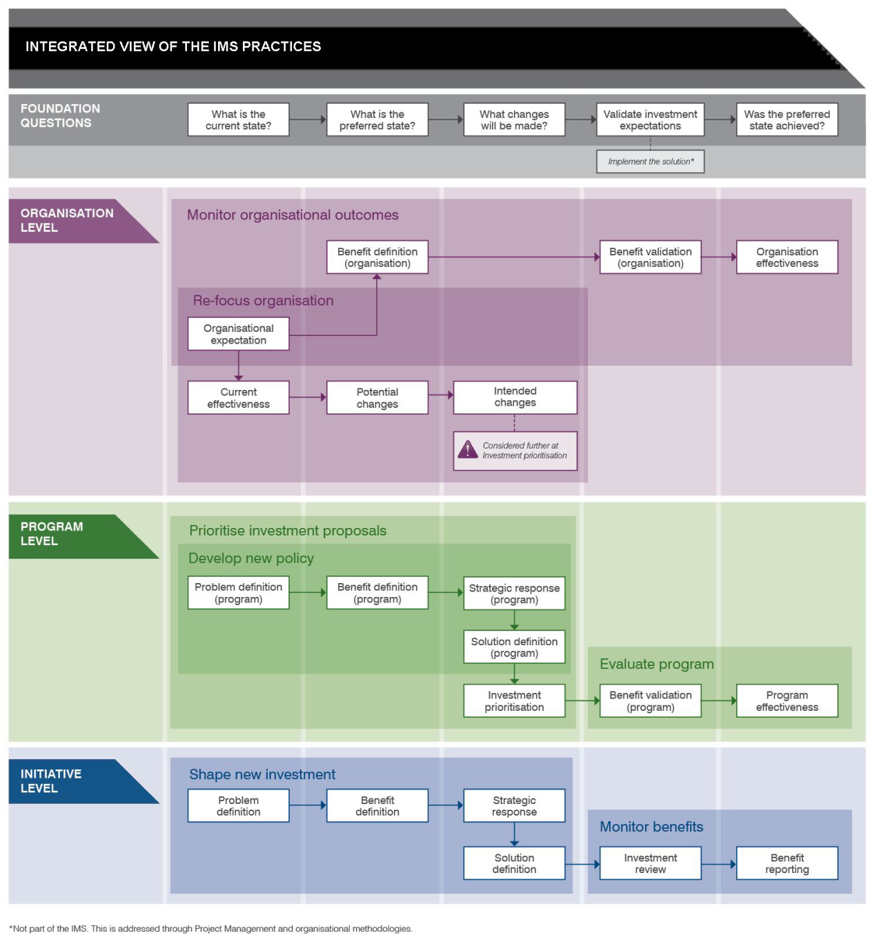

A logical data model (Figure 2.4) has been developed to further support a system view of the standard. This depicts nine data entities needed to support resource allocation within an organisation. Against each entity are the data elements that can be defined through the practices of the IMS.
Figure 2.4: Logical data model
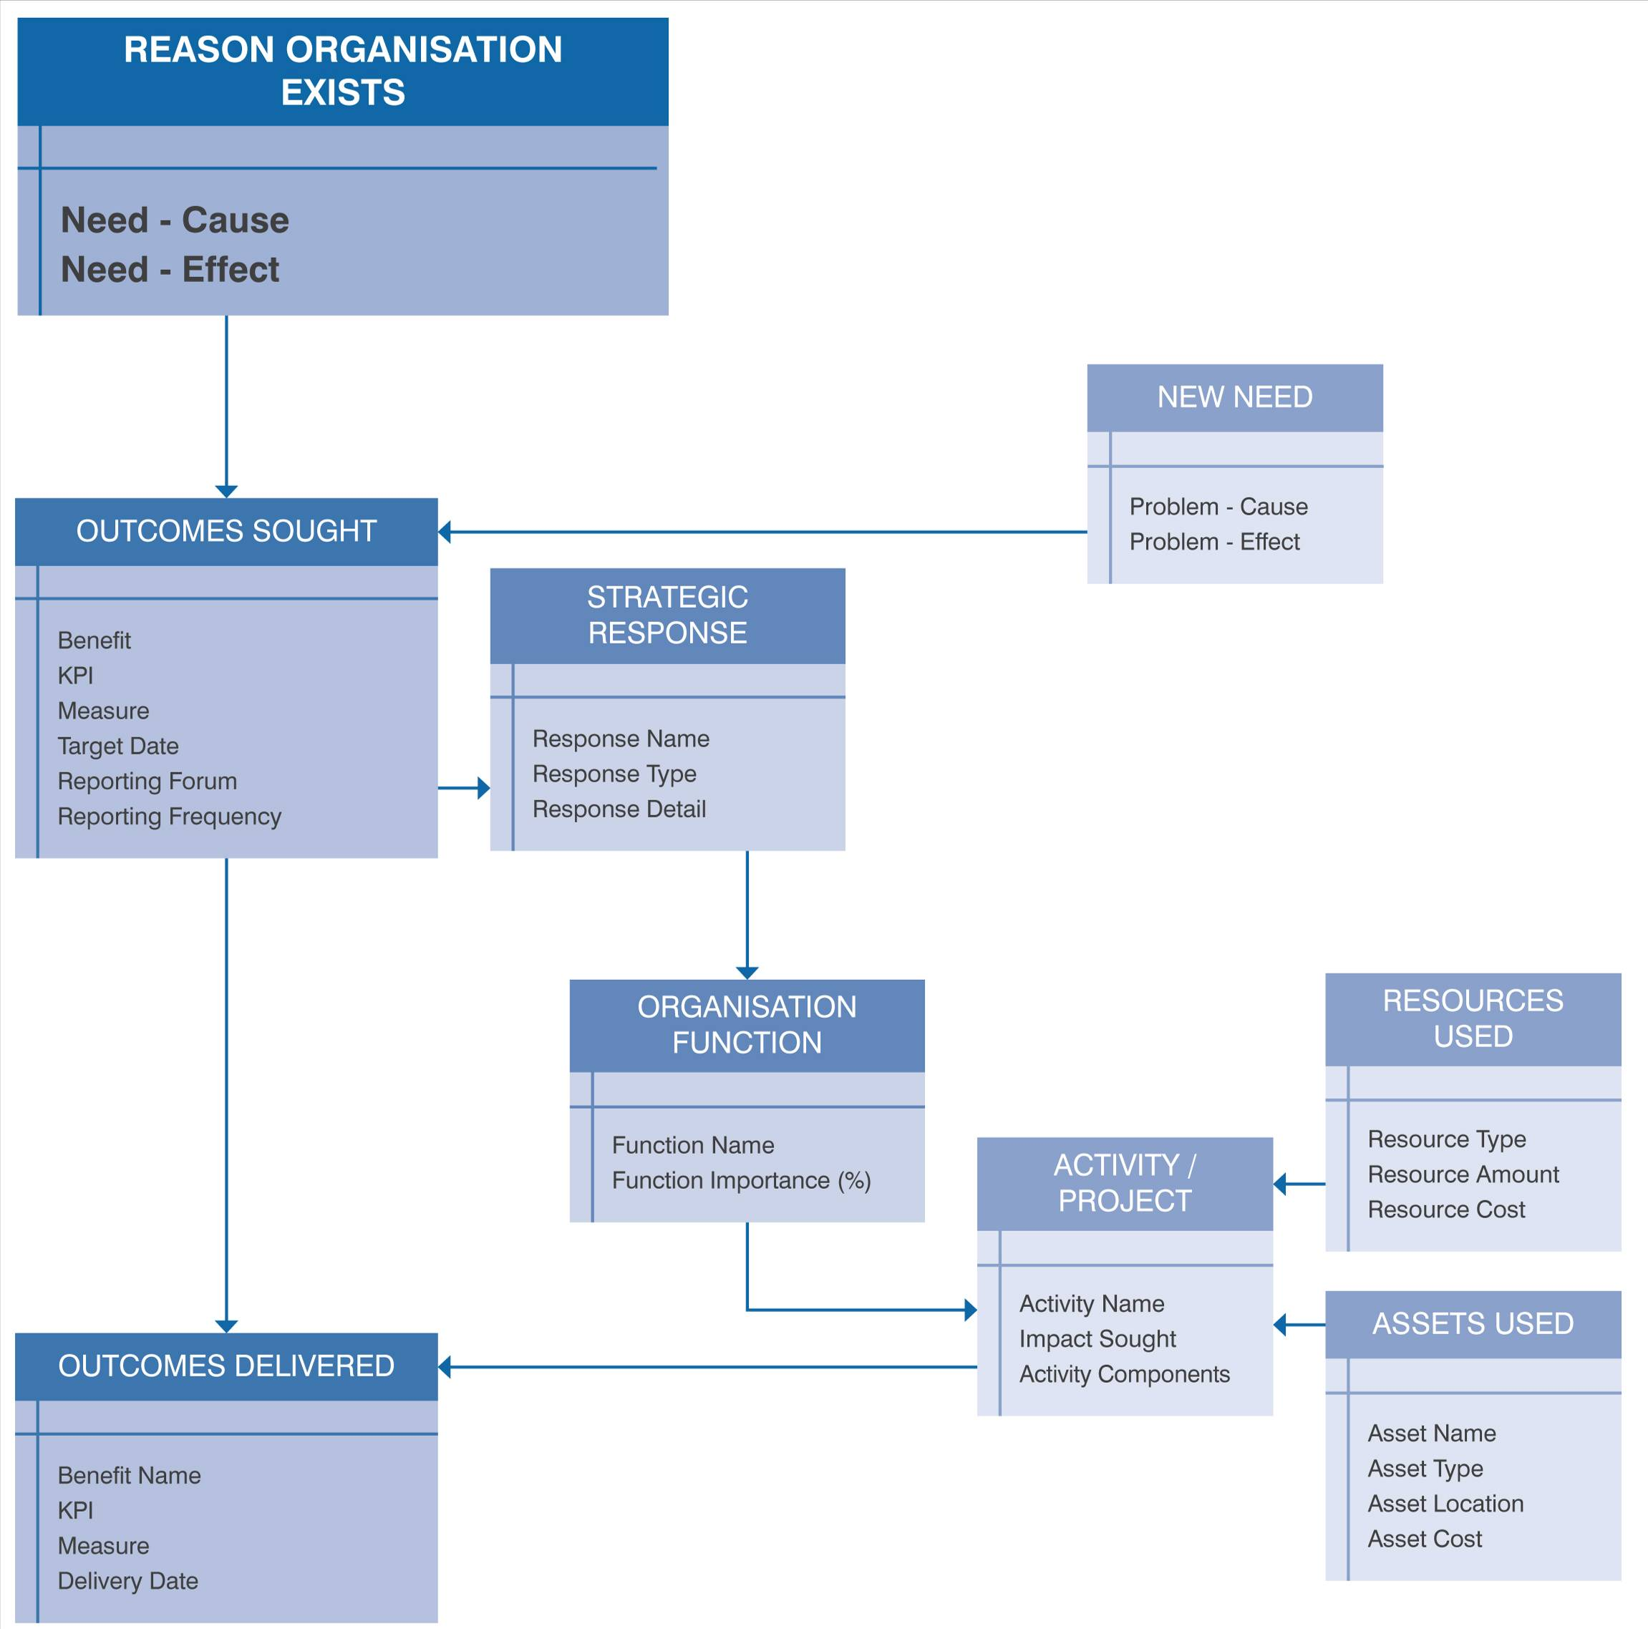

What’s next?
The subsequent seven sections take a look at the IMS practice in detail. The first is Shape a new investment.

Shape a new investment

Intent
Shapes an investment that will deliver the maximum benefit to the organisation.

Business context
The only reason an organisation makes an investment is to obtain some benefit – either by solving a problem or taking a new opportunity. If we didn’t have a problem or wouldn’t receive any benefits, what would be the point of making an investment?
Most organisations have adopted the business case as the way that potential investments articulate and justify the case for an investment. In common practice, business case documents have a strong focus on the solution that is planned to be delivered. However, they often fail to adequately describe the problem, explore the strategic options or specify the benefits that the investment will produce.
Whether buying a pair of shoes or building the Snowy Mountains Scheme there are a number of basic questions that must be addressed in sequence. The Victorian Government has defined these in the form of the 16 questions investment decision checklist, which provides the foundation for investment decision making in the Victorian Government. It has aligned its business case format to these questions. This practice aims to elicit the information required to address the ‘16 questions’.

Benefits of using this practice
This practice has been used extensively since 2005. It has been found to:
- shape investments that are more strategic and drive better outcomes;
- establish the logic and key content of the business case;
- reduce the time and cost taken to develop business cases; and
- improve the chances that an investment will be funded.

General approach
This practice is suitable for investments of any type or complexity. Irrespective of the complexity they will all be required to follow the same ‘line of enquiry’ as they develop their respective investment stories. However, the number of informed discussions (workshops) required will be different. Very large or complex investments will require four workshops that will produce four documents that are key to a business case. Small investments may be able to complete the investment story in just one discussion that would only produce an Investment Logic Map.
The four steps involved in this practice are depicted in Figure 3.1.
Figure 3.1: The steps in shaping a new investment
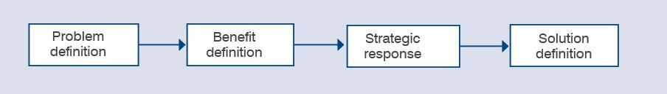

The steps in shaping a new investment

Problem definition
The purpose of this first workshop is to answer the following questions:
- What is the problem that is driving us to consider a new investment (both the cause and effect)?
- Is there evidence to confirm both the cause and effect of the problem?
- What benefits can the organisation expect in successfully responding to the problem?
The investor should attend this workshop. The investor should bring together those people who understand the problem(s) and can provide the evidence that will validate that the identified problem(s) are real.
The number of people involved will probably be between five and eight, depending on the nature of the investment but could be anything up to 15.

Benefit definition
This workshop will establish the basis for success of the investment in the form of the first draft of a benefit management plan, which will be amended as the investment is shaped. It should answer the following questions:
- What evidence will be needed to demonstrate that the identified problems have been properly addressed?
  - What are the KPIs?
  - Against the KPIs, what measures will be used?
  - What is the current baseline, target values and timelines for these measures?
- Who will be responsible for delivering the benefits?
- How will the benefits be tracked and reported?
In attendance should be the investor, those people who participated in the previous workshop who have most knowledge of the problem environment, a benefit specialist who has expertise in KPI design and understands what is possible in the subject area, and benefit data providers who will be responsible for providing the data to determine whether the investment has delivered the benefits.

Strategic response
This workshop aims to explore a broad range of potential strategic responses and decide which one is preferred. It should answer the following questions:
- What are the strategic interventions that could be taken to deliver the identified KPIs (and respond to the problem)?
- How can these interventions be packaged into a range of sensible strategic options?
- Which strategic option is likely to be the most suitable (on the basis of the benefits delivered, cost, timelines, risks and dis-benefits)?
It should include the following people:
- the investor;
- those people who participated in the previous workshops who have most knowledge of the problem environment;
- a strategist who can act as the ‘custodian of the strategic direction’ of the organisation;
- an innovator and an implementer who can test both the breadth of the proposed interventions and their feasibility; and
- a benefit specialist who has expertise in KPI design and understands what is practical in the subject area.

Solution definition
The three previous workshops established the need for an investment and the preferred strategic response. It is now necessary to specify a solution consistent with the strategic response – a case of a problem driving a solution. To do that, this workshop must answer the following questions:
- What business changes will be needed to implement the strategic response?
- What assets (if any) will be required to support these business changes?
- Will the defined solution (expressed as the changes and assets) deliver the investment KPIs identified in the benefit management plan?
- What costs, risks, timeframes and dis-benefits are associated with the defined solution?
In attendance must be the investor, the strategist and the implementer from the previous workshop and anyone who would be involved in the implementation of any solution and would benefit from understanding its intent.
The number of people involved might be between six and eight.

Documents produced through these discussions

Investment Logic Map (initiative)
A single-page depiction of the logic that underpins a single investment. It represents an ‘agreed investment story’ that is created in an informed discussion. It is written in plain English in a way that will allow a layperson to understand the language and the concepts. It provides the core focus of an investment and is modified to reflect changes to the logic throughout its lifecycle.

Benefit management plan
A short document that specifies the benefits an investment will need to deliver to successfully address an identified problem. It includes the measures to be used as evidence that the benefits have been delivered. These measures are initially used to select the most suitable response to the problem. The benefit management plan also defines the dates the benefits are expected to be delivered, who is responsible for their delivery and how they will be reported.

Strategic options analysis
A document that explains the logic used to identify which strategic response would best address the identified problem and deliver the expected benefits. This will describe the strategic interventions that were considered, how these were grouped to form a range of strategic options and why the preferred option was selected.

Investment concept brief
A two-page document that depicts the logic underpinning an investment and identifies the likely costs, risks, dependencies and deliverables of the proposed solution. It is used to summarise the merits of an investment and so allow decision-makers to prioritise competing investments before proceeding to a business case.

Workshops
The workshops involved in this exercise are best held at two-weekly intervals. Experience has shown this provides sufficient time for the thinking of the previous workshop to be absorbed and is not so distant that the momentum is lost.
While the practices of the IMS were originally used for single initiatives, they are increasingly being used to establish the logic for programs of investment.
It is highly recommended that only an accredited facilitator be used to facilitate the workshops for the more important investments. Evidence shows they are more likely to produce a quality result. (More information is provided about accredited facilitators in section Support for facilitators.)

What’s next?
The next section examines the second IMS practice: Prioritise investment proposals.

Prioritise investment proposals

Intent
Identifies the major problems a new investment must address and establishes the criteria it then uses to select the most sensible investments.

Business context
Most organisations operate an annual budget cycle where the need for new investment is considered, potential investments are identified, and decisions are made as to how the budget will be spent. The people charged with making these decisions sometimes do so without the benefit of a clear understanding of the challenges to the organisation or criteria to evaluate competing bids. In the absence of such criteria, investment decisions are often determined by ‘the loudest voices’.

Benefits of using this practice
Organisations that have used this practice have found it provides a range of benefits including:
- better engagement of senior executives and key stakeholders;
- improved articulation of the need for new investment and the establishment of strong prioritisation criteria;
- substantial reduction in the number of ‘irrelevant’ investment ideas;
- better investment solutions; and
- time and cost efficiencies.

General approach
Figure 4.1 depicts the five steps involved in this exercise. Steps 1, 2 and 3 establish the need, the preferred strategic response and the criteria for selecting the best investments. Step 4 defines how the strategic response should be put into effect. When candidate investments have been shaped, step 5 uses the criteria developed in step 2 to prioritise them and make investment decisions.
Figure4.1: The steps in prioritising investment proposals
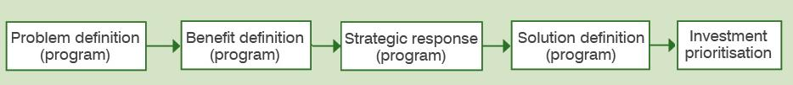
The steps in prioritising investment proposals

Problem definition (program)
The first step to establishing an informed investment program is to identify an organisation’s current priorities and future challenges.
When developing new policy, it is necessary to first establish an agreed understanding of the problem the policy must address.
This workshop can address either of these needs and should answer the following questions:
- What needs or problems is this [organisation/portfolio/policy] facing over the next period (10–15 years) that will require us to consider new investment or change our current investment priorities?
- Is there evidence to confirm both the cause and effect of the problem?
- What benefits can the organisation expect by successfully responding to the needs/problems?
In attendance should be the investor, strategists, a benefit specialist and any key stakeholders who will be important to giving effect to any identified investment. Depending on the nature of the investment the number of people involved will probably be between five and 10 but could be up to 15.
The output of the workshop will be an Investment Logic Map (problem).

Benefit definition (program)
This step establishes the criteria that will enable candidate investments to be prioritised based on their relative ability to deliver the benefits that are sought, and should answer the following questions:
- What are the KPIs that an investment must deliver before it can claim to have delivered the sought benefits?
- What plain-English ‘public value messages’ could be made when each benefit has been delivered?
The key person is again the investor, but it is also important that a benefit specialist participates. This discussion should involve between eight and 15 participants.
The discussion should produce, on a single page, a description of the agreed KPIs and the public value messages (part 2 of the Service Logic and Investment Prioritisation – SLIP – document).

Strategic response (program)
This workshop aims to explore a broad range of potential strategic responses and decide which one is preferred. It answers the following:
- What are the strategic interventions that could be taken to deliver the identified KPIs (and respond to the problem)?
- How can these interventions be packaged into a range of sensible strategic options?
- Which strategic option is likely to be the most suitable (on the basis of the benefits delivered, cost, timelines, risks and dis-benefits)?
The number of people involved might be anything from eight to 15, depending on the nature of the investment. At a minimum it should include the investor, a strategist, an innovator/implementer and a benefit specialist.
A strategic options analysis will be produced.

Solution definition (program)
This step provides what is often a ‘missing link’ – an activity where policy and strategy are directly translated into a balanced set of actions and investments. This is then used to mobilise the preferred investments. The alternative approach is the practice of, ‘just wait and see what comes along’. It should answer the question:
- What set of initiatives will be most effective at implementing the strategic interventions and delivering the expected benefits?
The number of people involved will probably be less than the previous discussions – maybe eight to 10. At a minimum it should include the investor, a strategist, an implementer and any other people who would be involved in the implementation of any solution and would benefit from understanding its intent.
An investment concept brief will be developed to reflect the expected ranges regarding time, costs, dis-benefits, risks, etc. (the quality will depend on how well they are understood at the time).

Investment prioritisation
In this workshop candidate investments are considered and prioritised against the criteria developed in previous steps. It should answer the question: Using the criteria developed earlier, how do the candidate investments rank against one another?
The investor, those people who share responsibility for investment decision-making in this organisation/portfolio, and investment analysts should attend. The number of people involved may vary from four to 12.
A completed and agreed prioritised investment list (part 4 of SLIP) should be produced.

What’s next?
The next section looks at the third IMS practice: Develop new policy.

Develop new policy

Intent
Defines the need for new policy and specifies the best strategic response.

Business context
The ability to identify the changing needs of society and develop policy that will best respond to these needs is central to good government. Policy is sometimes developed without a full and shared understanding of the need, without fully comprehending the broader implications of the policy, or without having explored a range of innovative responses.

Benefits of using this practice
This practice will assist policy developers to:
- engage with those people who most understand the need for new policy;
- develop policy responses that are evidence-based, innovative and practical;
- mobilise those investments that will best implement the intent of the policy; and
- establish the criteria to evaluate whether the policy, when implemented, is successful.

General approach
The four steps involved in this exercise are depicted in Figure 5.1. These steps are the same as those undertaken to prioritise investments. While in that case the focus may be on the unmet service needs facing an organisation, the practice can also be used to develop policy within an organisation or across the whole of government. Each step represents an informed discussion.
Figure 5.1: The steps in developing new policy
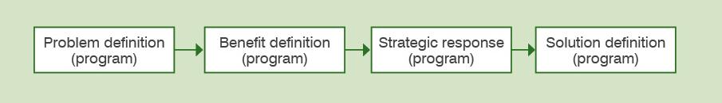

The steps in developing new policy
- Problem definition (program)
- Benefit definition (program)
- Strategic response (program)
- Solution definition (program)
All these steps are outlined in the previous section: Prioritise investment proposals. The physical output of these discussions is a SLIP.

What’s next?
The next section examines the fourth IMS practice: Monitor and measure the delivery of benefits.

Monitor and measure the delivery of benefits

Intent
Provides a continuous focus on benefits during the implementation of an investment and determines whether the expected benefits were delivered.

Business context
The only reason an organisation makes an investment is to obtain some benefit. This is therefore the prime consideration of investment decision-makers when considering an investment proposal. For this reason people seeking new funding for their proposed investment must articulate the benefits the investment is expecting to deliver.
Once funded, with the inevitable challenges and stresses that occur as the investment is implemented, the focus on benefits is often lost. This is exacerbated by the difficulty in measuring and tracking benefits and evaluating the real effectiveness of an investment.

Benefits of using this practice
Using this practice will:
- drive more benefit from a funded investment;
- validate the success of a completed investment;
- provide lessons that will inform the shaping of future investments; and
- support better decision making.

General approach
There are two steps involved, as depicted in Figure 6.1. However, they do assume that a benefit management plan was previously developed using the practice ‘Shape a new investment’.
Figure 6.1: The steps in monitoring and measuring the delivery of benefits
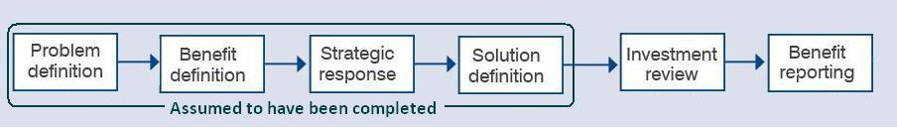

The steps in monitoring and measuring the delivery of benefits

Investment review
This discussion allows the investor to validate the original assumptions at various stages during the implementation and to amend the benefit management plan or the solution to ensure the investment delivers maximum benefit. The following questions should be answered:
- Working to the solution that is currently planned, will this investment deliver the benefits that were originally expected?
- Are there any changes that could be made to take advantage of opportunities to deliver benefits not originally identified?
As in all discussions, the investor must present. Included also should be subject matter experts, a benefit specialist, the project manager and a strategist. The number of people involved will probably be between six and eight.

Benefit reporting
The benefit framework upon which the IMS has been built and the creation of benefit management plans as a normal practice now make it both practical and cost-effective to track the delivery of the planned benefits. This discussion should answer the question:
- Is the investment delivering the KPIs consistent with the benefit management plan?
This step is not done as a group exercise using the informed discussion but is a desk exercise undertaken by the benefit specialist.
The resultant benefit report is then submitted to the forum(s) specified in the benefit management plan. This approach is repeated throughout the period specified in the benefit management plan.
The physical outputs of these two steps are:
- amendments to or validation of the benefit management plan and the Investment Logic Map; and
- a benefit report.

What’s next?
The next section looks at the fifth IMS practice: Evaluate a program of investment.

Evaluate a program of investment

Intent
Provides an understanding of whether the outcomes sought by a program of investment were actually achieved.

Business context
Government organisations continually develop new policy that aims to address an existing or emerging unmet need of society. Implementing the policy often requires a significant commitment of resources and takes a long time. There is always a risk that the original need has changed or the original interventions no longer make sense in a changed environment. This practice validates the ongoing need for the program and its design and, once complete, evaluates its effectiveness.
The knowledge gained in this exercise is then used to inform the development of future policy.

Benefits of using this practice
This practice will assist those people involved in program evaluation to:
- understand the logic that formed the foundation of the investment program;
- direct or re-direct resources to ensure the policy intent is met;
- evaluate the overall effectiveness of a program; and
- provide new knowledge to those people responsible for developing policy.

General approach
There are two steps involved in this exercise and these are depicted as the last steps in Figure 7.1. This practice assumes that a policy framework has been previously established using the practice Prioritise investment proposals (steps 1 to 5 below).
Figure 7.1: The steps in evaluating a program of investment
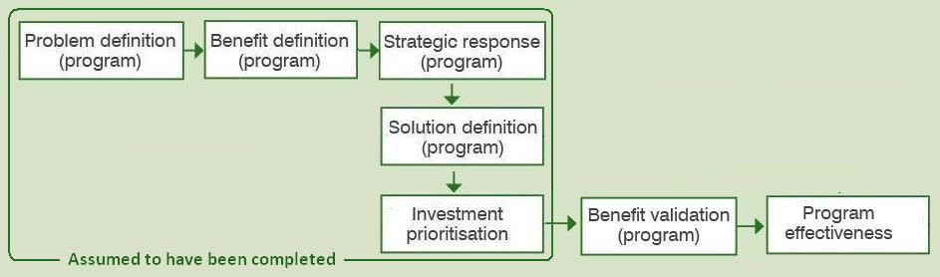

The steps in evaluating a program of investment

Benefit validation
Based on the expectations established earlier (at either the prioritise investments or develop policy stage) this step will assess whether the program is on track to deliver the expected benefits. The outcomes of this assessment might be to modify the program either in some detail or substantially – it may even be decided to discontinue the program if the need has changed or the original assumptions are no longer valid.
In this discussion the following questions should be answered:
- Is the original need for this program still valid today?
- Are the benefits expected to be delivered by the program still relevant and valuable to the organisation?
- Are the expected benefits being delivered as planned?
- Are there changes that can be made to improve the relevance or effectiveness of the program?
The investor, those people who participated in the previous workshops who have most knowledge of the problem environment, a strategist and a benefit specialist should all be present. The number of people involved may be between six and 12.
As appropriate, new versions of any of the investment management documentation should be produced.

Program effectiveness
The timing of this discussion is when the majority of the expected benefits should have been delivered.
Questions to answer are:
- Did this program satisfactorily address the ‘problem’ upon which it was founded?
- To what degree did the program deliver the expected benefits? And how valuable are the delivered benefits to the organisation?
- Was the selected strategic response an effective way to address the need?
- Was the program delivered to both time and budget expectations?
- How successfully was the program managed?
- What lessons should be recorded to inform future decision making and program design?
- How will these lessons be used?
In attendance should be the investor, those people who participated in the previous workshops who have most knowledge of the problem environment, a strategist, a benefit specialist and those people responsible for implementing the program.
The physical outputs of these steps are:
- as required, changes to the investment management documentation; and
- a program evaluation report that also lists the lessons learned for future program design and management.

What’s next?
The next section examines the sixth IMS practice: Refocus an organisation to improve its effectiveness.

Refocus an organisation to improve its effectiveness

Intent
Establishes a shared understanding of why an organisation exists, assesses its current effectiveness and identifies the changes that should be made to become more effective.

Business context
It’s easy for an organisation to keep doing the same things this year as it did last year and the year before. It worked then, so why shouldn’t it work now? But is the need the same now as it used to be? What outcomes is the organisation now creating and what value are these to government? What functions are being undertaken and how do these contribute to the outcomes?

Benefits of using this practice
This practice can be used to:
- enable the people responsible for steering an organisation to restate its mission and make the changes needed to improve its effectiveness and reset its direction; and
- allow teams to establish a strong sense of ownership of an organisation’s direction and empower them to work innovatively to that direction. (‘When we’re clear about where we are going we can work from imagination rather than habit’ – Tony Richardson, film director and producer).

General approach
There are four steps involved in this exercise and these are depicted in Figure 8.1. An organisation does not need to complete every step to obtain value but may elect to do just the first, or steps 1–3. As each step builds on the previous one, they must be done sequentially. How far an organisation goes depends on what it is seeking to achieve.
Figure 8.1: The steps in refocusing an organisation to improve its effectiveness
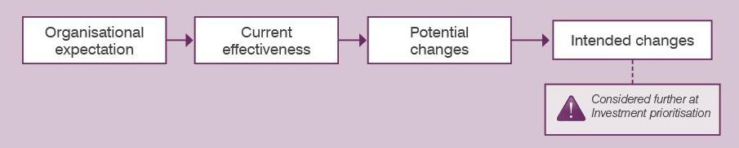

The steps in refocusing an organisation to improve its effectiveness
As with all discussions of the IMS, the most important outcome is that the key people have come together, shared their thinking and agreed to the ‘investment story’. At the end of the discussion they are all ‘on the same page’.

Organisational expectation
This discussion will elicit the logic that underpins the organisation’s existence. In it, the following should be answered:
- What is the need that this organisation exists to meet?
- What benefits is the organisation required to provide to its stakeholders?
- What strategic response is the organisation taking to respond to the need and deliver the benefits?
- What functions should the organisation undertake to put the strategic interventions into effect?
The key person (the investor) is the high-level executive responsible for delivering the outcomes of the organisation, and must be attendance. If applied at whole-of-department level, this would be the Secretary or CEO. This person would bring together those who understand the expectations of the organisation and the best strategic and organisational responses. These might include:
- heads of the various divisions within the organisation;
- people involved in strategically steering the organisation;
- those who understand outcome expectations and are involved in outcome reporting;
- other people who can contribute to the discussion and will be instrumental in owning and implementing the decisions (stakeholders and key staff).
The number of people involved will probably be between eight and 15, depending on the size of the organisation.
Most of the discussion time will be spent identifying and articulating the organisation’s need to exist. When the need has been agreed the benefits that the organisation is expected to deliver to its stakeholders are defined. The strategic interventions that should be taken to respond to the need are identified. Finally, the way the organisation should respond in terms of its functions is defined.
In the 48 hours following the discussion, the decisions that have been made will be depicted in the form of an Investment Logic Map (organisation) and circulated among the participants for discussion and finalisation.

Current effectiveness
Using the organisational expectation defined in the previous workshop an assessment will be made as to how effective the organisation is currently performing. This will then provide the basis for identifying what changes could be made to improve the effectiveness of the organisation.
The following questions should be answered during the discussion:
- What activities are currently being undertaken under each of the identified functions?
- What impact is each of the individual activities having?
- Overall, how effective is each function?
The investor is again the key person. Other participants would be those people who understand what activities the organisation currently undertakes and how effective each is in contributing to the outcomes of the organisation. These might include:
- heads of the various divisions;
- strategists and policy people who understand the cause and effect of various activities; and
- people who monitor and measure the organisation’s outcomes.
Again, it is worthwhile to include key staff who will be instrumental in owning and implementing the decisions made. The number of people involved might be between eight and 15, depending on the size of the organisation.

Potential changes
This discussion will identify the changes that could be made to improve the organisation’s effectiveness. It should answer the following:
- What new activities or changes to existing activities could significantly improve the effectiveness of the organisation?
- What would be the relative merit of each of these?
Included in the discussions should be the same people involved in the previous Current effectiveness discussion, plus key staff who will be instrumental in owning and implementing the decisions made. Additionally, it would be valuable to include one or two innovators not directly connected to the previous exercises (or even to the organisation) who might bring different insights and innovations to the discussion. The number of people involved might again be between eight and 15, depending on the size of the organisation.

Intended changes
This discussion will decide what changes will be either implemented or progressed towards possible implementation (such as the development of a business case). Changes requiring new funding may be directed to, and considered as part of, the organisation’s program of new investment. It should answer:
- What changes should be made to improve the effectiveness of the organisation?
- How will these changes be progressed?
For this discussion the investor will bring together those people within the organisation who are responsible for the outcomes of the organisation and for making the major resource decisions. Investment analysts/advisers or other people who can provide the decision-makers with objective information about the changes being considered might also be present.
The number of people involved will be determined by the breadth of the changes being considered and the size of the organisation’s decision-making body.
The physical output of all the Refocus an organisation to improve its effectiveness discussions is a document titled ‘Organisation effectiveness’.

What’s next?
The next section examines the seventh and final IMS practice: Monitor organisational outcomes.

Monitor organisational outcomes

Intent
Establishes a shared understanding of why an organisation exists, defines the measures and targets to be used as evidence of its success and monitors its progress against those measures.

Business context
Corporate plans, business plans, annual reports, monthly reports … organisations use a range of reporting methods to provide confidence to themselves and their stakeholders that they are on the right track. These reports usually focus on things that can be easily measured but often provide poor evidence that valued outcomes are being achieved.

Benefits of using this practice
This practice will:
- support a cyclic program that validates whether an organisation or its parts are delivering benefits of high value to the organisation;
- help shape and support programs that enable an organisation to gauge the impact of any part of the organisation and then validate or adjust organisational strategies; and
- reduce the ambiguity of terms and measures used across an organisation in corporate planning and reporting.

General approach
Figure 9.1 depicts the four steps involved in this exercise. The first two steps define why the organisation needs to exist and how it is responding to this need. A set of measures and targets are then established to provide evidence of its success. The third step (benefit validation) is conducted as part of a corporate cycle to determine whether the outcomes are being delivered as expected. Step 4 is also a cyclic exercise that questions whether the responses taken by the organisation to deliver the outcomes are the most effective or if different approaches should be adopted.
Figure 9.1: The steps in monitoring organisational outcomes
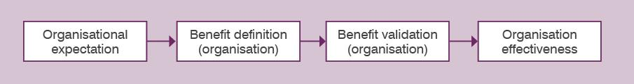

The steps in monitoring organisational outcomes

Organisational expectation
The discussion is outlined in the previous section, Refocus an organisation to improve its effectiveness.

Benefit definition (organisation)
This step defines the outcomes the organisation is expected to deliver and specifies the measures that will be used as evidence the outcomes are ultimately delivered. The following questions should be answered:
- What are the benefits that must be delivered to successfully respond to the need specified in the previous workshop?
- What KPIs with their measures and timelines will provide the evidence that the benefits have been delivered?
- How will the delivery of these be measured, monitored and reported?
Involved in this discussion should be the investor, benefit specialists, those people with responsibility for corporate reporting, heads of the various divisions within the organisation and people involved in strategically steering the organisation, adding up to between eight and 15 participants.
The discussion will generate an outcome management plan for the organisation.

Benefit validation
Based on the outcome expectations established earlier, this step will assess whether the progress in delivering the benefits is proceeding to plan. It will then decide what actions should be taken to increase the rigour of the outcome monitoring process or improve the organisation’s outcomes. Questions to be answered include:
- Are the measures defined in the outcome management plan being delivered as planned?
- Which measures need to be reported and in what forum should this happen?
- What changes should be made to the outcome measurement plan to drive better outcomes or increase accountability?
The people included should be the same as in the previous workshop – Benefit definition (organisation).
The result of the discussion will be agreed changes to the outcome managed plan.

Organisation effectiveness
This is an ongoing cyclic exercise that allows selected functional units of an existing organisation (a division, branch or even a team) to be evaluated in terms of the contribution they are making to the organisation’s outcomes.
It should answer the following questions:
- What contribution has the selected functional unit made to the organisation’s outcomes over the selected period?
- What strategic interventions were used by the unit and how effective was each of these?
- What organisational response was used and were these the most effective?
- What changes could be made to improve the organisation’s effectiveness to deliver the expected outcomes?
This session should involve the same people as the previous discussion: Benefit validation.
Executed properly, this practice will bring together a diverse mix of people from across the organisation and should provide clarity of the purpose of the organisation to its employees and stakeholders.

What’s next?
The next section outlines the resources available to further support those considering applying IMS practices.

Support in adopting the practices
This chapter provides information about how to access more support and resources for those people considering applying some or all of the IMS practices.

Getting started
Adopting a new approach or methodology normally requires a major commitment by management and a program to educate and skill staff. It will then be a year or more before the value of a new approach can be assessed.
This doesn’t need be the case when adopting the IMS. The value of the standard can be gauged in one use. A way forward is to apply the practices to either an existing ‘challenged’ investment or to understand and decide the best response to a serious problem that is facing an organisation. To do this you should engage an accredited facilitator who will professionally apply the current standard. For minimal cost and in a very short time your organisation will be able to witness the impact of the practices and decide how they could be used in the future.
The following resources provide further help and support:
- To obtain more information about the standard you can attend the free, 120-minute Investment Management information session held in Melbourne each month. Visit the Investment Management website for session times.
- Viewing the adoption videos might also help. These can be viewed on the Investment Management website or downloaded as Microsoft Word documents.
For more intensive learning you could attend the facilitator training. Although designed for intending facilitators of the IMS it will provide anyone with a solid understanding of how the practices of the IMS are applied. There is a cost for this training and a booking can be made online at <www.facilitatortraining.com.au>.
- The Investment Management process introduces some new terms, concepts, documents and roles that some people may not be familiar with. The Investment Management website contains a glossary that covers:
  - abbreviations
  - general terms
  - documents produced by the practices
  - people involved in the practices.
- A small collection of case studies is available to provide real examples of how organisations have applied the practices. These provide some understanding of the outcomes they obtained and the wisdom they have to pass on. See the Investment Management website for examples of these case studies.
- These are also good examples of the documents that are produced. Most are fictional but real examples are used where permission of the organisation has been provided. Some provided in the appendix to this book; others are provided online at the Investment Management website.
- You may like to join our e-newsletter Investment Matters or read previous editions. Visit the Investment Management website and search Investment Matters.

Do we need to train in-house facilitators?
First, while the IMS practices are simple to understand, facilitating them to get the best outcomes is not simple at all. For this reason it was necessary to introduce an accreditation process to give investors a level of confidence that the practices would be properly applied. How to become an accredited facilitator? on the Investment Management website describes the process of accreditation. An analysis of a large sample of Investment Logic Maps submitted in an annual budget process has shown there is a major difference in the quality of those produced by accredited facilitators compared with others.
People who are not accredited sometimes state they are a ‘trained facilitator’ to give them credibility with investors. The licence to use IMS materials (clause 4e) requires that facilitators who are not accredited must make this clear to all participants. See the Investment Management website for more information.
Now back to the question. The question of in-house accredited facilitators is regularly asked but there is no single answer. Some large organisations that have a high need for the IMS products have a number of accredited facilitators among their staff. Others might only have one. As the cost of engaging external accredited facilitators is very low in the context of the overall investment many organisations engage them as required from the DTF accredited facilitator list.

Engaging an accredited facilitator
The accredited facilitator list (available on the Investment Management website) provides the profile and costs of all facilitators. When shaping a new investment the number of workshops required may be anything from one to four and will be determined by the complexity of the investment. A better understanding of this is provided in Guidance – How many workshops on the Investment Management website.

What’s next?
Next section examines options for supporting facilitators in more detail.

Support for facilitators
Having people who are competent to facilitate informed discussions is critical to the success of the IMS. For this reason, a process has been designed to train, test and accredit investment management facilitators. Investors using the practices of the IMS are strongly advised to use only accredited facilitators.
This chapter provides information to assist people aspiring to become accredited facilitators and to help those who are accredited to keep abreast of current best practices.

How to become an accredited facilitator
The process of becoming an accredited facilitator aims to test a person’s understanding of the theory behind the standard and the way they apply it as a facilitator. A one-day facilitator training course is available and is highly recommended to build knowledge and skills. However, it is not a mandatory prerequisite for accreditation. What is mandated is that you submit at least three examples of completed Investment Logic Maps with feedback from the investor and that at least two have demonstrated the necessary level of competence. Aspiring facilitators are required to make themselves familiar with the accreditation process. The document How to become an accredited facilitator provides full details of the process and the costs involved. This also defines the requirements for re-accreditation by existing facilitators. (Visit the Investment Management website for more details.)

Ongoing support for facilitators
While the theory behind the informed discussions that create investment logic maps is simple, their facilitation requires a lot of knowledge and skill. Added to this, the evolving nature of the investment management practices mean that facilitators need to share experiences and ensure they are operating to the current standard.
To support facilitators the Investment Management website provides the following resources:
- Facilitator tips and traps provides guidance on what facilitators should do before, during and after each facilitated discussion.
- A set of facilitator video clips provide the basics about the theory and practices.
- Good examples of documents that facilitators are expected to produce are provided.
- The set of templates used to produce the documents is available, often catering for different software packages.
As mentioned in the previous section, a forum for accredited facilitators and those nearing accreditation is held quarterly in Melbourne. This forum has proven valuable in increasing the capability of facilitators though sharing experiences and contributing to the evolution of the standard.

Templates, examples and case studies
The templates, examples and case studies for the above outlined and listed practices are available for download at http://www.dtf.vic.gov.au/Investment-Planning-and-Evaluation/Investment-professionals-toolkit/Investment-management-products
Appendix 1: Sample 16 questions checklist

Appendix 2: Benefit framework
Each time an organisation makes an investment there is an expectation that some form of benefit will be returned. It therefore follows that the ability to design investment solutions that provide maximum benefits and to be able to confirm that the expected benefits were delivered is critical to every organisation.
Why is it then that very few investments are able to articulate the benefits they will provide, to define how they will be measured or to actually measure the benefits that are ultimately delivered?
In taking a fresh look at the problem of benefit management, it seems that within large organisations there has been an inability to define how each individual investment contributes to the primary benefits that are the point of the organisation’s existence.
It is typical and appropriate that everyone within, say Victoria Police, believes their individual investment will provide the benefit of ‘reduced crime’ and everyone in Education will claim theirs will result in ‘better learning outcomes’. But until now there has been limited ability to describe the contribution of an individual investment to ‘reducing crime’ or to achieving ‘better learning outcomes’.
The benefits framework that is depicted below has evolved, been trialled and found to be effective at addressing this longstanding problem.
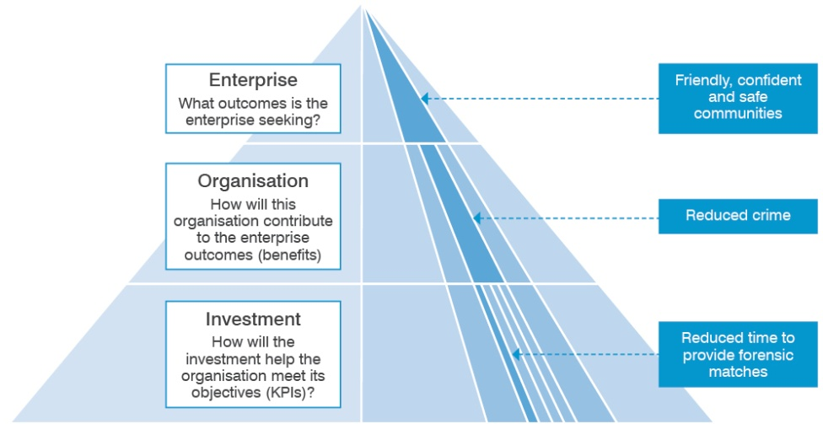
The framework is a three-level structure that links the contribution of an individual investment to the outcomes the enterprise is seeking.
In the example depicted here, at the enterprise level, the government is seeking to create ‘friendly, confident and safe communities’. To this end they set benefits and targets that must be met at the organisation level – in this case the police are required to ‘reduce crime’.
At the investment level it is necessary to demonstrate how a particular investment will contribute to the benefits sought by the organisation. In the fictional example we are using here, the team of forensic scientists are seeking an investment to acquire state-of-art forensic software and to renew their aged computer system. In return for this investment they claim they will ‘reduce crime’. Their evidence to support this claim is that they will reduce the time it takes to provide forensic matches by 30 per cent and obtain 20 per cent more forensic matches.
The head of the police organisation is then left to decide the following:
- How significant will meeting the targets associated with these KPIs be to a reduction in crime?
- Would the claimed KPIs and their targets be directly attributable to the proposed investment?
- Would the likely impact on crime reduction be worth the cost of the proposed investment?
This benefit framework is used as the basis for considering the validity of potential benefits during the development of ILMs. It has also been used during the development of more than 60 BMPs, many of which are now tracking the delivery of benefits.
Any KPI selected must be meaningful, attributable and measurable.
Glossary
Accredited facilitator: Someone who has demonstrated their ability to lead the informed discussions of the IMS and has been accredited by the Victorian Government to do so.
Appraisal: The process of defining objectives, examining options and weighing up the costs, benefits, risks and uncertainties of those options before a decision is made.
Asset option: An asset option is a means of satisfying service needs by investing in existing assets or creating new assets.
Asset strategy: Sets the direction and communicates up-front the assumptions and decisions about levels of service and who provides them; is the means by which an entity proposes to manage its assets over all phases of their lifecycle to meet service delivery needs most cost-effectively.
Assets: Service potential or future economic benefits controlled by an entity (e.g. a department) as a result of past transactions or other past events. Assets may be physical (e.g. plant, equipment or buildings) or non-physical (e.g. financial investments). Assets may also be current (having a store of service potential which is consumed in one year or less) or non-current (having a store of service potential that is consumed over a period of more than one year).
Base case: The base case is a realistic option that involves the minimum expenditure to sustain existing standards of service delivery or to achieve previously agreed service standards. Therefore, the base case does not always mean ‘do nothing’; rather it is the minimum essential expenditure option (e.g. carrying out obligatory works to meet safety and health regulations).
Benefit data provider: A person who has been identified as the custodian of data that will be required as evidence that a KPI has been met.
Benefit management plan: A short document that specifies the benefits an investment will need to deliver to successfully address an identified problem. It includes the measures to be used as evidence that the benefits have been delivered. These measures are initially used to select the most suitable response to the problem. The BMP also defines the dates the benefits are expected to be delivered, who is responsible for their delivery and how they will be reported.
Benefit Map: A one-page document that depicts the logical connection of an investment’s benefits to the KPIs, measures and targets.
Benefit reports: A report for the investor that depicts the status of the delivery of the benefit compared with the original expectations.
Benefit specialist: A person who has expertise in the definition, management and evaluation of the benefits of an investment. People responsible for program evaluation have this expertise.
Benefit: The value that the investment will provide to the organisation or its customers. Benefits are normally a positive consequence of responding to the identified driver. Each claimed benefit must be supported by key performance indicators that demonstrate the investment’s specific contribution to the identified benefit.
Business case developer: A person with responsibility for developing the business case for a potential investment.
Business case: A document that forms the basis of advice for executive decision making for an asset investment. It is a documented proposal to meet a clearly established service requirement. It considers alternative solutions, and identifies assumptions, benefits, costs and risks. The development of the business case is based on the logic in the Investment Logic Map.
Candidate investment list: A list of the investments that are to be considered and prioritised based on their ability to respond to the needs of an investment program.
Candidate investment list template
Investment concept brief: A two-page document that depicts the logic underpinning an investment and identifies the likely costs, risks, dependencies and deliverables of the proposed solution. It is used to summarise the merits of an investment and so allow decision-makers to prioritise competing investments before proceeding to a business case.
Capital expenditure: Expenditure involved in creating or upgrading assets.
Cost-benefit analysis: Cost-benefit analysis is a technique that can express in a comparable (monetary) way the net effect of the costs and benefits associated with an investment proposal.
Dis-benefit: A negative impact that might occur as a direct consequence of implementing a particular solution.
Driver: The reason that action needs to be considered at this time. Drivers are normally couched in negative terms such as ‘Climate change is demanding new ways of living in Australia’. A driver should capture the essence of what is broken and the consequences.
Economic cost (or opportunity cost): The value of the most valuable of alternative uses.
Evaluation: The process of defining objectives, examining options and weighing up the costs and benefits before a decision is made to proceed.
Financial analysis: An investment evaluation technique that is confined to the cash-flow implications of alternative options and is undertaken from the perspective of the individual department or agency or government as a whole.
Impact: The cost, benefit or risk (either financial or socioeconomic) rising from an investment option.
Implementer: Someone who has experience and a practical sense of what is possible and can help shape, scope, analyse and quantify a potential solution.
Innovator: A person with the experience and skills to question whether a proposed solution has considered the current best thinking and practices.
Investment analyst: Someone who will analyse the case for investing in a particular proposal and will provide advice to the investment decision-makers.
Investment concept brief: A two-page document that shows the logic underpinning an investment and identifies the likely costs, risks, dependencies and deliverables of the proposed solution. It summarises the merits of an investment and allows decision-makers to prioritise competing investments before proceeding to the business case.
Investment Logic Map: A simple single-page depiction of the logic that underpins an investment. It represents an ‘agreed investment story’ that is created in an informed discussion. It is written in plain English in a way that will allow a layperson to understand the language and the concepts. It provides the core focus of an investment and is modified to reflect changes to the logic throughout its lifecycle.
Investment Management Standard: A best-practice approach applied over the life of an investment that aims to reduce the risk of investment failure, provide greater value-for-money and drive better outcomes. It has been designed to enable the investor to shape and control investments throughout their lifecycle.
Investment review: Formal scheduled periodic reviews that aim to confirm that the logic for an investment remains valid.
Investment: The expenditure of funds intended to result in medium to long-term service, or financial benefits rising from the development or use of infrastructure or assets by either the public or private sectors. A single investment proposal may contain a number of related investment expenditures addressing the same service need.
Investor: The person who has an identified business problem (or opportunity), who will be responsible for making or advocating an investment decision, and who will ultimately be responsible for delivering the expected benefit. This person is often referred to as the ‘senior responsible owner’ or SRO.
Key performance indicator (KPI): A measure that has been selected to demonstrate that a benefit expected from an investment has been delivered. The KPI must be directly attributable to the investment.
Lifecycle cost: Lifecycle cost is the total cost of an item or system over its full life. It includes the cost of development, production, ownership (operation, maintenance, support), and disposal, if applicable.
Multi-year strategy: An agreed listing of asset and non-asset initiatives intended to be implemented in the medium term (generally, the next 5–10 years).
Objective: The high-level action (or strategic intervention) that is proposed as the response to the identified driver. This intervention must be framed within the context of the organisation’s purpose.
Options analysis: A process in which a range of options (both asset and non-asset) are evaluated. The most cost-effective options are then selected for more detailed evaluation through a business case.
Organisation effectiveness: A document that articulates why the organisation exists, its current effectiveness and the changes that will be made to improve its effectiveness.
Organisation outcome assessment: A report that contains an assessment of the contribution a selected functional unit has made to an organisation's outcomes over a selected period. This will include a judgement of the effectiveness of the strategic interventions that were adopted to deliver the expected outcomes and the changes that could be made to improve the impact of the unit.
Outcome management plan: A document that specifies the benefits that an organisation is expected to deliver and the measures, baseline and target dates and values that will provide the evidence the benefits have been delivered. It also specifies the forum for reporting progress, the frequency of reporting and responsibility for reporting.
Outcome(s): In the government’s output/outcome framework, outcomes equate to benefits.
Prioritised investment list: A list of candidate investments that are prioritised on the basis of their ability to respond to the needs of an investment program. This is Part 4 of the Service Logic and Investment Prioritisation (SLIP) document.
Program evaluation report: A report that makes an assessment of the effectiveness of a program of investment. The assessment is based on the benefits the investment delivered compared to those defined in the benefit management plan at the time the investment decision was made. To inform future investment decisions, the report also provides an assessment of the effectiveness of the strategic response in responding to the problem and of the way the program was managed.
Project lifecycle: The stages of an asset lifecycle between the identification of the need and the delivery and handover of an initiative.
Project manager: The person who is responsible for implementing all or part of the solution.
Proposal: An idea for a policy, program or project that is under development and appraisal
Residual value: The net value applied to the asset at the end of the investment lifecycle or evaluation period; this may result in either a positive or a negative value.
Resources: Labour, materials and other inputs used to produce outputs.
Revenue: Inflows or other enhancements, or savings in outflows, of service potential or future economic benefits in the form of increases in assets or reductions in liabilities of the entity (other than those relating to contributions by owners) that result in an increase in equity during the reporting period.
Risk: Risk is often characterised by reference to potential events, consequences, or a combination of these and how they can affect the achievement of objectives. Risk is often expressed in terms of a combination of the consequences of an event or a change in circumstances, and the associated likelihood of occurrence.
Scenario analysis: Scenario analysis is a procedure for providing the decision-maker with some information about the effect of risks and uncertainties on an investment. In a scenario analysis, a set of critical parameters and assumptions that define a particular scenario are identified and varied to reflect a best-case and a worst-case scenario.
Service Logic and Investment Prioritisation (SLIP): A document that articulates the problems confronting the organisation or program and the response that will be taken to address the problems. It then documents how candidate investments have been prioritised based on their ability to respond to the problem and deliver the benefits.
Service strategy: The strategy for the supply of appropriate services to the community, which is consistent with the entity’s corporate goals. It is based on strategic analysis and review of how services are presently provided.
Social benefit: The estimated direct increase in the welfare of society from an economic action. It is the sum of the benefit to the agent performing the action, plus the benefit accruing to society as a result of the action.
Social cost: The estimated direct total cost to society of an economic activity. It is the sum of the opportunity costs of the resources used by the agent carrying out the activity, plus any additional costs imposed on society from the activity.
Strategic assessment: The phase of the project lifecycle during which a need is translated, where justified, into a proposal where outcomes, purpose, critical success factors and the level of strategic alignment are clearly defined.
Strategic options analysis (SOA): A document that explains the logic used to identify which strategic response would best address the identified problem and deliver the expected benefits. This will describe the strategic interventions that were considered, how these were grouped to form a range of strategic options and why the preferred option was selected.
Strategist: A person with the background and skills who can act as the ‘custodian of the strategic direction’ at the informed discussions of the IMS.
Subject matter expert: A person who has expert knowledge of the problem area being discussed or the most effective responses to the problem.
Value management: Value management is a technique that seeks to achieve optimum value for money, using a systematic review process. The essence of value management is a methodical study of all parts of the product or system to ensure that essential functional requirements are achieved at the lowest total cost. Value management examines the functions required from a product, functions actually performed, and roles of the product’s components in achieving the required level of performance. Creative alternatives which will provide the desired functions better or a lower cost can also be explored.
Weighting and scoring: A technique that assigns weights to criteria, and then scores options in terms of how well they perform against those weighted criteria. Weighted scores are summed, and then used to rank options.

Further information
For more information, please contact the Investment Management unit within DTF at investmentmanagement@dtf.vic.gov.au or phone:
- Eldar Salkovic (03) 9651 1830.

www.dtf.vic.gov.au

