Construction Supplier Register: New applicant checklist for suppliers of construction works and services
The Construction Supplier Register (CSR) is an open pre-qualification scheme for suppliers of construction works and construction services interested in accessing tender opportunities to deliver Victorian Government construction projects.
New applicants and pre-qualified suppliers of construction works and construction services are bound by and must comply with the CSR Conditions of Pre-qualification and Supplier Code of Conduct. This includes undertaking a review on request by the Construction Supplier Register in order to remain registered on the CSR.
NOTE: Construction works and services categories are related to the building industry. The building industry encompasses work for or in connection with the construction, demolition or removal of all types of buildings. Buildings include all classes of buildings under the National Construction Code, structures, temporary buildings, temporary structures and any part of a building or structure.

Further information is also available online on the DTF website.
Note: `
- This checklist has been provided to assist you in completing the online application and is for your use only.
- Based on the category being applied for, suppliers are advised to download the required documents, date and sign and have them ready for upload prior to starting a Full pre-qualification application online through the CSR supplier portal.
- Online applications without a mandatory OHS criteria document (criteria 1-12) submissions will be rejected.
- 2 completed independent referee reports must be provided in support of the application. Online applications without mandatory completed referee checks will be rejected.
- Click the links below to download the relevant required document.
- It is the responsibility of the applicant to submit all documentation to support an application. The application will not progress if the required evidence for the eligibility criteria published on our website is not provided with the initial submission.

New applicant checklist

Business details, work history, maximum project size
Checklist | Completed / Attached
Provide a copy of the certificate of currency for each insurance – WorkCover, Public Liability and Professional Indemnity (as applicable)
*For Works suppliers Only – Should your company not hold Professional Indemnity (PI) insurance and you are not providing any consulting/advisory services as part of your offerings, please provide a letter on company letterhead (signed by an ASIC registered Director) confirming that you are a “construct only” supplier and do not enter into any Design and Construct Contracts for the purposes of any government works you are engaged to undertake.
Provide a copy of the latest renewal WorkCover premium notice / statement showing the insurance premium rate, compared with the relevant industry (see example below).
Provide Director ID # and certificate if available.

Registrations and professional qualifications
Checklist | Completed / Attached
Provide a copy of each certificate of registration, or an extract from a register for each registration (Building practitioner registration BPC/BLA PE - Professional Engineers registration /Architects ARBV registration).
Provide a copy of each qualification.
Provide CSR Deed Poll where applicable.
Download links:
- Land Remediation category
- Engineering-related categories
- Asbestos Inspection and Hygiene Services category
Provide copy of WorkSafe issued asbestos licence – Class A – friable and non-friable where applicable.

Project History - Practice and experience in a pre-qualification category
Checklist | Completed / Attached
Provide details of at least three completed building and construction projects of a similar size and complexity to the pre-qualification category applied for, to the satisfaction of the Lead Department.
Note: Information to include address, location, value of project, completion date, fee paid by client, scope and description, contract type, client's name, independent referee name, referee's contact number, referee's email.

Fair Jobs Code pre-assessment certificate
FJC certificate required for both Works and Services suppliers seeking a project limit above $1M.
Checklist | Completed / Attached
Attach the Fair Jobs Code if applicable – Pre-assessment certificate if you are seeking a project limit above $1M
Apply for a FJC pre-assessment certificate:
https://www.buyingfor.vic.gov.au/apply-fair-jobs-code-pre-assessment-certificate

Industrial relations management

Not required if the supplier has Fair Jobs Code pre-assessment certificate.
Required for Works suppliers only seeking project limit of below $1M.
Checklist | Completed / Attached
Complete the Industrial Relations management self-assessment if applicable.
Download the self-assessment

Cladding categories
Required for Works and Services suppliers seeking additional cladding sub-categories.
Checklist | Completed / Attached
Complete the ‘Cladding form’ as required and upload to full application.
Download the form

Occupational Health and Safety management
Checklist | Completed / Attached
Prepare an Occupational Health and Safety management system using the templates available below:
Download Links:
- Detailed Guide on the mandatory OHS management criteria
- For Works Suppliers:
  - OHS management system template Works with third party certification
  - OHS management system template Works without third party certification
- For Services Suppliers:
  - OHS management system template Construction Services with third party certification
  - OHS management system template Construction Services without third party certification
OR
Submit a current certificate from an approved assurance system to satisfy the requirements of the OHS eligibility criteria 1 – 10, as well as completing Criteria 11 and 12.
Submit OHS management system.
Attach evidence of compliance with the OHS management system for each OHS criterion.

Financial statements
FOR WORKS ONLY – CONSTRUCTION SERVICES APPLICANTS DO NOT COMPLETE
Checklist | Completed / Attached
Financial statements (including profit and loss statements, balance sheets and notes to accounts) covering at a minimum the last two financial years, prepared in accordance with Australian Accounting Standards. External financial assessor will contact you to request information as required.
Note: Audited financial statements required for pre-qualification with a maximum project limit higher than $15 million, inc. GST.

For Low value works suppliers:
Suppliers may use the following ‘Low Value Works Financial standing form’ template to describe their financial standing, if annual financial statements are not prepared:
Download the form

Practice and experience in a pre-qualification category

Independent project referee report x 2
Checklist | Completed / Attached

Attach 2 x completed independent project referee report
Download the template
Note: The CSR team may contact any of the listed referees for any further information it may deem necessary to check that the supplier practices in the category being applied for and holds the level of experience expected of a competent practitioner of that category.
- Agreement and consent
Checklist | Completed / Attached
Company Director, Partner within partnership or Sole Trader to complete the agreement and consent – on behalf of applicant.
Download the checklist

Full application Submission – Review screen
Before submitting the full application, suppliers are advised to use the UPLOAD button at the bottom of the webpage application form, as shown in the image below.
- upload the 2 x Referee reports (mandatory).
- upload executed Deed Poll/s relevant to your categories selected - All Engineering categories, Asbestos hygienist OR Land remediation contractor category (as applicable).

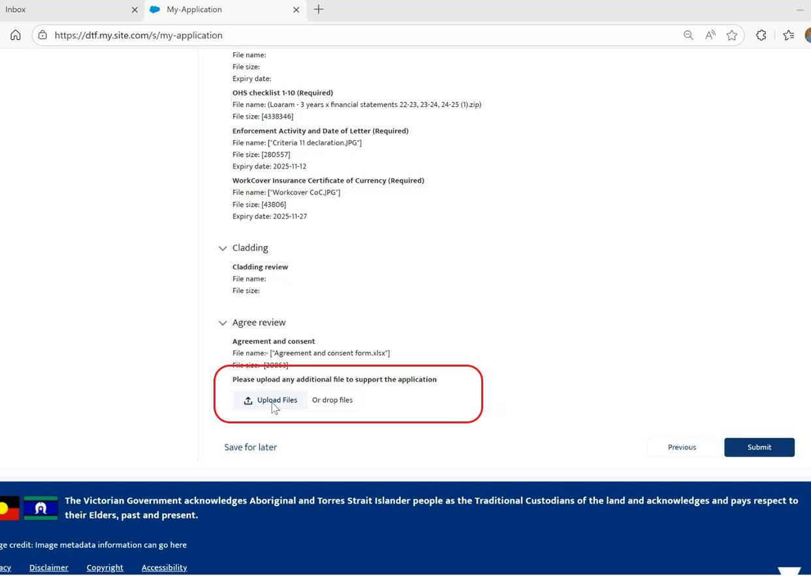

Workcover premium notice: Example
The premium notice generally has a cover letter and three to four extra pages. Submit the full notice statement, including the covering letter. Refer to the example provided at Annex 1.
Note: The premium notice is not a copy of the certificate of insurance currency.
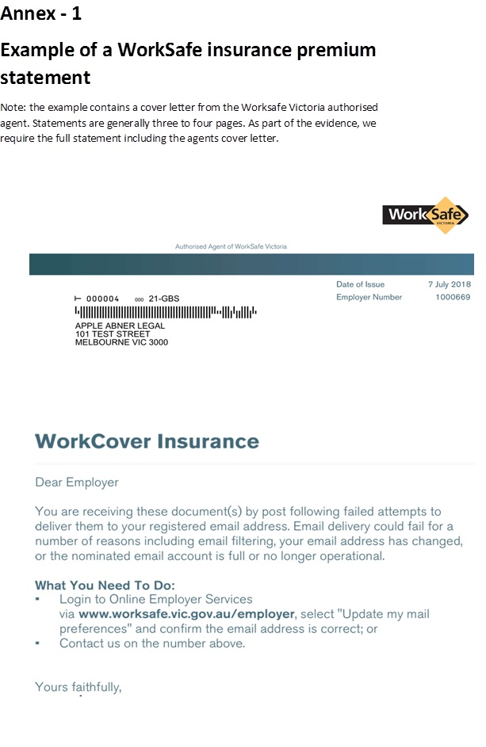
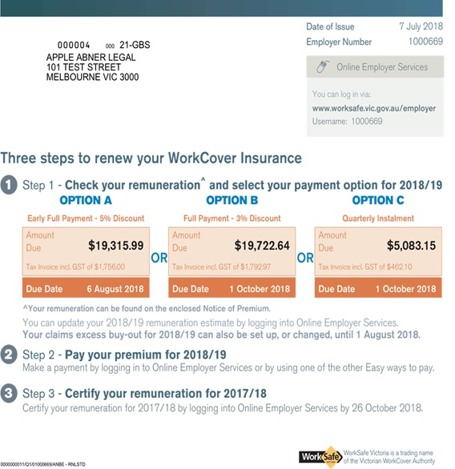

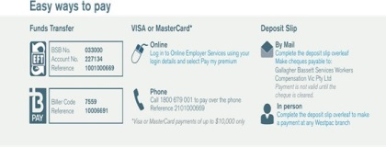

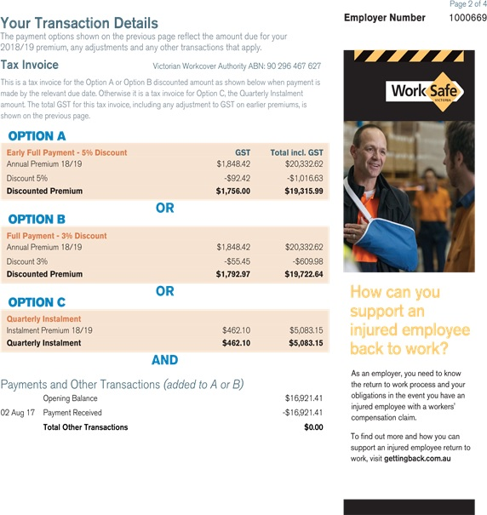

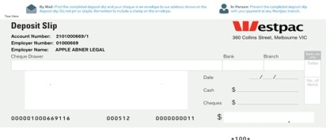

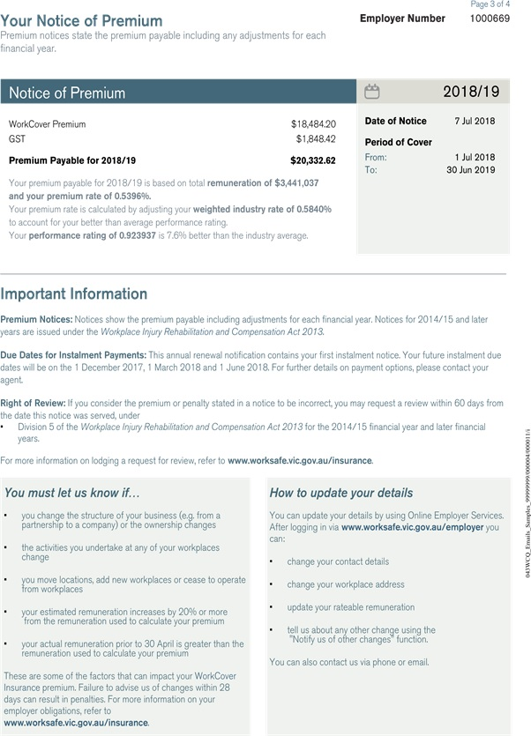
The copyright in this New applicant checklist is owned by the State of Victoria (Department of Treasury and Finance).
© State of Victoria 2025

You are free to re-use this New applicant checklist under a Creative Commons Attribution 4.0 licence, provided you credit the State of Victoria (Department of Treasury and Finance) as author, indicate if changes were made and comply with the other licence terms. The licence does not apply to any branding, including Government logos.
Copyright queries may be directed to IPpolicy@dtf.vic.gov.au

