Community Support Fund
Final Outcomes Summary for the Projects Completed 2022-23

Contents
Home Stretch Trial 3
Toomuc Recreation Reserve Number Two Pavilion Upgrade 4
East Ballarat Cricket Club - Community Cricket Nets Project 5
Afghan Australia Social Sports Club 6
Aborigines Advancement League 7
Inner South Metropolitan Mayors Forum's Graffiti Removal Pilot Program 8
2022 National NAIDOC Award Ceremony 9
Major Aboriginal Cultural Events and Awards program 2022-23 9
Faith Communities Council of Victoria 11
Hispanic Latin American Festival 2023 11
Get Active Kids Voucher Program 11
Sporting Club Grants Program 12
Foodbank Hubs 13
Community Sport Emergency Flood Assistance Program 14
Creative State 2021-25 - New Creative Neighbourhoods Program 15
Animal Welfare Support Package 2021-22: Winged Horse Equine Welfare Project 16
Ballarat Cemetery Trust refurbishments and Gym Equipment for Russell Square 17
Carnegie Basketball Club 18
Collingwood Housing Site Recreational Facilities Upgrade 19
Five CSF funding requests in 2022-23 relating to Victorian State Emergency Services 20
Diamond Valley Community Support 20
Business Chambers and Traders Group 21
Fitzroy Legal Service 21
Heatherdale Reserve Pavilion 22

Home Stretch Trial
Through the Home Stretch program, young people and their kinship and foster carers have the option of the young person remaining with their carer up to the age of 21 years, supported by a care‐allowance. Young people leaving residential care, or those who cannot remain with their kinship or foster carer are eligible for an allowance to support alternative accommodation up to 21 years of age.
The Home Stretch program includes three components: continuation of care allowance or an accommodation allowance, case work support targeted to the young person (and to support the carer if required), and brokerage to facilitate the young person’s access to education, employment and health and wellbeing supports.
Young people developed positive working relationships with their Home Stretch workers, who provided them with support across 5 service offers, including housing and independent living skills, health and wellbeing, education, employment and connections. Evaluations have shown that young people are engaging in more help-seeking behaviours, suggesting stronger agency and confidence and are benefiting from access to flexible funding to help them achieve their transition goals.
As a result, more than 250 young people were supported to transition. Data suggests that almost 40 per cent of young people chose to continue to reside with their carers at the commencement of Home Stretch support, and a further 10 per cent commenced the program living with their carers but moved to alternative arrangements prior to turning 21 years. A little over 21 per cent chose to move to independent living (from foster or kinship care) at the commencement of Home Stretch, and further 30 per cent commenced Home Stretch in independent living arrangements due to their last placement type being residential care.
Disclaimer: The above information was provided by the Department of Families, Fairness and Housing.

Toomuc Recreation Reserve Number Two Pavilion Upgrade
Cardinia Shire Council have completed upgrades to the Toomuc Reserve Number Two Pavilion to create safer, more accessible facilities to encourage greater participation by all members, women and girls and the wider community.
The project has enabled the at Pakenham Junior Football Club and Pakenham Cricket Club to meet the growing needs of the local sports clubs through the provision of the safer and more welcoming community sport infrastructure.
Disclaimer: The above information was provided by the Department of Jobs, Skills, Industry and Regions.

East Ballarat Cricket Club - Community Cricket Nets Project
Ballarat City Council have completed upgrades to the East Ballarat Cricket Club Community Cricket Nets that addressed the safety issues for the Club’s players during their sessions.
The project has enabled the East Ballarat Cricket Club to meet the growing needs of the local sports clubs through the provision of the safer and more welcoming community sport infrastructure.
Disclaimer: The above information was provided by the Department of Jobs, Skills, Industry and Regions.

Afghan Australia Social Sports Club
Afghan Australia Social Sports Club have completed their equipment purchase project to build community engagement and connectedness through sports particularly, soccer.

The project has enabled the Afghan Australia Social Sports Club to develop and maintain participation
opportunities as there are risk of participation decline.

Disclaimer: The above information was provided by the Department of Jobs, Skills, Industry and Regions.

Aborigines Advancement League
The Aboriginal Advancement League’s office upgrade and financial sustainability project was successfully delivered with funding from the Community Support Fund. The project delivered upgraded facilities which are modernised, safe, compliant, and fit for purpose. The improvements better enable the Aboriginal Advancement League to host community events and provide meeting and event spaces for hire.
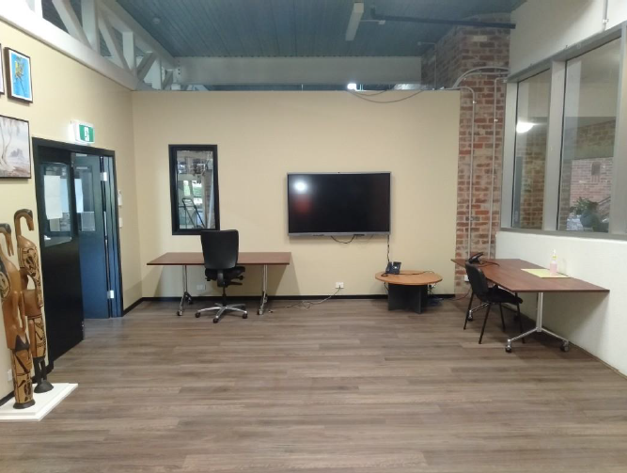
Disclaimer: The above information was provided by the Department of Premier and Cabinet.

Inner South Metropolitan Mayors Forum's Graffiti Removal Pilot Program
These initiatives gave all six councils an opportunity to collaborate and to build trust with the graffiti community and give the residents and locals an avenue to learn and educate themselves on the varying levels of understanding graffiti. Over 200 individual creatives and artists have contributed to beautifying and bringing colour to the streets, while organically assisting in the mitigation of illegal graffiti on a range of third-party assets.

These programs will also introduce long-term benefits that can be initiated in future art in public spaces and creative programs by working collectively with internal and external stakeholders within each municipality. This includes placemaking initiatives, youth outreach programs, reimagining public art activations. Strengthening partnerships with indigenous groups and, at the same time, bringing vibrancy and colour to every community.

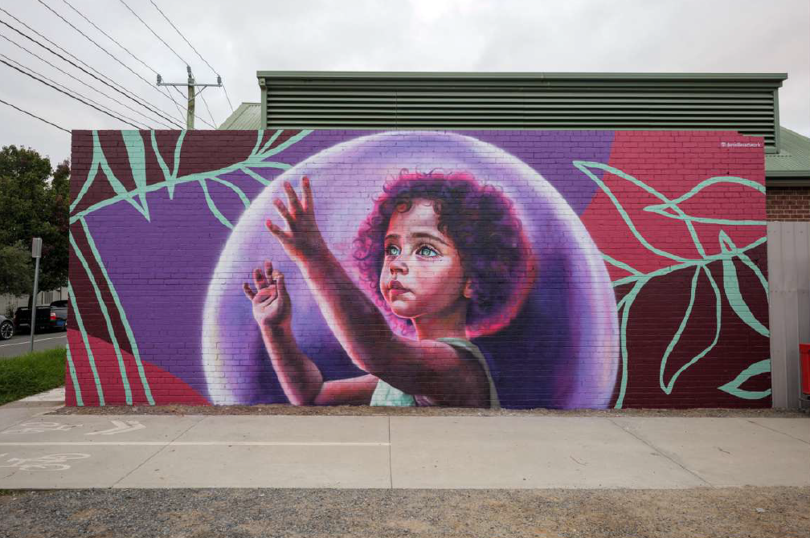
Disclaimer: The above information was provided by the Department of Treasury and Finance.

2022 National NAIDOC Award Ceremony
The 2022 National NAIDOC Week, held from 2 July to 9 July 2022, was a week-long celebration of the history, culture, and achievements of Aboriginal and Torres Strait Islander people. The 2022 NAIDOC Week theme was ‘Get up! Stand up! Show up!’. The theme encouraged Australians to champion institutional, structural, collaborative, and cooperative change. It also celebrated those who have already driven and led change in Aboriginal and Torres Strait Islander communities over generations.
Throughout the 2022 National NAIDOC Week, events and activities were held across the country to celebrate the contributions and achievements of Aboriginal and Torres Strait Islander people. These events included cultural performance, community gatherings, educational and advocacy activities such as the NAIDOC March in Melbourne.
Disclaimer: The above information was provided by the Department of Premier and Cabinet.

Major Aboriginal Cultural Events and Awards program 2022-23
DPC successfully delivered the program with the funding from the CSF. The program included the:
- 2022 NAIDOC State Reception
- 2022 Victorian Aboriginal Honour Roll
- 2023 Victorian Aboriginal Remembrance Service
- 2023 Recci Marks Award
The program also provided funding to the Victorian NAIDOC Committee, through their auspice the Victorian Aboriginal Community Controlled Health Organisation, to plan and deliver the Victorian NAIDOC Week program of community events in 2022.
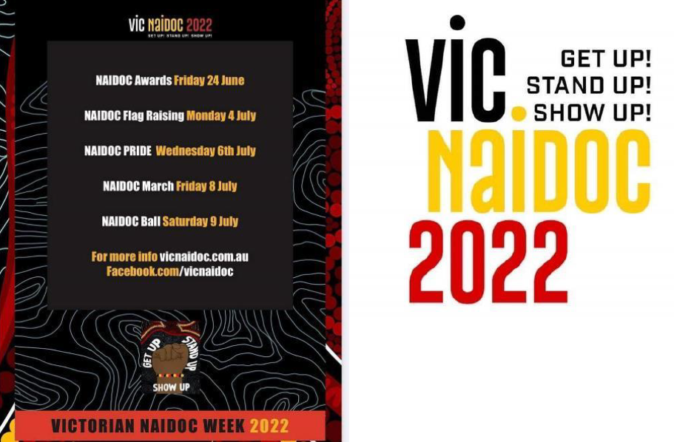
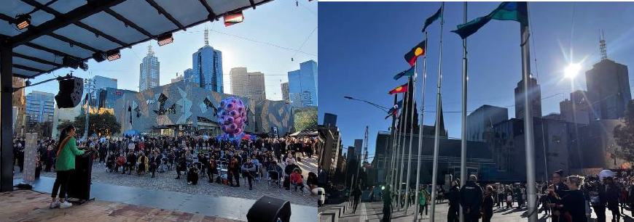
Disclaimer: The above information was provided by the Department of Premier and Cabinet.

Faith Communities Council of Victoria
The Faith Communities Council of Victoria (FCCV) project aimed to promote positive relations between people of different faiths and generate greater knowledge and mutual understanding of the customs and practices of Victoria’s diverse faith traditions.
The main objectives of the project were to:
- Maintain and further develop the organisational capacity and responsiveness of the Faith Communities Council of Victoria (FCCV)
- Support the development and growth of interfaith activity in Victoria
- Plan, manage and deliver the annual Victorian Interfaith Networks Festival (VINF)
Disclaimer: The above information was provided by the Department of Premier and Cabinet.

Hispanic Latin American Festival 2023
With the support of the CSF grant, the Hispanic Latin American Festival and Cultural Association were able to successfully deliver their 2023 Hispanic Latin American Festival. This festival takes place each year in the Spanish Quarter of Johnston Street Fitzroy and is a celebration of Spanish and Latin arts and culture. This funding ensured the event could go ahead, as escalating event costs and impacts of inflation were hindering event plans.
This event was an opportunity for the community of Melbourne to come together in celebration, which also provided extra income for the surrounding traders due to the influx of people. All Johnston Street traders on the same road benefit massively by being a part of the festival and having their tables on the street. It is an opportunity for people from all walks of life to come and taste and experience who the Melbourne Community of Latinx and Hispanic people are and join through food and music. It is a way for Melbourne to celebrate its multicultural identity by welcoming people from Latin America and Spain to say "We are here! Come see who we are!".
Disclaimer: The above information was provided by the Department of Premier and Cabinet.

Get Active Kids Voucher Program
The Get Active Kids Voucher Program is a Victorian-first initiative that delivers vouchers to eligible Victorian children and young people, assisting families with the costs of participation in sport and active recreation activities. The Program encourages children to re-engage or participate for the first time in new activities by reducing the cost of participation, which can be a significant barrier.

The Program is delivered in a targeted way to support families facing the greatest cost pressures to participation in sport and active recreation. The Project Objectives include:
- Assisting disadvantaged cohorts to participate in sport and active recreation.
- Increasing the number of children aged 0 to 18 years participating in sport and active recreation activities.
- Increasing awareness of positive impacts of participating in sport and active recreation.
- Increasing the number of children and youth meeting the national physical activity guidelines.
Disclaimer: The above information was provided by the Department of Jobs, Skills, Industry and Regions.

Sporting Club Grants Program
The Sporting Club Grants (SCG) Program provides funding for grassroots sport and active recreation organisations across Victoria to assist in addressing a range of barriers to participation in community sport and active recreation.
Round 1 of the 2022-23 SCG Program was delivered under three categories:
- Category 1: Uniforms and Participation Equipment – Up to $1,000 to purchase uniforms or equipment that is essential for participation
- Category 2: Skill Development – Up to $2,000 (clubs) and $5,000 (associations and leagues) for training courses or projects to upskill coaches, officials and volunteers
- Category 3: Operational Capacity – Up to $5,000 for projects that support organisations to operate more effectively, explore new participation opportunities and plan for future growth.
Round 1 of the 2022-23 SCG Program was open for applications between 16 June and 21 July 2022 and was significantly oversubscribed, with 1,608 applications received, requesting funding of $2,488,528.64
In response to this oversubscription, $1.2 million from the Community Support Fund (CSF) enabled all eligible grants that addressed the assessment criteria through Round 1 of the SCG Program to be supported.
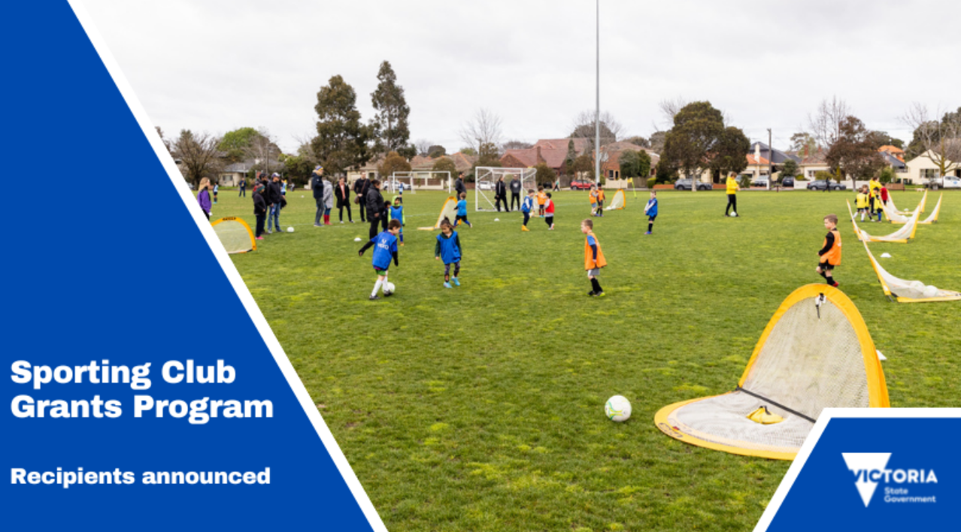
Disclaimer: The above information was provided by the Department of Jobs, Skills, Industry and Regions.

Foodbank Hubs
The major outcome of this project has been the establishment of a dedicated night and daytime outdoor entertainment venue with particular emphasis on supporting arts and cultural activities across a whole range of creative endeavours. The project objective was to establish Foodbank Hubs in Ballarat and Morwell. These centralised regional warehouses are operated by Foodbank Victoria and are intended to increase the supply of fresh, frozen and chilled foods to those experiencing food insecurity in the Gippsland and Grampians regions.
The Foodbank Hubs will provide critical emergency food provision infrastructure for the region while also providing education and employment pathways for disadvantaged communities. Now completed, the new centres will enable a coordinated food relief response across the state. The new Foodbank Hubs will ensure that Victorian families have fresh and nutritious food on their table when they need it most. The CSF funding was in addition to $10 million funded through the Department of Families, Fairness and Housing. Both hubs were officially opened by July 2024.
Disclaimer: The above information was provided by the Department of Families, Fairness and Housing.

Community Sport Emergency Flood Assistance Program
The Community Sport Emergency Flood Assistance Program (the Program) was developed to assist Victorian sport and active recreation organisations directly affected by the October 2022 Victorian floods. One-off grants of $5,000 were available to assist in the replacement of items that had been lost, damaged or destroyed.
The Program assisted with the replacement of items lost, damaged and destroyed by the floods and could be used for:
- Playing equipment
- Injury prevention equipment
- First-aid equipment
- Non-participation equipment
- Canteen or clubroom items
- Maintenance equipment.
A key objective of the Program was to administer a rapid application and assessment process to ensure impacted community sport and active recreation organisations receive funding as quickly as possible - within 5 to 10 business days of eligible applications being received.
A total of 598 applications were received through the Program. The final outcomes for the Program were as follows:
- 438 approved applications
- 3 of the approved organisations have Electronic Gaming License and were funded from DJSIR funds
- 140 unsuccessful applications
- 46 applications were flagged as potentially fraudulent as they were submitted by unauthorised persons. Of these, 27 applications were processed as unsuccessful and the remaining 19 were rejected / cancelled and are not included in the applications received.
- one application was withdrawn by the applicant.
Disclaimer: The above information was provided by the Department of Jobs, Skills, Industry and Regions.

Creative State 2021-25 - New Creative Neighbourhoods Program
Creative Neighbourhood (CN) aims to support stronger, more sustainable creative industries by investing in more accessible, secure and fit for purpose spaces for creative practice and presentation across Victoria. It was designed to enable government to swiftly respond to demand for creative industry spaces and strengthen creative industries’ recovery and growth through four streams.

CN was delivered through four streams:
- Brokering and Partnerships: A dedicated brokering service to respond to the increasing demand of creative organisations looking for space
- Strategic Infrastructure: Competitive grants for minor infrastructure upgrades or refurbishments to adapt or unlock existing assets for creative purposes, namely Creative Neighbourhood Infrastructure Support Program (CNISP) LGA (Local Government Authority) and CNISP Public
- Neighbourhoods & Precincts: Identification and formal designation of Victoria’s priority creative neighbourhoods -suburbs and towns where creative spaces, activity and impact are highest -and foster their growth and resilience through planning interventions and co-investments with local councils
- Capability Building: An online Creative Infrastructure Toolkit responding to an identified need of stakeholders for research and guides to assist local councils, developers, and the creative enterprises to better identify and respond to demand for creative spaces.
Disclaimer: The above information was provided by the Department of Jobs, Skills, Industry and Regions.

Animal Welfare Support Package 2021-22: Winged Horse Equine Welfare Project
The Winged Horse Equine Welfare Inc. (‘Winged Horse’) is a not-for-profit organisation that aims
to rescue, rehabilitate and rehome at-risk horses and other animals, and raise awareness about
issues related to animal welfare. The objectives of the Winged Horse Equine Welfare Moving
Forward project was to:
- Improve Winged Horse’s ability to assist more animals in need (specifically, to be able to
- rehabilitate 12 more horses per annum).
- Employ skilled workers as set out in the approved project plan.
- Increase Winged Horse’s capacity to raise funds.
- Bring Global Federation of Animal Sanctuaries standard of accreditation to Australasia.
- Upgrade shelter and fencing at Winged Horse’s premises.
- Update Winged Horse’s website.
- Facilitate training and workshop events.

The Winged Horse Moving Forward project resulted in the rehabilitation of 70 equines: provision of
veterinary services including chiropractic, hoof and dental care; purchase of feed including a bulk purchase of hay and rodent-proof storage container; improved fencing and shelters to enable the accommodation of more equines; provision of employment for 4 part-time positions throughout the project period; and training of Winged Horse’s CEO as the first Global Federation of Animal Sanctuaries Australasian Farm and Equine site inspector.

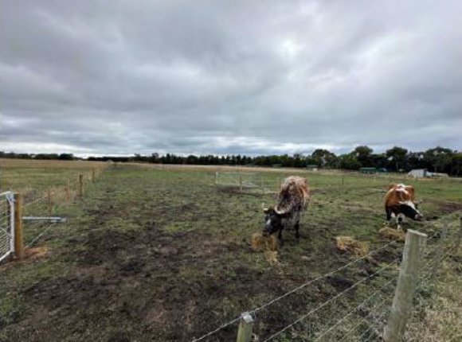
Disclaimer: The above information was provided by the Department of Energy, Environment & Climate Action.

Ballarat Cemetery Trust refurbishments and Gym Equipment for Russell Square
Ballarat Cemetery Trust refurbishments

This project was to restore two rotundas that were in a state of disrepair at the Ballarat General Cemetery. The completed works allows for patrons to attend funeral and memorial ceremonies during inclement weather and community members to gather for special occasions and anniversaries.

The project resulted in the following outcomes:
- two refurbished rotundas at the Ballarat General cemetery.
- evidence of increased usage of the rotundas.

Gym Equipment for Russell Square

The project was installation of outdoor gym equipment at Russell Square, Ballarat. The project replaced two outdated outdoor fitness stations with new gym equipment and installed a third and fourth station and gym equipment which links the existing fitness track around the Russell Square Recreation Reserve. Stations have play matta installed as required.

The project resulted in the following outcomes:
- Installation of four new fitness stations.
- Evidence of increased activation of the reserve using new fitness equipment.
Disclaimer: The above information was provided by the Department of Jobs, Skills, Industry and Regions.

Carnegie Basketball Club
The Carnegie Basketball Club have completed upgrades to the two basketball rings through the installation of two adjustable basketball rings. This project saw the purchase of two Goalrilla CV60 basketball rings to be installed by the Carnegie Basketball Club at Carnegie Primary School.
The project will provide safer, more accessible facilities to encourage greater participation by all members, women and girls and the wider community.
The project has enabled the Carnegie Basketball Club and Carnegie Primary School to meet the growing needs of the local sports clubs through the provision of the safer and more welcoming community sport infrastructure.
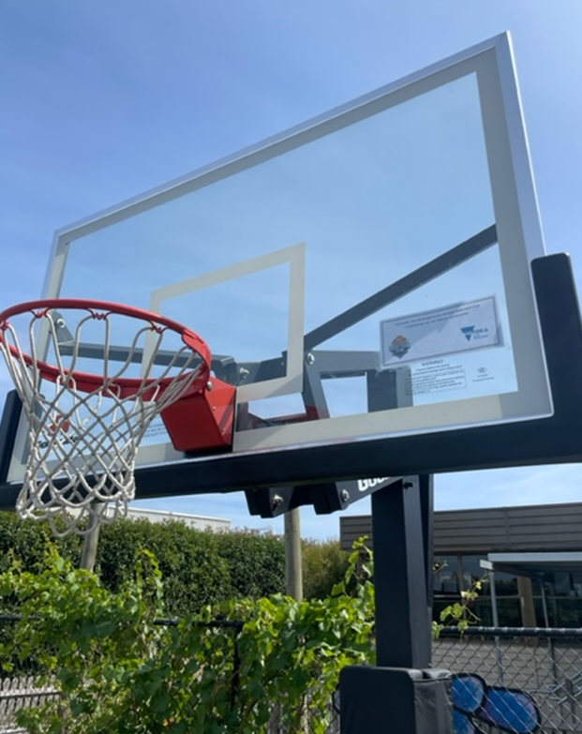
Disclaimer: The above information was provided by the Department of Jobs, Skills, Industry and Regions.

Collingwood Housing Site Recreational Facilities Upgrade
This project included installation of one full basketball court, a half-court, seating and lighting in collaboration with the National Basketball League and DreamCourts. The funding aimed to improve community participation and cohesion, space activation, and establishing a potential location for future basketball events. Observations and monitoring activities indicate the new facilities are being used from early morning to late evening and has attracted positive local feedback.
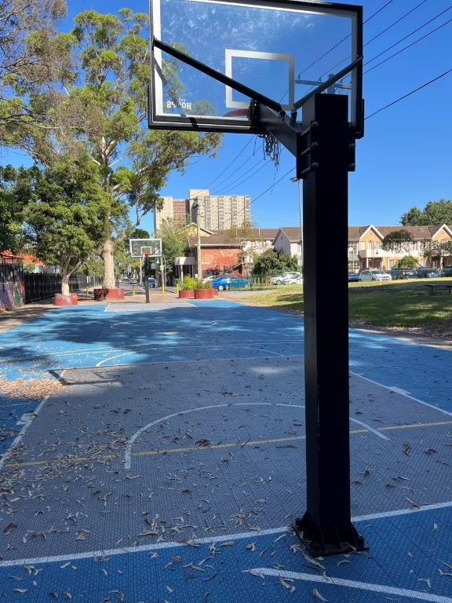
Disclaimer: The above information was provided by the Department of Families, Fairness and Housing.

Five CSF funding requests in 2022-23 relating to Victorian State Emergency Services
The Five CSF funding requests in 2022-23 relating to Victorian State Emergency Services was to provide flood and rescue equipment, operational vehicles, solar energy capability, facility upgrades, and facility asbestos remediation works.
This project provided grants to four volunteer emergency service organisations to enable the organisations to purchase equipment or undertake facility improvements. These grants have supported the organisations with their emergency response role.
The project enabled Werribee Fire Brigade to upgrade its facilities to move to automatic rear roller doors, to purchase a series of audio-visual and computer equipment to support their volunteers, and a trophy cabinet. The Benalla SES unit purchased additional storm, flood and rescue equipment to support operational response capabilities. Monash SES unit was supported to purchase and equip a new operational support vehicle for their unit, while Stawell SES unit made some upgrades to its facilities to include the installation of a solar PV system.
Disclaimer: The above information was provided by the Department of Justice and Community Safety.

Diamond Valley Community Support
Funding was provided to Diamond Valley Community Support (DVCS) to provide emergency relief, material aid, information and referral supports to people in hardship, financial and/or personal crisis in the north-east Banyule and Nillumbik regions and surrounds.

DVCS provided material aid that includes grocery vouchers, food parcels and bags, pre-made meals, payment of prescription medicines, phone bills and top-ups, toiletries, and cleaning parcels as well as items for the homeless such as sleeping bags and blankets.
Disclaimer: The above information was provided by the Department of Families, Fairness and Housing.

Business Chambers and Traders Group
Business Chambers and Trader Groups Round Three grants provided funding for locally led initiatives to support metropolitan and regional business chambers and trader groups. 62 grants were available for business chambers and trader groups to deliver activities or programs to advance business community participation across Victoria and to build strong and sustainable communities.
Key objectives of Round 3 of the grants program were to support business chambers and trader groups to run locally led initiatives between October 2022 and 30 April 2023 that enabled local business collaboration; educated, informed, and empowered small businesses; supported small businesses to build digital capability; and helped members transition into recovery and restart.
Key metrics from the program included that over 9,400 businesses that were positively impacted by the program; over 1,049 new members were joined the business chamber or organisation due to the program; and qualitative feedback highlighted that many business owners perceived that the program had a positive financial impact on them.
Disclaimer: The above information was provided by the Department of Jobs, Skills, Industry and Regions.

Fitzroy Legal Service
The Community Support Fund allocation to Fitzroy Legal Service has enabled the organisation to make infrastructure and IT upgrades post lockdowns with outcomes including safer work environments and an increased number of confidential working and consulting spaces with benefits for both staff and clients. A Staff break out area has also been created. Staff and volunteers have had up to date computers/laptops to support their important work with the clients, enabling it to be undertaken in a way that is secure, efficient and effective.

Cybersecurity has improved through software and through planning towards the completion of the migration to the cloud of a range of documents. Staff have greatly appreciated the improvements with a key indicator being the increased numbers of staff now working regularly in the office, and the regular use of the breakout space for shared activities in work breaks and the use of this area for celebrations.
Disclaimer: The above information was provided by the Department of Justice and Community Safety

Heatherdale Reserve Pavilion
Fit out of the Heatherdale Reserve Pavilion to include portable stage, blinds, alarm, modem/internet connection, carpet, rubber mats, kitchenware, deep fryers, pie warmer, bain-marie, ice maker, coffee machine, tables, chairs, couches, outdoor heaters, shelving and trophy cabinets.
As a result, more participation opportunities made available through the development of new or upgraded existing multi-use, sport, and active recreation infrastructure. Improved participation of those who participate less in community sport and recreation, particularly those from communities experiencing long-term socio-economic disadvantage, growth and regional areas and areas affected by natural disaster. More equitable and inclusive participation of women and girls in local sport by investing in well-designed and high-quality facilities. Improved sustainable design and planning to ensure infrastructure investment is building better and more liveable communities. Increased local economic activity through the planning, building, management, and activation of redeveloped or new infrastructure.
Disclaimer: The above information was provided by the Department of Jobs, Skills, Industry and Regions.

