Community Support Fund
Final Outcomes Summary for the Projects Completed 2023-24

Contents
Connect Health and Community Pilot Dental Screening Program 2
The Bendigo Foodshare Community Food Hub 2
The Lexton Community Hub 3
Carisbrook Bowls Club 4
Ross Reserve Upgrade 5
Murrumbeena Tennis Club 6
Basin Football and Netball Club 7
Emerging with Stronger Communities - Sikh Volunteer Vans 8
Mount Evelyn Community House and Reading Room 8
Regional Food Relief Hubs 9
Helping Hands Mission Inc. 10
Dja Dja Wurrung Aboriginal Corporation Community and Corporate Centre 10
Lake Wendouree and Victoria Park in Ballarat - Light installation 11
Creative Infrastructure Program 11
Animal Law Institute 11
Clunes Booktown Festivals 12

Connect Health and Community Pilot Dental Screening Program
Early Learning Centres (ELCs) actively participated throughout the project and achieved Smiles 4 Miles certification which is part of Healthy Early Childhood Services framework (Achievement Program). ELCs continue to deliver oral health messages and implement practices to create a healthier environment for the children. Group oral health sessions were provided by the clinical team during site visits and dental packs were distributed for those present on the day.
Overall, the participation rate for dental screening was more favourable than the attendance rate for recall visits. Of the 180 children recruited, 64% did not attend any of their recall appointments and 35% attended at least one recall appointment. Constant ELC staffing issues posed a challenge to deliver the planned activities. Competing priorities and change in circumstances due to the pandemic influence the final outcomes of the project and contributed to the attrition rate. Project Working Group were satisfied with the activities delivered whilst adapting to and managing changes throughout the project lifecycle
Disclaimer: The above information was provided by the Department of Health.

The Bendigo Foodshare Community Food Hub
Funding supported Bendigo Foodshare to build a multi-purpose Food Hub to enhance food storage and distribution facilities, social supermarket, community garden, food education hub, and space for the Bendigo Community Farmers Market. The Food Hub will provide a centralised location for the community to come together to address food security, share ideas and access locally grown produce.
The objectives of the project include building a new, larger and permanent Food Relief Hub in Bendigo; expanding food relief storage and distribution capacity; improving range of healthy food choice and essential supplies for those in need; enabling more large volume produce donations from farmers; appointing a builder to undertake the building works; and laying a concrete slab and installation of roof for the new facility.
Disclaimer: The above information was provided by the Department of Families, Fairness and Housing.

The Lexton Community Hub
This project delivered female friendly facilities at Lexton Recreation Reserve including upgraded player and umpire changing rooms with amenities, storage rooms, a multi-purpose space, first aid room and a covered spectator area. The completed works provide modern facilities for women and girls who currently do not have dedicated female change amenities. The hub supports Lexton Football Netball Club in meeting the growing local needs through the provision of safe and welcoming community sport infrastructure. The facilities are also accessible by the wider community outside of club organised activities.
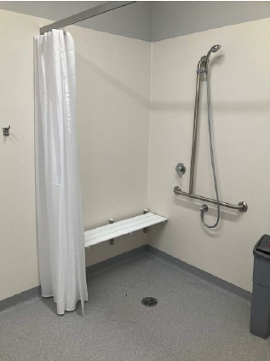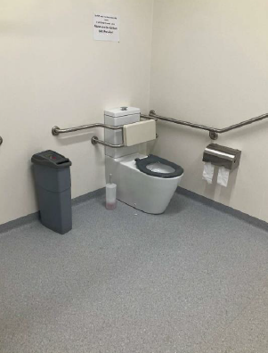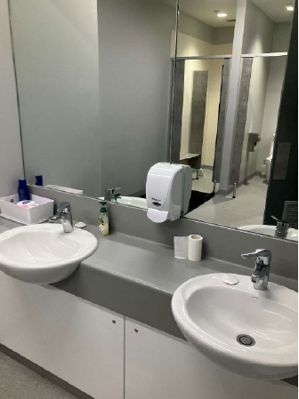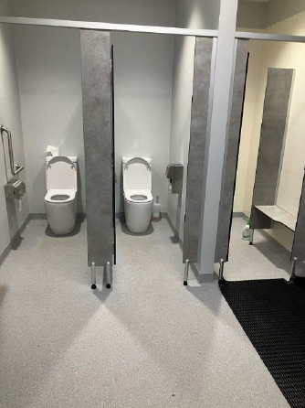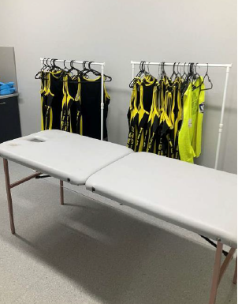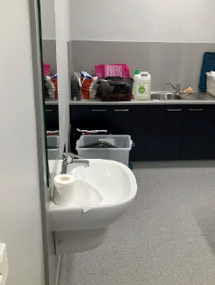
Disclaimer: The above information was provided by the Department of Jobs, Skills, Industry and Regions.

Carisbrook Bowls Club
Funding delivered an upgrade of the synthetic bowling green, installation of a new woven bowls playing surface, signage, twelve bench seats, and four new shelters with wheelchair access.
The upgrades provide developed facilities with greater access to support people of all ages and abilities. Central Goldfields Shire Council and Carisbrook Bowls Club can provide increased community sport and active recreation participation opportunities through the upgraded and accessible facilities. The facilities are also accessible by the wider community.
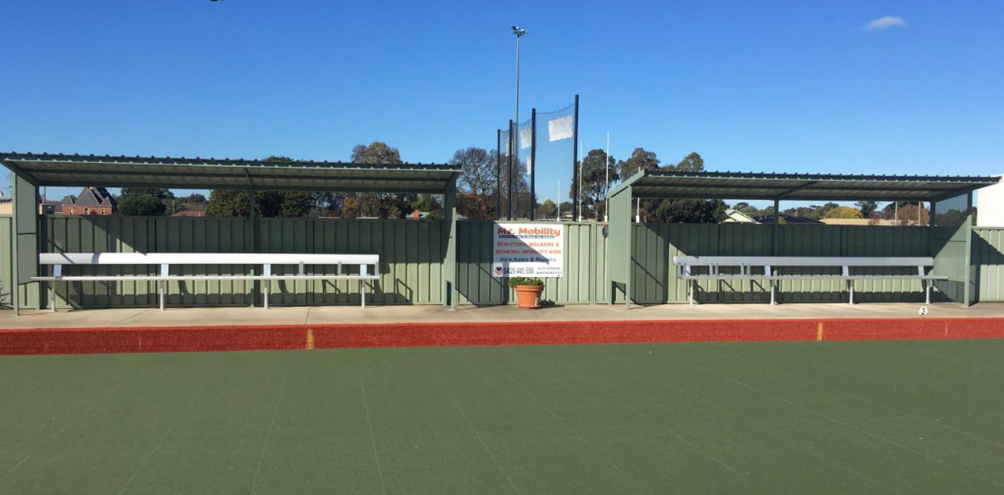
Disclaimer: The above information was provided by the Department of Jobs, Skills, Industry and Regions.

Ross Reserve Upgrade
Funding delivered upgrades to the basketball court and jogging track, lengthened the junior football oval, an all-abilities playground, and upgrades to parking and other amenities.
The completed project provides modern, safe and accessible facilities to encourage greater participation by all members of the community including children, young people, people with disabilities, women and girls. Greater Dandenong City Council can provide a welcoming space for families and community members to enjoy accessible active recreation infrastructure and meet the needs of people of all ages and abilities.
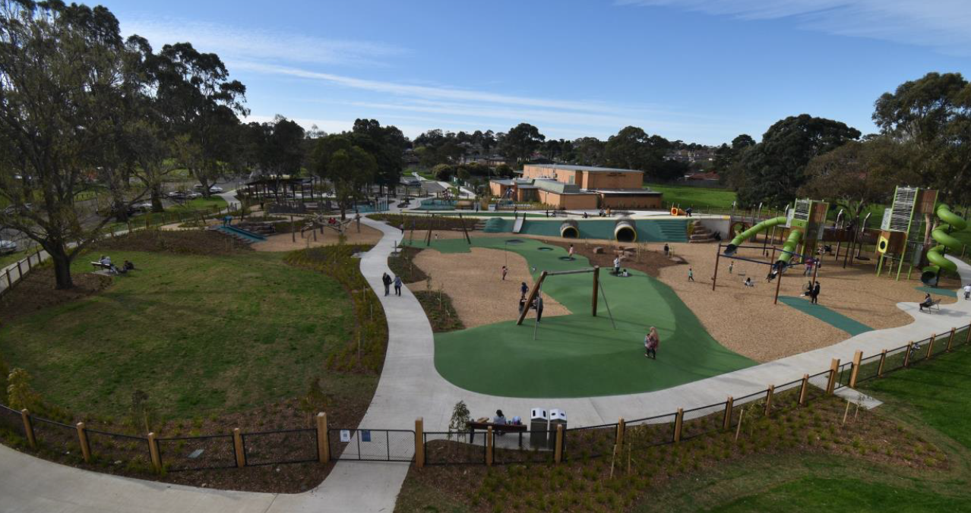
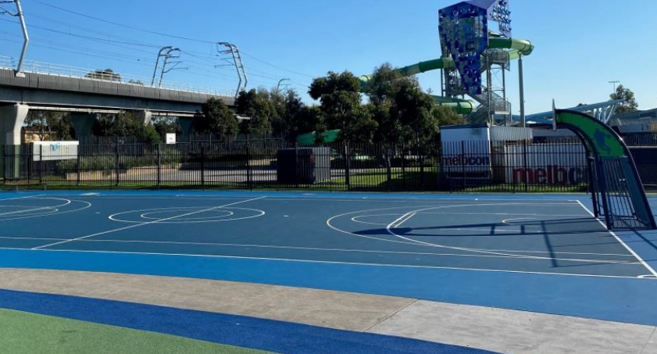
Disclaimer: The above information was provided by the Department of Jobs, Skills, Industry and Regions.

Murrumbeena Tennis Club
The project delivered an upgraded pavilion at Murrumbeena Tennis Club including a new kitchen, toilet, shower and community space. The project will allow for future growth in members and participation through provision of a safer, accessible and welcoming facility.
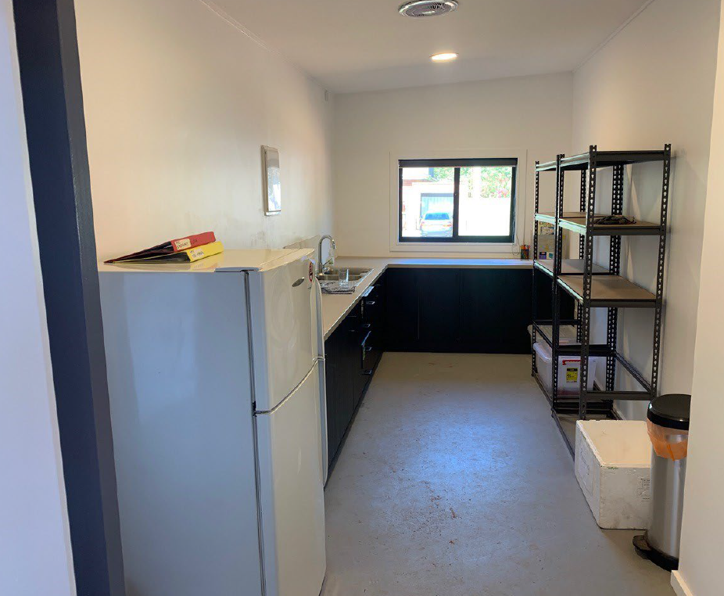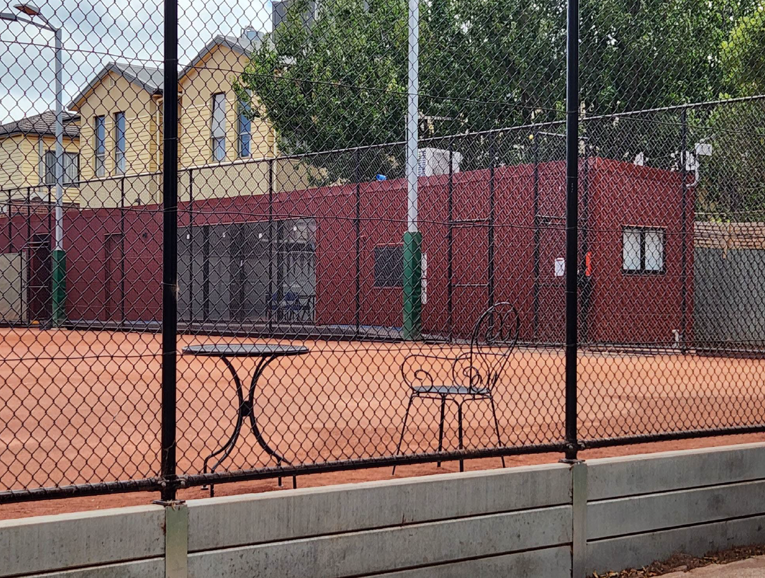
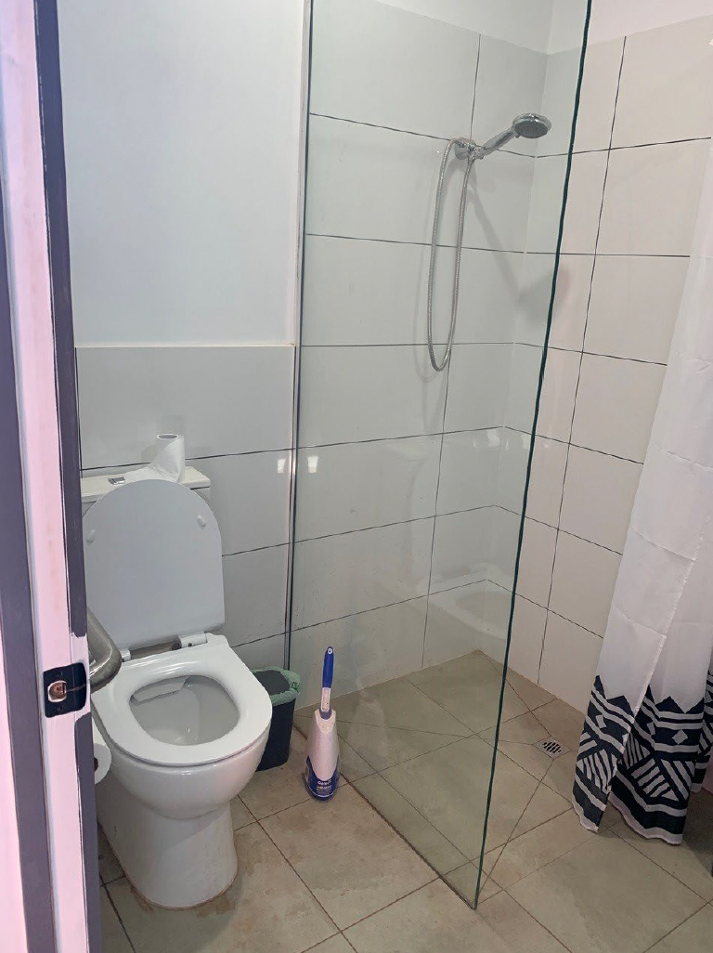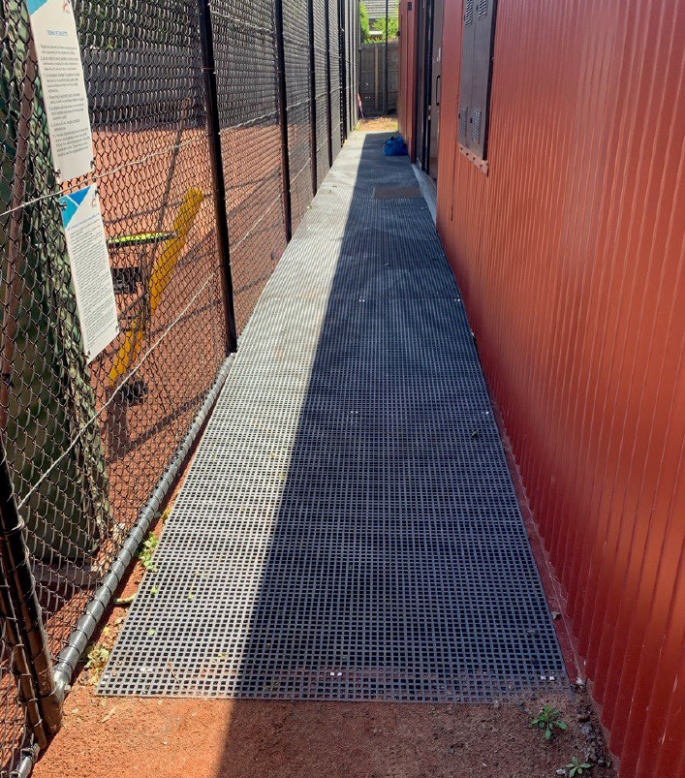
Disclaimer: The above information was provided by the Department of Jobs, Skills, Industry and Regions.

Basin Football and Netball Club
Funding delivered AFL goal netting at the end of two ovals and a digital scoreboard at Batterham Reserve for the Basin Football and Netball Club. This has enabled the Basin Football and Netball Club to provide greater participation opportunities and greater safety through the goal netting. Spectator and volunteer experience has also improved through the remote-controlled siren, time, and scorekeeping capability of the digital scoreboard.
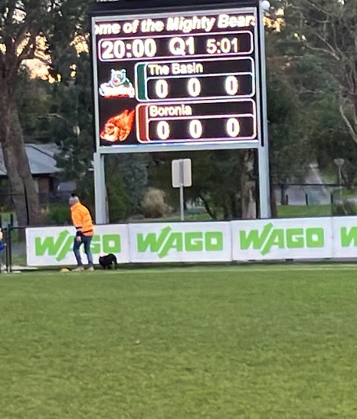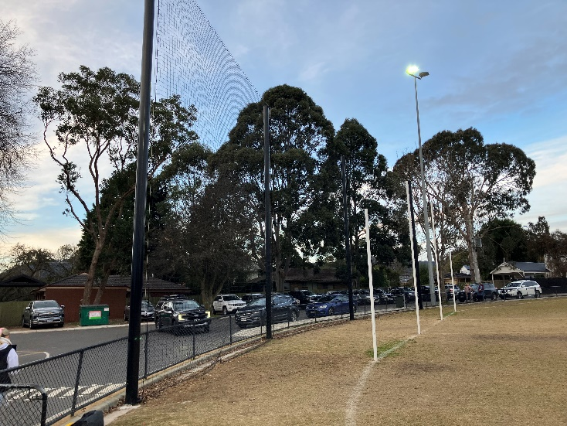
Disclaimer: The above information was provided by the Department of Jobs, Skills, Industry and Regions.

Emerging with Stronger Communities - Sikh Volunteer Vans
To purchase two new vans and one food truck to enable the Sikh Volunteers Australia to expand the area they currently service to ensure they can further help those experiencing food insecurity. Sikh Volunteers Australia will use the vehicles to expand their community outreach services and deliver much needed food relief to people experiencing hardship.
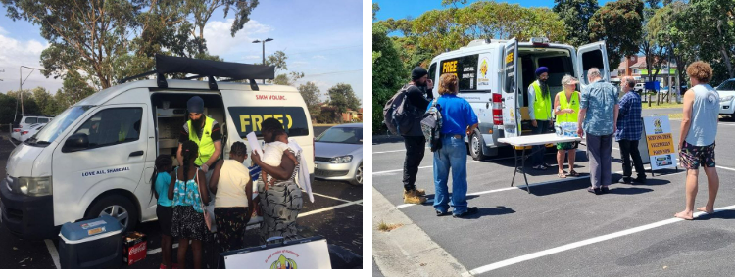
Disclaimer: The above information was provided by the Department of Families, Fairness and Housing.

Mount Evelyn Community House and Reading Room
The objective of the program was to refurbish and expand the Art Shed, a building used by the Mount Evelyn Community House to run workshops for community members.
The $15,000 provided through the Community Support Fund allowed the Mount Evelyn Community House to refurbish and expand the Art Shed, a building used to run workshops for community members. The Art Shed was previously in a poor state of repair. These works have established the Art Shed as an inclusive, safe, and flexible space for community to interact in a range of different ways and utilise to run beneficial programs for the Mount Evelyn community.
Disclaimer: The above information was provided by the Department of Families, Fairness and Housing.

Regional Food Relief Hubs
Regional Foodshare Operations

Operational funding for the regional foodshares supported up to 10 full-time equivalent jobs across the six organisations and contributed to operating costs, including warehouse, fleet maintenance and waste collection. This funding enabled the foodshares to focus on service capacity and sustainability, while responding to increased demand for food relief. Regional foodshares play a unique role in their communities by providing large-scale capacity to receive, store and distribute rescued and donated food, for distribution to frontline community organisations in their area. In 2023-24, the six foodshares collectively sourced enough food for more than 6 million meals for people living in 35 local government areas across regional Victoria. The foodshares also continued to strengthen partnerships and local community engagement, review operating models and implement programs and service improvements.

Shared Services Pilot

The Regional Food Security Alliance (RFSA) continued to successfully facilitate and implement
cooperative approaches to large scale food sourcing, shared activities and resources. In 2023-24, the RFSA sourced 170 tonnes of additional food donations worth $2.48 million, including healthy and nutritious food quality such as dairy and meat. Work continued shared services and collaboration to increase efficiency, including a collective platform for volunteer management and consistent approaches to data collection. The RFSA also led a sector workshop bringing together all major players (statewide providers, regional foodshares, VicHealth, CISVic and DFFH) to strengthen relationships and consider principles to boost food security in Victoria.

Foodbank Victoria

Foodbank Victoria is unable to separate the additional charity freight funding from the base allocation in their funding agreement with DFFH and budget sourced from within Foodbank. In 2023-24, the grant contributed 24% of the total program budget of $1,030,000 with Foodbank’s contribution equating to 19% of the total. In 2023-24, a total of 3.1 million kilograms of food was distributed across 6,100 orders to charities in regional Victoria. Approximately 43% was chilled and fresh food products. This additional grant funding has not been provided in 2024-25, resulting in a service reduction and a decreased ability of Foodbank to meet heightened demand for food in regional Victoria.
Disclaimer: The above information was provided by the Department of Families, Fairness and Housing.

Helping Hands Mission Inc.
Construction of a building at newly acquired site to be Helping Hands Mission Inc.’s main operating site. The project has allowed Helping Hands Mission to continue to provide aid and provided room for us to grow their program. They are seeing approximately 30 new applications for aid each week on top of the 10000 clients in their database.
Disclaimer: The above information was provided by the Department of Families, Fairness and Housing.

Dja Dja Wurrung Aboriginal Corporation Community and Corporate Centre
Construction of a permanent, purpose-built Corporate and Community Centre (Larnangurrak) on Dja Dja Wurrung Country in Bendigo has finalised and an official opening celebration was held on Friday, 22 November 2024.
Larnangurrak provides a dedicated space for the Dja Dja Wurrung People to practice, strengthen and share their Culture. The architectural form, design features and functions of Larnangurrak were informed by a Dja Dja Wurrung advisory group comprised of Elders and knowledge holders called a Wartaka, meaning ‘come together with purpose’ in Dja Dja Wurrung language. Larnangurrak features yarning and sand circles for ceremony, landscaping that reintroduces culturally important plants and approximately twelve major site specific Dja Dja Wurrung artworks. Larnangurrak reflects the organisations commitment to renewable energy through inclusion of a storm water landscape watering system, solar panel system and electric vehicle chargers.
Approximately 100 staff have moved into office spaces at Larnangurrak, enabling colleagues to collaborate under one roof to advance corporate and business operations. Once settled in Larnangurrak, the organisation indicated an intention to welcome the broader Bendigo community through art and Cultural events, and use of multipurpose spaces such as a theatre and conference room. Construction of Larnangurrak has already delivered tangible benefits to the broader Bendigo community, including creating local jobs to support the build/fitout and ongoing servicing roles.
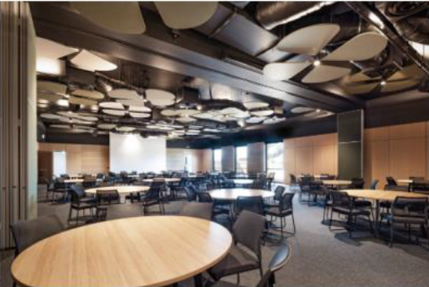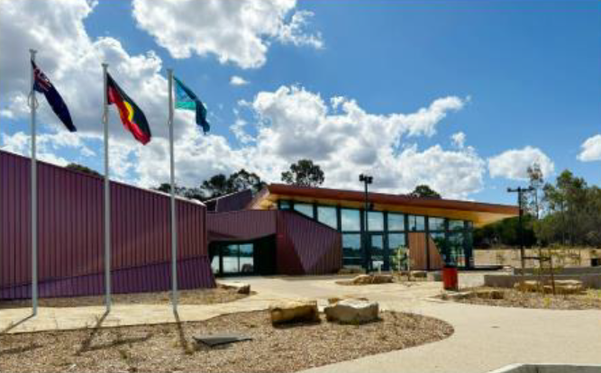
Disclaimer: The above information was provided by the Department of Premier and Cabinet.

Lake Wendouree and Victoria Park in Ballarat - Light installation
Funding was provided for the installation of pedestrian lighting around the Lake Wendouree Moneghetti track to increase community safety, enable expanded use and support growth of evening-based events, and tourism opportunities, around the iconic lake in central Ballarat. This has delivered 225 light poles and fittings around the Steve Moneghetti Track and a further seven light poles and fittings along Morrison Street to connect the Lake Wendouree precinct to nearby Victoria Park.
The installed lights turn on between 5.30am and 10pm during dim natural light via a light sensor. This ensures a period of darkness is preserved in line with the recommendation of the Biodiversity Impact Assessment undertaken for the project.
The City of Ballarat has received anecdotal and qualitative feedback from the community regarding the lights and the increased usability of the precinct during hours of darkness. This has been for both running and athletic use, but also for groups such as dog-walking and other community groups.
Disclaimer: The above information was provided by the Department of Jobs, Skills, Industry and Regions.

Creative Infrastructure Program
CSF funding was provided to progress the design development of three projects:
- Tarneit Performing Arts Centre
- City of Dandenong – Creative Industry Space
- Footscray Community Arts Precinct.
The funded activities included the production of planning, design, costing and other related work as part of respective reports on the feasibility of each project. The findings were finalised and delivered to government for consideration.
Disclaimer: The above information was provided by the Department of Jobs, Skills, Industry and Regions.

Animal Law Institute
CSF funding supported the delivery of the Anti-Puppy Farm Legal Clinic. The clinic provided free initial legal advice relating to domestic pet purchases with underlying health issues. It assisted with matters going before VCAT and negotiated out of court settlements on behalf of its clients.
Disclaimer: The above information was sourced from the Memorandum of Understanding between the Department of Treasury and Finance and the Department of Energy, Environment and Climate Action.

Clunes Booktown Festivals
Funding was provided to Creative Clunes to deliver the Clunes Booktown Festival 2024 (festival). The festival held performances, talks, seminars, publications and workshops aimed at encouraging writing. This contributed to the following outcomes:
- Provided writers with access to new audiences and the opportunity for those that self-publish to sell their books.
- Provided musicians with employment and audience access.
- Assisted participating artists with audience development, networking activities, sales growth and marketing. The festival also promoted and supported literacy and education opportunities.
- Ticketed and free program mix assisted with festival affordability and raising regional visitation.
- Encouraged visitation to Clunes to increase the economic sustainability of local business.
- Clunes is nationally and internationally identified as a favoured destination based on the profile of the Booktown Festival.
Disclaimer: The above information was provided by the Department of Jobs, Skills, Industry and Regions.

