Community Support Fund
Final Outcomes Summary for the Projects Completed 2024-25

Contents
Ability Fest 2024 3
Asylum Seeker Resource Centre 3
Ballarat Cemetery Trust refurbishments and Gym Equipment for Russell Square 4
Bayswater Football Club 4
Carnegie Basketball Club 5
Creative State 2021-25 – New Creative Neighbourhoods Program 6
Diamond Valley Community Support 6
Facilitating Sport and Recreation Participation for Disadvantaged Children 7
Fitzroy Legal Service 7
Live Music Performers Fund 2024-25 7
Local History Grant Program 8
Major Aboriginal Cultural Events and Awards 2023-24 and 2024-25 9
Myrtleford Savoy Soccer Club 10
National Centre for Farmer Health 11
Nagambie Soccer Club 12
Northcote Public Golf Course 12
Power Neighbourhood House 13
Reclink ActiVIC 14
Reclink Australia 2024-25 15
Strategic Partnerships Program 16
Supporting Sporting Excellence at Paris 2024 17
The Big Issue 18
Thomas Carroll Pavilion 18
Upgrade of Frank Holohan Soccer Complex in Endeavour Hills 19
Victorian Aboriginal Funeral Service 19
West Welcome Wagon 20

Ability Fest 2024
Ability Fest is an inclusive and accessible music festival managed by the Dylan Alcott Foundation, delivered in partnership with Untitled Group and presented by Triple J. The event is one of the leading inclusive events in Australia and internationally, showcasing the national standard for accessibility and inclusion.
Funding was provided to:
- Deliver an inclusive and accessible event for people of all identities, cultures, and abilities.
- Deliver social, community and reputational benefits for Victoria.
- Support the Victorian live music industry.
- Support the visitor economy.
- Provide information to support other events to deliver accessible events.
Ability Fest was conducted at Alexandra Gardens in Melbourne on Saturday 19th October 2024. The Festival attracted 5,408 people, almost 20% more than the 2023 event.
The organisers delivered an inclusive and accessible event for all. It provided a showcase on delivering an accessible event, enabling people no matter their background or ability, to attend a one-day music festival and in turn showcase to other events how you can be inclusive and accessible for all.
Disclaimer: The above information was provided by the Department of Jobs, Skills, Industry and Regions.

Asylum Seeker Resource Centre
Funding was provided to the Asylum Seeker Resource Centre (ASRC) to undertake essential building repairs, maintenance, and security upgrades at its office and service delivery hub. These works included the installation of CCTV and alarm sensors, maintenance and remote upgrades for the garage roller door, and the replacement of an interior door. These improvements will strengthen the Centre’s security and ensured a safe environment for staff and clients, enabling the organisation to continue delivering vital assistance to asylum seekers and refugees in Victoria.
This project’s objective was to safeguard the Centre’s operations by enhancing security and maintaining its facilities, ensuring that staff and clients can access critical services in a safe and supportive environment.
The ASRC is an independent, not-for-profit organisation dedicated to supporting people seeking asylum. Through more than 40 programs, the Centre works to protect individuals from persecution and destitution, promote wellbeing and dignity, and empower people to build a secure and thriving future.
Disclaimer: The above information was provided by the Department of Premier and Cabinet.

Ballarat Cemetery Trust refurbishments and Gym Equipment for Russell Square
Funding was provided to restore two rotundas at the Ballarat General Cemetery. The completed works allows attendance at funeral and memorial ceremonies during inclement weather, and for community members to gather for special occasions and anniversaries.
The project resulted in the following outcomes:
- two refurbished rotundas at the Ballarat General cemetery;
- the project supported six full-time employees during construction.
Disclaimer: The above information was provided by the Department of Jobs, Skills, Industry and Regions.

Bayswater Football Club
Funding was provided to replace existing poles and lights with 200 lux LED lighting at Marie Wallace Oval. The lights provide modern, safe and accessible facilities and encourage greater participation by all user groups of the reserve. The nearby junior club utilises the lights and grounds on occasions to build a pathway between the two clubs. The league has also utilises the ground for umpiring training.
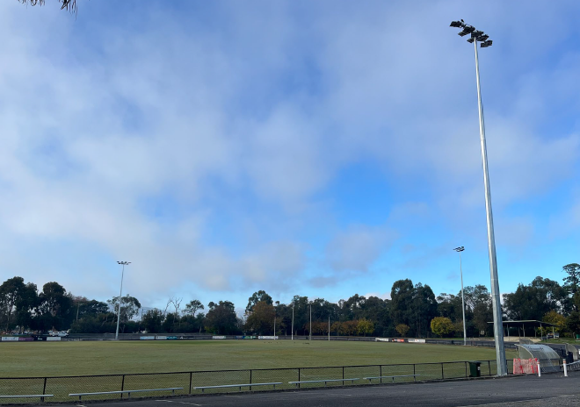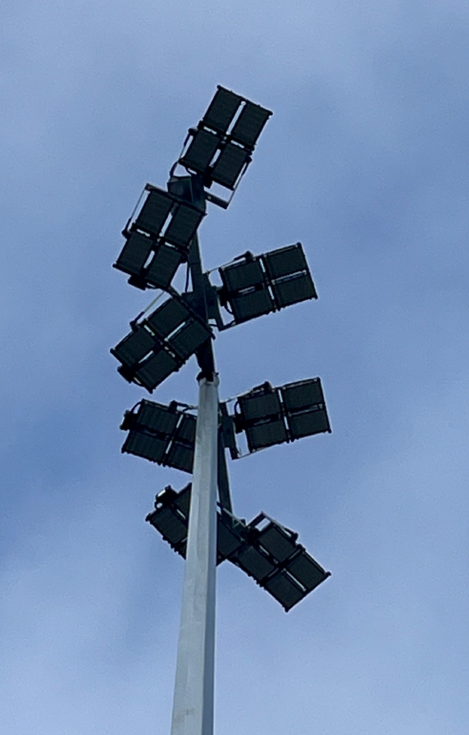
Disclaimer: The above information was provided by the Department of Jobs, Skills, Industry and Regions.

Carnegie Basketball Club
The Carnegie Basketball Club installed two adjustable basketball rings at Carnegie Primary School.
The funding enables the Carnegie Basketball Club and Carnegie Primary School to meet the growing needs of the local sports clubs through the provision of the safer and more welcoming community sport infrastructure.
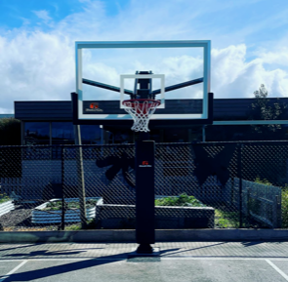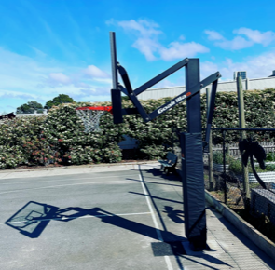
Disclaimer: The above information was provided by the Department of Jobs, Skills, Industry and Regions.

Creative State 2021-25 – New Creative Neighbourhoods Program
Creative Neighbourhoods supported creative industry sustainability by investing in accessible, secure and fit-for-purpose spaces for creative practice and presentation across Victoria. It was designed to respond to demand for creative industry spaces and strengthen creative industries’ recovery and growth through four streams including;
- Brokering and Partnerships: A dedicated brokering service to respond to the increasing demand of creative organisations seeking spaces.
- Strategic Infrastructure: Competitive grants for minor infrastructure upgrades or refurbishments to adapt or unlock existing assets for creative purposes.
- Neighbourhoods & Precincts: Identification and formal designation of Victoria’s priority creative neighbourhoods, suburbs, and towns, where creative spaces, activity and impact are highest and foster their growth and resilience through planning interventions and co-investments with local councils.
- Capability Building: Online Creative Infrastructure Toolkit responding to an identified need of stakeholders for research and guides to assist local councils, developers, and the creative enterprises to better identify and respond to demand for creative spaces.
The program resulted in capacity building and support for creative organisations, equipping them with knowledge on current market rates for suitable accommodation, access to fit-for-purpose longer term creative working spaces, and infrastructure upgrades contributing to activation of local community venues. Partnerships with councils have also enabled better utilisation of spaces and strengthened collaboration among creatives. Infrastructure support allowed grantees to progress building works and utilising purchased equipment to expand audiences. The strategic partnerships facilitated under the program have potential to generate long-lasting outcomes at neighbourhood and precinct scale in key locations.
The Creative Spaces Design guides have built creative spaces and neighbourhoods development capability and has received a Good Design Award in 2024.
Disclaimer: The above information was provided by the Department of Jobs, Skills, Industry and Regions.

Diamond Valley Community Support
Funding was provided to Diamond Valley Community Support (DVCS) to respond to increased demand for emergency relief, material aid, information and referral support in the north-east Banyule and Nillumbik regions and surrounds. The increased demand was driven by individuals in hardship, financial and/or personal crisis due to mortgage stress and increasing homelessness.
DVCS provided material aid that included grocery vouchers, food parcels and bags, pre-made meals, payment of prescription medicines, phone bills and top-ups, toiletries, cleaning parcels, and items for the homeless including sleeping bags and blankets.
Disclaimer: The above information was provided by Department of Families, Fairness and Housing.

Facilitating Sport and Recreation Participation for Disadvantaged Children
Eligible children were able to receive up to $200 as part of the Get Active Kids Voucher Program to help cover the costs of membership and registration fees. In the grants round, a total of 41,405 grants were approved. The program assisted disadvantaged children to participate in sport and active recreation, increase participation among children aged 0 to 18 years, and raise awareness of the positive impacts of being active. Overall, it boosted the number of children and young people regularly engaged in sport and active recreation activities. Of the recipients, 49% reported they would not have been able to participate in their chosen sport without this program.
Disclaimer: The above information was provided by the Department of Jobs, Skills, Industry and Regions.

Fitzroy Legal Service
Funding was provided to Fitzroy Legal Service (FLS) to improve service delivery through the purchase of air purifiers, a refurbishment of the office, system migration to a cloud environment and purchase of IT equipment. This contributed to safer work environment, additional client consulting spaces, a staff lunch area, updated laptops enabling efficient client work, and improved cybersecurity.
Disclaimer: The above information was provided by the Department of Justice and Community Safety.

Live Music Performers Fund 2024-25
The fund provided support Victorian artists and musicians to undertake more paid live music gigs across the state via partnerships with live music venues. Further information can be sourced from the Victorian Gig Fund website.
Disclaimer: The above information was sourced from the Memorandum of Understanding between the Department of Treasury and Finance and the Department of Jobs, Skills, Industry and Regions.

Local History Grant Program
The Public Record Office Victoria held annual programs for the Local History Grants Program (LHGP) and Victorian Community History Awards (VCHA) to support community groups and not-for-profit organisations that collect, preserve, record and share the materials, history and memories from Victoria’s past. It encouraged collaboration and partnerships between organisations to undertake publication, digitisation and interpretation projects. This developed local skills and resources to enable effective custodianship, building community strength, capability, and capacity. VCHA recognised and celebrated contributions in the preservation and appreciation of Victoria’s history and developed awareness of best practice community history.
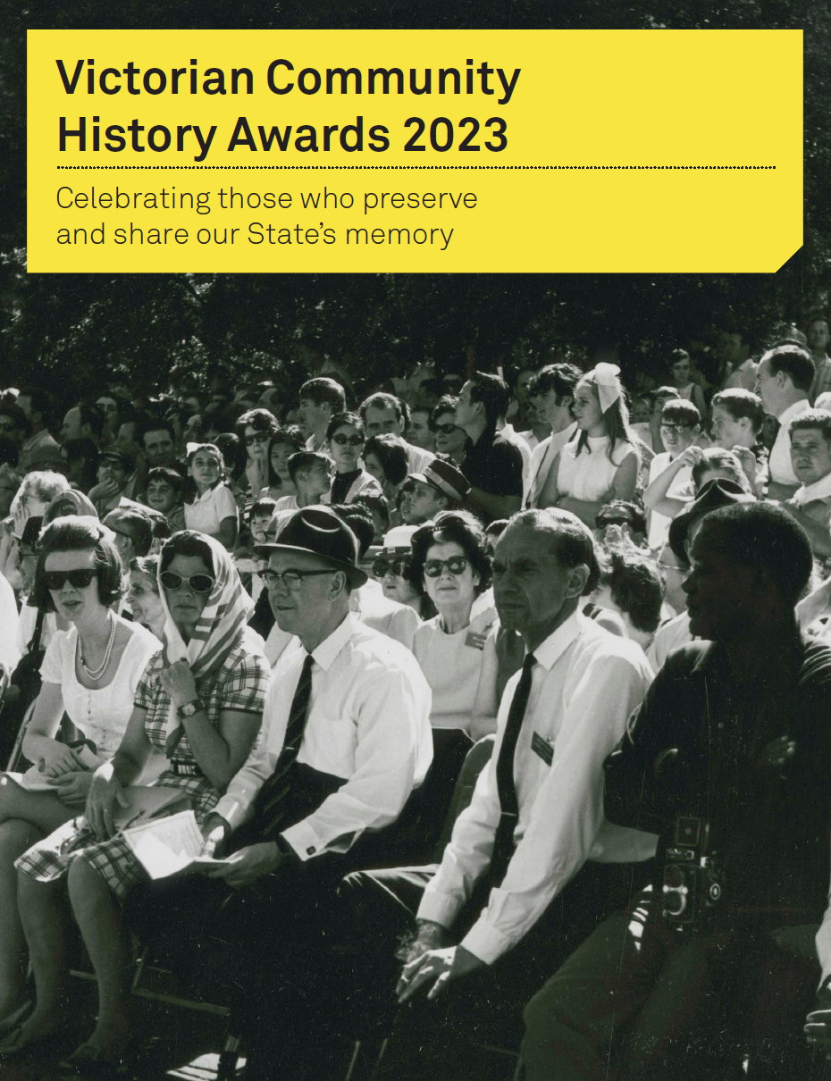
Disclaimer: The above information was provided by the Public Record Office Victoria.

Major Aboriginal Cultural Events and Awards 2023-24 and 2024-25
The Victorian Government celebrated the achievements of First Nations Victorians through the delivery of its 2023-24 and 2024-25 major Aboriginal cultural events and awards program. The following events and awards were delivered:
- 2023 NAIDOC State Reception
- 12th Victorian Aboriginal Honour Roll (2023-24)
- 2024 Victorian Aboriginal Remembrance Service
- 2024 NAIDOC State Reception
- 26th Ricci Marks Awards (2024-25)
- 2025 Victorian Aboriginal Remembrance Service
- 13th Victorian Aboriginal Honour Roll (2024-25)
Funding was also provided to the Victorian NAIDOC Committee to deliver the 2023, 2024, and 2025 NAIDOC Week events.
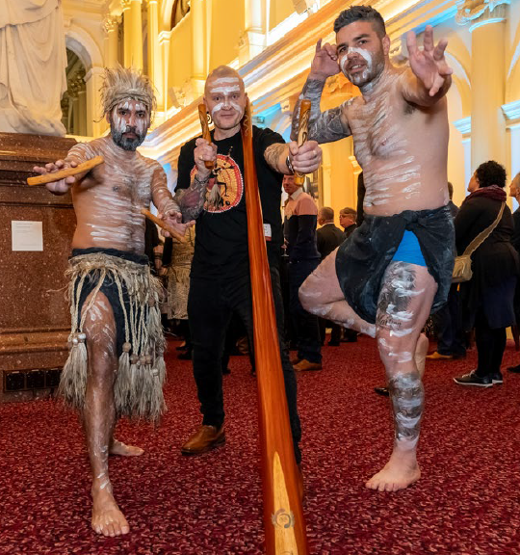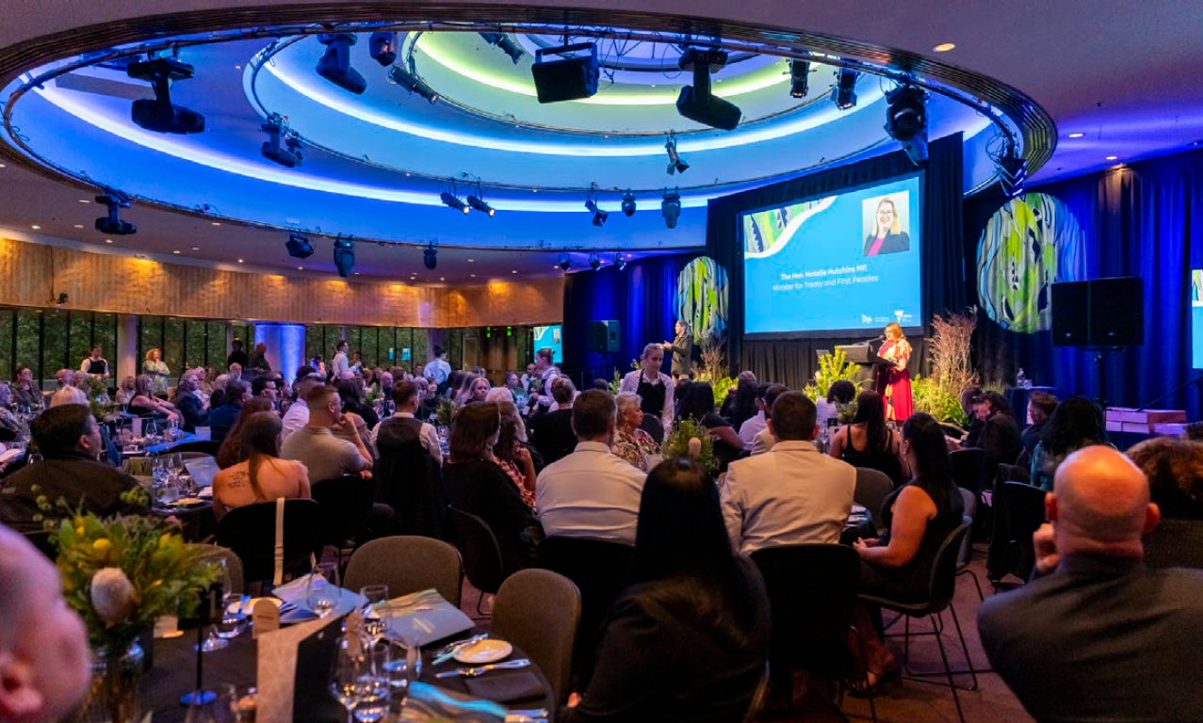
Disclaimer: The above information was provided by the Department of Premier and Cabinet.

Myrtleford Savoy Soccer Club
The funding delivered the purchase of equipment, including two portable goals, two exercise bikes, two rowing machines, seven exercise mats, six exercise balls, four rollers, a barrier net, clubhouse equipment, soccer balls and two marquees for outdoor spectator shelter. This enabled the Myrtleford Savoy Soccer Club to schedule new training programs and offerings through the new equipment. This provides the club with greater participation opportunities and membership growth. The barrier net and marquess will also provide shelter for improved visitor and volunteer experience.
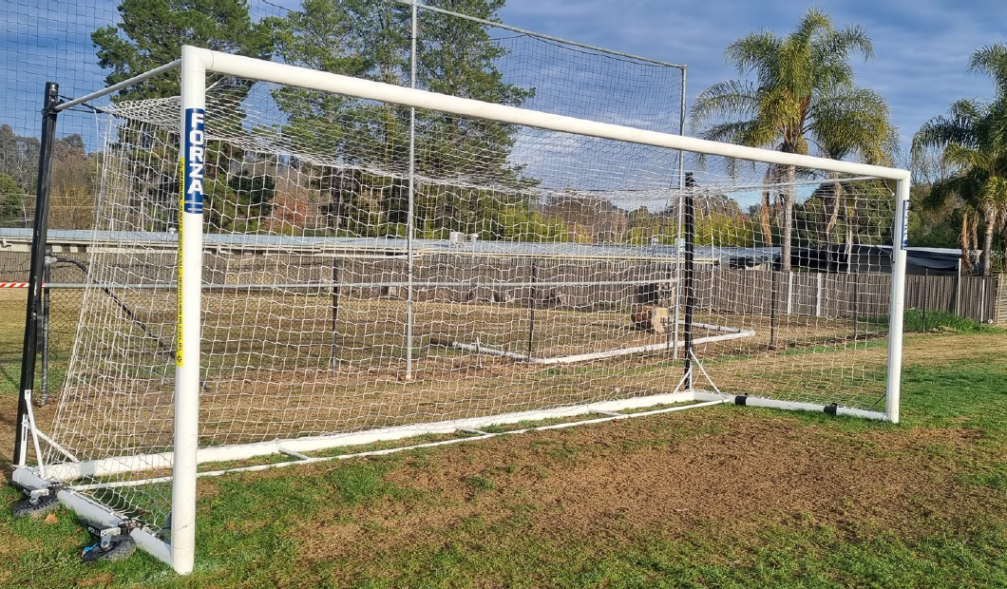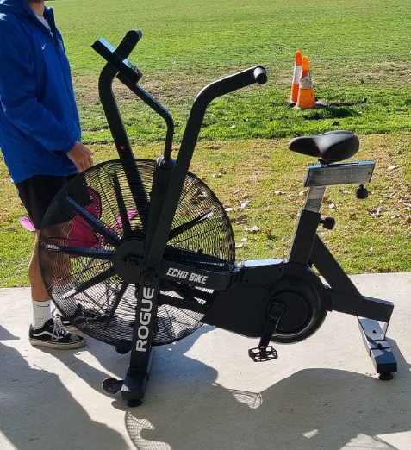
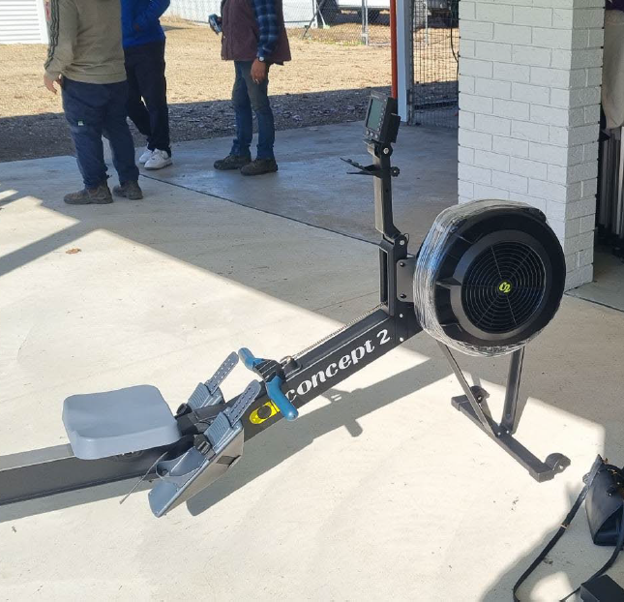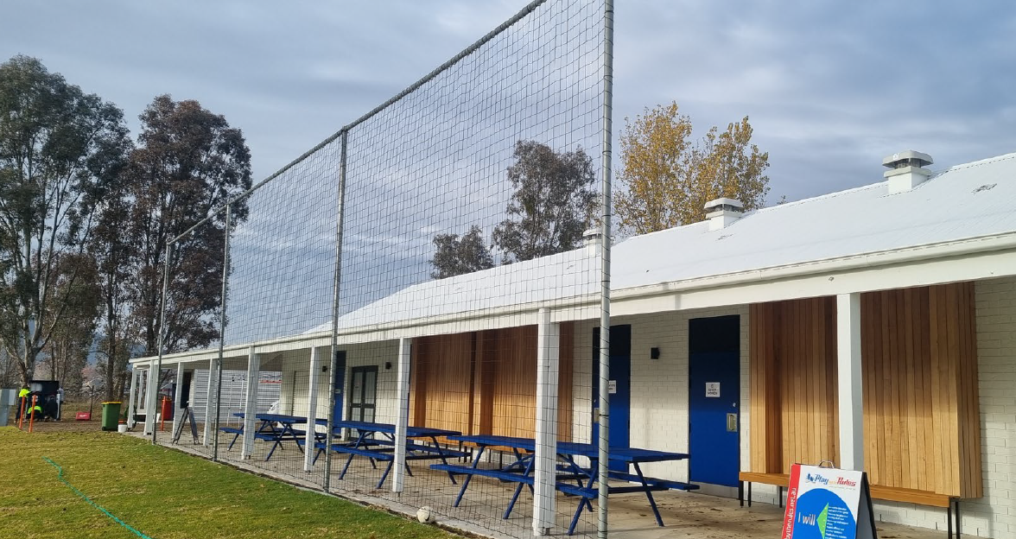
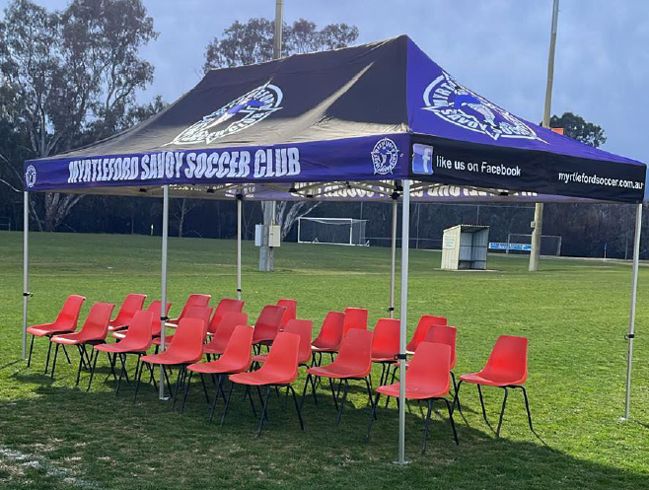
Disclaimer: The above information was provided by the Department of Jobs, Skills, Industry and Regions.

National Centre for Farmer Health
The National Centre for Farmer Health (NCFH) delivers a wide range of programs that strengthen the health, wellbeing and safety of farming communities across Victoria and Australia. Through Health and Lifestyle Assessments, AgriSafe Clinics, education workshops and field-day engagements, the NCFH provides farmers with comprehensive health checks, personalised advice, and practical tools to support long-term wellbeing.
With support from recent grants, the NCFH expanded its professional development for rural health providers, increased training opportunities, and facilitated co-designed prevention initiatives with farmers, health professionals and agricultural partners. These efforts have strengthened workforce capacity and created more culturally competent, accessible health services for farmers. Additional support during crisis events, such as bushfires, floods and industry change, ensures that farming communities receive targeted assistance when they need it most.
The programs are delivering clear and measurable benefits. Of the farmers receiving follow-up recommendations, 92% made lifestyle or behavioural changes, including healthier diets, reduced alcohol intake, increased physical activity, better stress management and improved safety practices. Furthermore, 69% followed up referrals to a GP or specialist, leading to early management of issues such as high blood pressure, abnormal glucose or cholesterol levels, skin cancer risks, vision and hearing concerns, and musculoskeletal problems. In total, 1,044 tailored recommendations and 224 clinical referrals have directly supported improved health outcomes.
Events such as the Farmer Health Symposium and field-day activations, alongside new partnerships and strengthened governance, have broadened the impact of the NCFH’s work across the sector. Overall, the NCFH’s integrated approach of combining assessment, education, training, research and community engagement is significantly improving the health, wellbeing and safety of Victorian farmers and strengthening the resilience of rural communities.
Disclaimer: The above information was provided by the Department of Health.

Nagambie Soccer Club
Funding was provided for the purchase of equipment for the Nagambie Soccer Club through the Shepparton Junior Soccer Association. The grant funded 6 portable goals with net and wheels (4 goals at 5m x 2m and 2 goals at 7.32m x 2.44m) and 100 soccer balls. The new equipment has enabled the Nagambie Soccer Club to improve the participation offerings and opportunities for training and matches. The new goals and soccer balls allow all participants equitable access to the new equipment, improving the player experience.
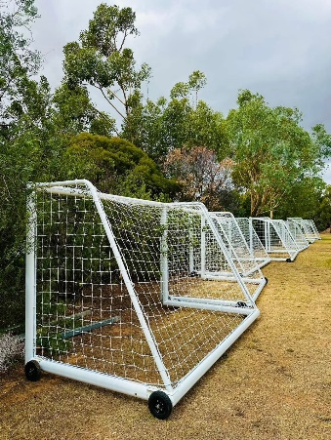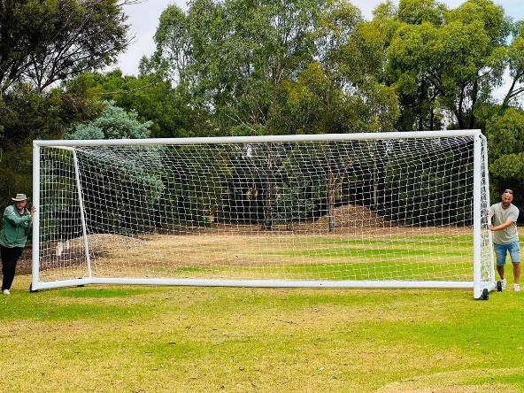
Disclaimer: The above information was provided by the Department of Jobs, Skills, Industry and Regions.

Northcote Public Golf Course
The funding delivered redesigns to the Northcote Golf Course, including:
- Designs for golf course/construction of new fairway, green and tees/decommission southern fair way.
- Designs and due diligence of new eastern pedestrian and cycling pathway (from Warrk-warrk Bridge to Normanby Avenue).
- Designs and due diligence of new northern park adjacent to Mayer Park.
- Designs and due diligence of improvements to the golf clubrooms to support community use.
The project enabled Darebin City Council to bring together key stakeholders, with the support of a golf architect, to redesign the Northcote Golf Course. The final design features the retainment of the 9-hole golf course while maximising accessible public space.
Disclaimer: The above information was provided by the Department of Jobs, Skills, Industry and Regions.

Power Neighbourhood House
Power Neighbourhood House is a community-managed organisation that aims to build community connections, advance mental health outcomes and prevent social isolation for people living and working in the broader Ashwood area. It provides programs including social groups for children, teens, carers and the LGBTQIA+ community, book clubs, yoga, arts and crafts, and food relief.
The Power Neighbourhood House project included a building refurbishment and security upgrade. These works included:
- Relocation of selected office space
- Improvements to the entrance façade, decks and veranda
- Painting and lighting upgrades throughout two buildings
- Minor upgrades to building interior and exterior.
Since completion of these works, the neighbourhood house has experienced an increase in foot traffic and has received positive feedback from staff, volunteers and visitors. The improvements will strengthen the organisation’s ability to provide a welcoming space for its important community programs.
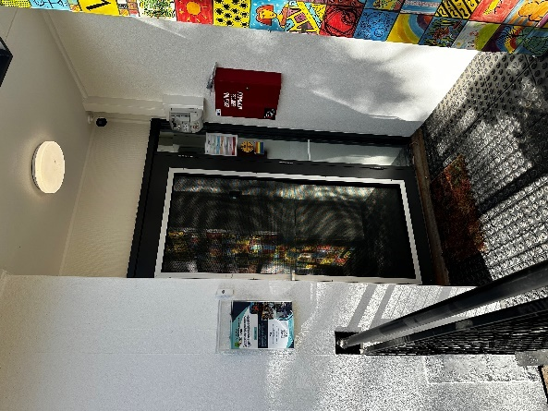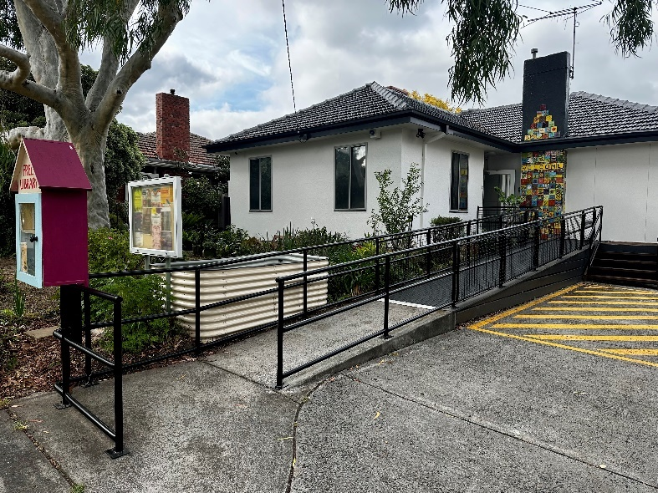
Disclaimer: The above information was provided by the Department of families, Fairness and Housing.

Reclink ActiVIC
The Reclink ActiVIC program provides sport, recreation and arts programs to improve health, wellbeing, education and employment outcomes for vulnerable cohorts experiencing social isolation and mental ill-health including people at risk of homelessness, drug and alcohol dependency, and intersection with the criminal justice system.
Grant funding enabled the following outcomes:
- 4,755 activity sessions (1,189 yearly average) across 11 LGAs and 48 suburbs
- 14,124 new participants
- 67 new member agencies
Engaging with new agencies was central to the program. Reclink reformed its member agency management by implementing a stakeholder management platform and new procedures and guidelines, improving member agency services since funding commencement.
Reclink worked with referral agencies to develop pathways for referrals. Referral partnerships to support participant employment pathways included Youth Projects (Job Provider), Jesuit Social Services and Young Communities, Jobfind and Angus Knight.
Of the participants that took part in the 2024 ActiVIC evaluation survey:
- 72% reported improvements in general health and wellbeing
- 64% reported improved connection to support.
- 19% reported improvements in education/work-based training
- 16% saw improvements to mental health
- 7% reduced drug and alcohol dependency
- 7% had better employment outcomes while participating in ActiVIC.
Other key findings include:
- Of those who had spent time in a mental health facility in the 12 months prior to ActiVIC, 75% spent less time in a mental health facility.
- Of those who were involved with the police, 79% reported less involvement.
- Of those that had spent time in a correctional facility 12 months prior to ActiVIC, 90% spent less time in correctional facility, for drug facilities, 89% spent less time in a drug or alcohol facility, for mental health, 75% had spent less time in a mental health facility.
- Of those involved with the police in the prior 12 months, 14% had less involvement with the police, 62% reported more stable housing, and 50% saw a reduction in problem gambling.
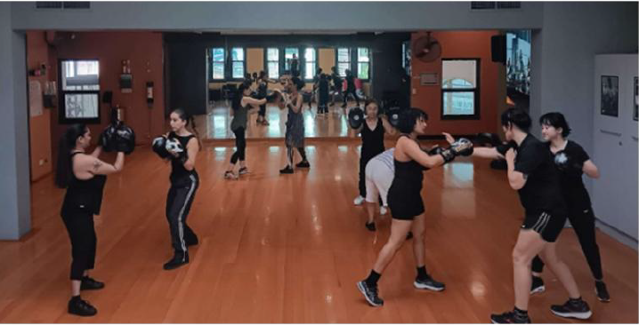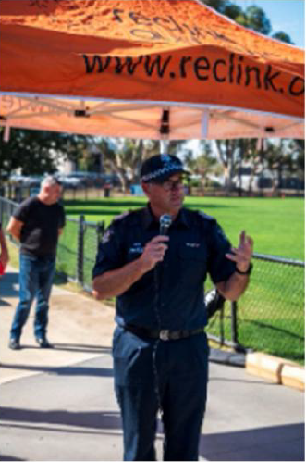
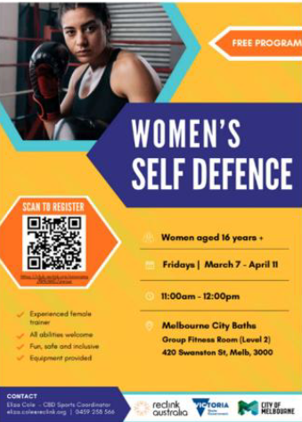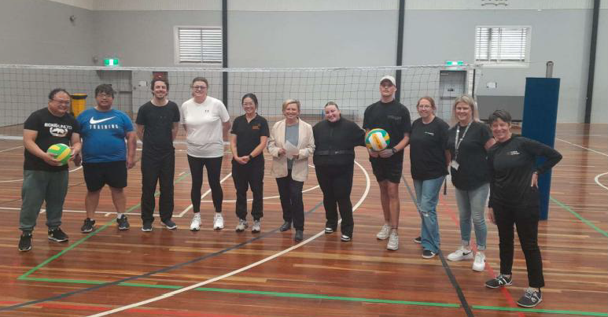
Disclaimer: The above information was provided by the Department of Jobs, Skills, Industry and Regions.

Reclink Australia 2024-25
The Reclink Active Connect project delivered fun and safe sport and recreation activities for people aged over 12 years across 13 local government areas to build social connection and improve physical and mental health. Localities of focus were Swan Hill Rural City Council, Yarriambiack Shire Council, City of Wodonga, Wyndham City Council, Yarra Ranges Council, City of Greater Dandenong, Frankston City Council, Greater Shepparton City Council, Hume City Council, City of Whittlesea, Melton City Council, Mitchell Shire Council and City of Casey.
The program worked with cohorts experiencing various forms of disadvantage including young people, culturally and linguistically diverse, people with a disability, people experiencing mental health or alcohol and other drug issues, and those at risk of gambling harm. Reclink delivered 1,849 sessions achieving 30,870 participations across activities. Working with local Gambler’s Help services, activities incorporated gambling harm messaging and awareness raising, as well as information on ways to seek help.

Strategic Partnerships Program
Funding went towards implementing the Strategic Partnerships Program (SPP) that delivered place-based settlement support to new, emerging and established migrant communities across seven regional areas in Victoria. These communities have limited access to settlement support services such as health, education, employment, and family relationships supports. Funding was utilised by partner organisations to collaborate with various regional and local level service providers to deliver localised and tailored supports for migrant communities in these areas. This allowed the partners to address the unique needs of the communities they serve to improve settlement outcomes. Funding from the CSF was crucial to continue the program aimed at improving regional settlement outcomes by connecting communities with these necessary supports.
Each partnership implemented area specific activities under six Key Priority Areas (KPAs) as identified through their workplan. The six key priorities were access to information and services, family relationships, education and employment, community governance and leadership, health, and social cohesion and community engagement.
Funding provided through the CSF for the SPP in 2024-25 (July 2024 – June 2025), managed to involve support over 29,000 people from new, emerging, and established multicultural communities through various activities carried out under the program across seven regional partnerships. This included:
- 11,439 individuals supported by activities relating to improving access to government services across Victoria, including better connecting communities with mainstream service systems (KPA: Access to information and services).
- 314 individuals supported by activities relating to strengthening leadership capacity in community organisations and a greater number of ethnic organisations accessing grants and running their own programs (KPA: Community governance and leadership).
- 1,203 individuals supported by activities relating to increasing understanding of healthy family relationships and increasing access to relevant services (KPA: Family relationships).
- 2,142 individuals supported by activities relating to Increasing employment and education opportunities (KPA: Education and employment).
- 4,785 individuals supported by activities relating to increasing usage of services relating to health and wellbeing, including mental health (KPA: Health).
- 9,713 individuals supported by activities relating to building knowledge and capacity to actively contribute to all aspects of life in Victoria and increasing their participation and inclusion in community life (KPA: Social cohesion and community engagement).
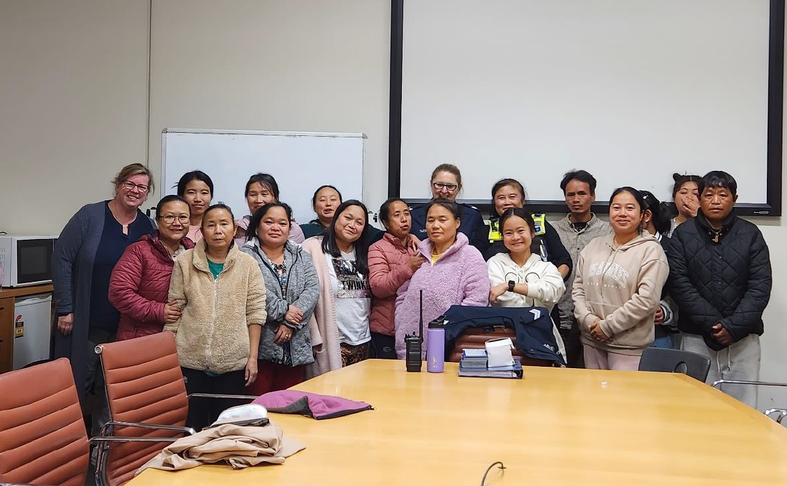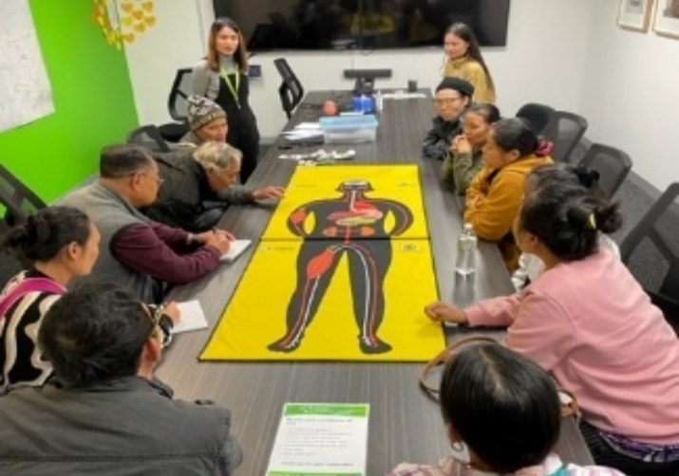
Disclaimer: The above information was provided by the Department of Premier and Cabinet.

Supporting Sporting Excellence at Paris 2024
The Victorian Government’s funding contribution to the Paris 2024 Australian Olympic Team Appeal and the Paris 2024 Australian Paralympic Team Appeal supported the preparation and participation of the Australian teams competing in Paris, enabling Victorian athletes to strive for international sporting excellence and building Victoria’s reputation as a world-class centre for sport.
125 Victorian athletes competed for Australia across the Paris 2024 Olympic and Paralympic Games.
The Paris 2024 Australian Olympic team was the third largest team competing at the Games with 467 athletes competing in 33 sports
- 83 Victorian athletes represented Australia (18% of the team)
- Victorian athletes won 11 medals including 3 Gold, 1 Silver and 7 Bronze.
- The Paris 2024 Australian Paralympic Team comprised 160 athletes competing in 17 sports
- 42 Victorian athletes represented Australia (26% of team)
- Victorian athletes won 18 medals including 4 Gold, 4 Silver, 10 Bronze
The performances of the Victorian Olympic and Paralympic athletes competing as part of Australian teams at the Paris 2024 Games:
- showcased sport and high-performance pathways
- inspired and encouraged participation in sport and active recreation.
- built civic pride and fostered social cohesion in the community; and
- reinforced Victoria’s reputation as a sporting capital and home of sporting excellence
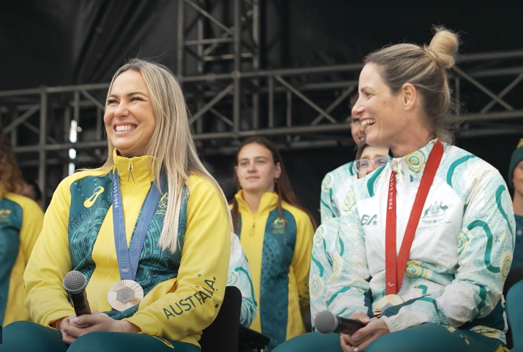
Disclaimer: The above information was provided by the Department of Jobs, Skills, Industry and Regions.

The Big Issue
Due to the COVID-19 impacts on the traditional vendor model of selling magazines, The Big Issue received funding to undertake a digital transformation strategy over two years to lay the foundations for securing the organisation’s long-term future and to support its vendors. The digital transformation led to the following benefits:
- Creation of a new revenue stream for The Big Issue.
- Increased revenue was used to reduce wholesale prices provided to vendors.
- An increase in the number of people supported by The Big Issue.
- The Big Issue has new digital tools to assist in completing the first social impact report.
Disclaimer: The above information was provided by the Department of Families, Fairness and Housing.

Thomas Carroll Pavilion
The WJ Crowe Pavilion at Thomas Carroll Reserve was rebuilt to create a four female friendly change rooms with associated amenities, public toilets, additional storage, social/multipurpose room, canteen, and timekeepers room. The completed project provides modern, safe and accessible facilities to encourage greater participation by all user groups of the reserve including children, young people and women and girls. Greater Dandenong City Council can provide a welcoming space for families and community members to enjoy accessible and female friendly facilities to meet the needs of people of all ages and abilities.

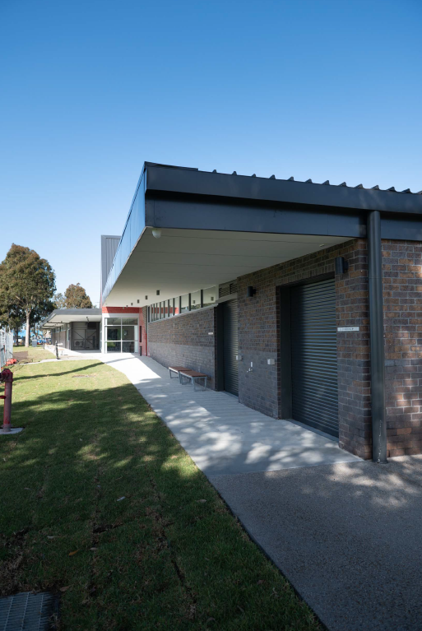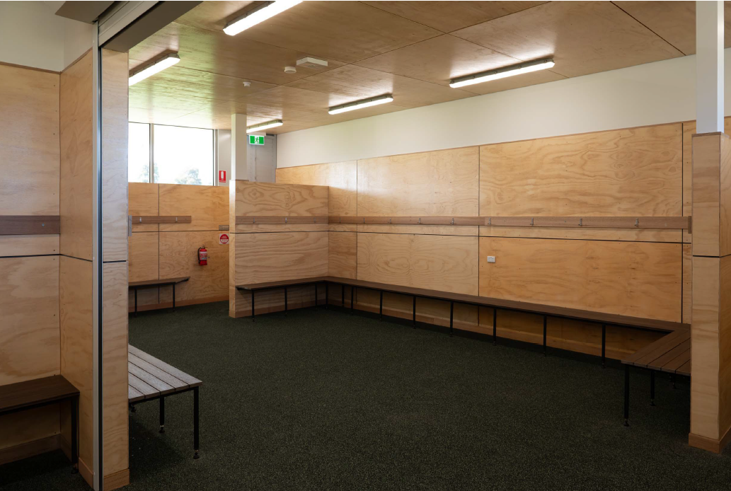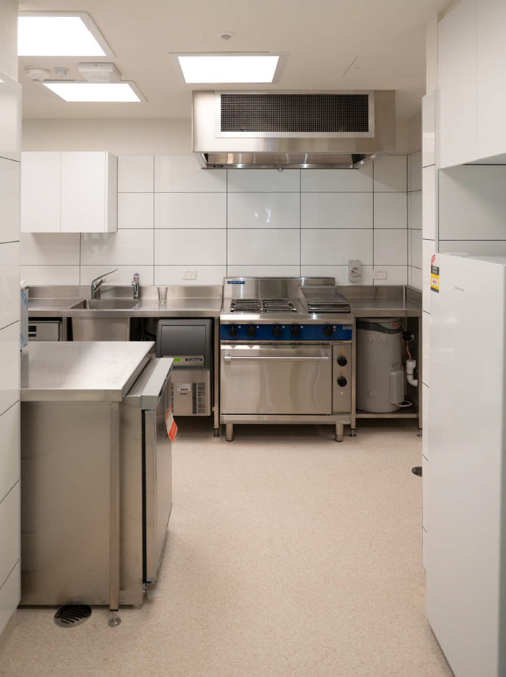

Disclaimer: The above information was provided by the Department of Jobs, Skills, Industry and Regions.

Upgrade of Frank Holohan Soccer Complex in Endeavour Hills
Funding was provided to upgrade the change rooms and amenities to female friendly and Football Victoria standards, upgrade existing male and female public toilets and construct a new accessible public toilet.
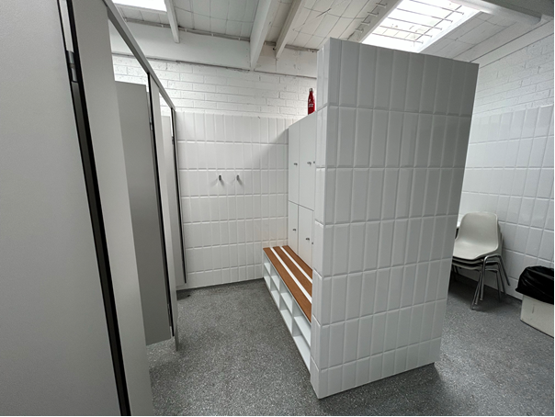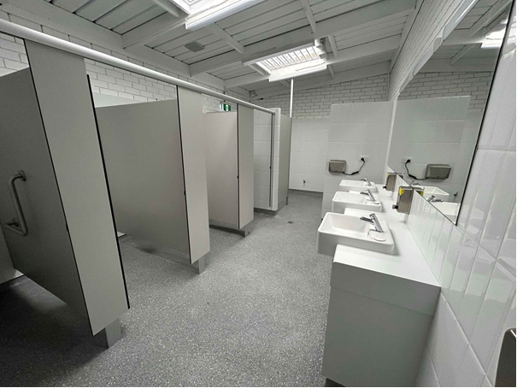
Disclaimer: The above information was provided by the Department of Jobs, Skills, Industry and Regions.

Victorian Aboriginal Funeral Service
The Aboriginal Advancement League purchased a second-hand hearse to replace their previous hearse that was irreparably damaged by fire.
The funeral service is invaluable to First Nations communities as all community members using the service have used the hearse. The replacement of the hearse has enabled low-cost funerals for First Nations Victorians, First Nations access to culturally-safe burials for loved ones, and the return First Nations people to Country upon their death.
Disclaimer: The above information was provided by the Department of Premier and Cabinet.

West Welcome Wagon
West Welcome Wagon (WWW) is a small, predominantly volunteer-run, not-for-profit organisation. It supports people seeking asylum and refugees in Melbourne's western suburbs by providing essential items to help them establish a comfortable home and feel welcome in their new community.
WWW was allocated funding to expand reach, increase social impact and contribute to a more sustainable and welcoming community.
The project improved organisational capacity through extra staffing and volunteers who were able to respond to community needs. The funding:
- Delivered 2,267 essential household items free to 351 households to support 2,457 adults and children.
- Delivered critical items to enable safe food storage, comfortable sleep, and personal hygiene, directly improving clients’ well-being.
- Enabled families to redirect limited funds to other urgent needs.
- Delivered Reach Out Days to foster greater client choice and participation, improved self-esteem, and facilitated community engagement.
- Diverted 124 tonnes of goods from landfill, reducing waste and greenhouse gas emissions.
- Supported the contribution of 80 volunteers, fostering strong ties between clients and the wider community.
Additionally, the organisation was able to:
- Expand their service reach and exceed service targets for households and items delivered.
- Increased capacity through launch of new delivery methods (e.g., Reach Out Days) and improved referral pathways.
- Establish new income-generating initiatives (e.g., textile collection fee-for-service, donation collection fee), supporting ongoing sustainability.
- Formalised collaboration with organisations such as Greater Western Water, leading to additional financial and service benefits.
Disclaimer: The above information was provided by the Department of Premier and Cabinet.

