Side by Side PAD Interim Evaluation (2022-23)
Victoria Department of Treasury and Finance
July 2024

Glossary
Acronym | Full name
ACCO | Aboriginal Community Controlled Organisation
AED | Area Executive Directors
BSEM | Berry Street Education Model
CSC | Cluster Steering Committees
DE | Department of Education
DTF | Department of Treasury and Finance
FECM | Family and Education Case Manager (Note: This term is used to describe both the roles of FECM at Berry Street and FESW at VACCA in the report)
FESW | Family and Education Support Worker
IY | Intervention Year
JDP | Joint Development Phase
MY | Monitoring Year
NCCD | Nationally Consistent Collection of Data on School Students with Disability
OOHC | Out-of-home Care
PAD | Programs Addressing Disadvantage
RY | Referral Year
Side by Side | ‘the Side by Side program’ or ‘the program’
SEIL | Senior Education Improvement Leader
SFOE | Student Family Occupation and Education
SIB | Social Impact Bond
SVA | Social Ventures Australia
VACCA | The Victorian Aboriginal Child and Community Agency

Executive Summary

About Side by Side
The Side by Side program (‘Side by Side’ or ‘the program’) was designed jointly by Berry Street Victoria (Berry Street) and the Victorian Aboriginal Child and Community Agency (VACCA) in 2018 and concluded its third year of implementation in 2023. The program aims to improve school attendance, engagement and learning outcomes for some of Victoria’s most vulnerable and disadvantaged children through strengthening learning environments at school and at home. Its design is based on components of the VACCA’s Koorie Kids Stay @ School program and the Berry Street Education Model (BSEM).
Nine Victorian government primary schools participate in the program across three locations in Victoria (Northern Melbourne, Inner Gippsland, and Western Melbourne). Approximately 300 students and their families are expected to be supported over the course of the program.
      - Overview of the key components of the Side by Side program
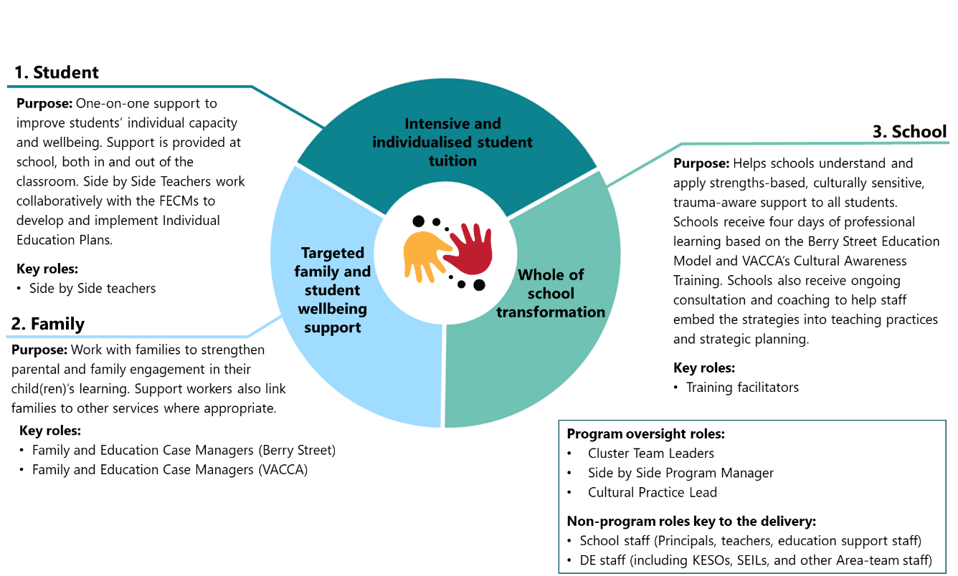
Source: Deloitte Access Economics 2022.
The Side by Side program is funded as a Partnership Addressing Disadvantage (PAD) – an outcomes-based funding model which builds on the concept of Social Impact Bonds (SIBs). It is Australia’s first primary school-based SIB representing an investment of approximately $13 million over 2021-2026 under the target performance scenario. The program presents a unique opportunity to better understand how early intervention and intensive support in primary years work to improve educational and social outcomes for vulnerable students generally, and how this impact is sustained over time.

This evaluation
The Victorian Department of Treasury and Finance (DTF) engaged Deloitte Access Economics to undertake a multi-year evaluation of the Side by Side PAD. The evaluation is of dual nature, considering both formative findings to inform ongoing implementation, and summative findings to estimate the impact and overall outcomes of the program and the PAD funding model.
The evaluation follows a co-design approach where Berry Street, VACCA, DTF, the Department of Education (DE) and Social Ventures Australia (SVA) all contributed to the development of a comprehensive evaluation framework and plan in 2021, and are engaged in the ongoing governance of the evaluation. The evaluation framework comprises evaluation questions, three program logic models (at student-, school-, and PAD-levels), and an indicator framework which underpin the methodological approach of this evaluation.
Berry Street and VACCA also play an active role in collecting data for this evaluation from families and students.
This Interim Evaluation represents the second of three reports of the multi-year evaluation (over 2021-2027), with the Formative Evaluation Report delivered in 2021. The Interim Evaluation Report draws on a rich set primary and secondary data, including:
- Secondary data:
  - documentation review
  - program data collected by Berry Street and VACCA
  - school- and student-level administrative data provided by the DE
- Side by Side PAD stakeholder voice (collected in 2022 and 2023):
  - consultations with over 50 Side by Side program stakeholders, including Berry Street, VACCA, DTF, DE, SVA, and investors
  - online survey of approx. 20 Side by Side program staff on the ground
- School voice (collected in 2022 and 2023):
  - consultations with schools involved in the program (leadership and selected teachers)
  - online survey of over 50 school staff
- Student and family voice (collected in 2022 and 2023):
  - 27 family responses to pre- and post-program feedback forms
  - 39 student responses to pre- and post-program feedback forms.
The above data is analysed and triangulated using mixed-methods, including: qualitative coding of consultation notes, documentation analysis, descriptive analysis of quantitative data, correlation analysis, as well as quasi-experimental methods (propensity score matching, difference-in-difference analysis).

Overview of findings
This Interim Evaluation Report observes the Side by Side program at a critical point in time. Following a delayed Joint Development Phase (JDP), a difficult commencement period amid the COVID-19 pandemic, and challenging initial roll-out against the backdrop of state-wide workforce shortages, 2023 is the first opportunity to see the program operating at its full capacity in nine schools across all three Clusters.
While it is premature to draw conclusive assessment regarding the program’s or the PAD’s overall effectiveness, this Interim Evaluation Report offers insights and early indications of impact. Three overarching observations are made.
First, despite all the challenges, program implementation is largely on track. As intended, the program operates at nine schools, and has supported 142 students and their families participating in the program (of the intended 150, representing 95% of the target as of December 2023). The slightly lower number of participants is primarily due to one school leaving the program in Cluster 1 – with a new school subsequently recruited as a replacement. Schools are increasingly engaged in the program, can see its value (particularly the value of individualised student and family supports), and are gradually embedding the Side by Side staff in their school community. The program is received positively by most school staff, families and students who each speak highly of the Side by Side staff. One aspect of implementation which is not as progressed as originally intended is the whole-school training and transformation component. Schools’ capacity to leverage the program more strategically to facilitate whole-school improvement is limited, with time constraints, mixed leadership buy-in, and competing priorities posing the key barriers.
Second, the potential of VACCA to influence program impact is not yet fully realised. While all parties acknowledge the importance of ensuring legitimate space for Aboriginal voices in the decision-making process, there are structural barriers to VACCA engaging with and leading the Side by Side program in a truly Aboriginal-centred way. The challenge lies not with the intentions between the parties (which were positively reflected on), but with the power and resourcing structures in which these relationships operate, including a significant disparity in the resources allocated to Berry Street and VACCA to support program delivery. The original agreed resource allocations between the two service providers largely reflected the expected share of Aboriginal students participating in the program. However, with time it became evident that more resourcing is required to build cultural awareness and embed culturally sensitive practice across the whole program. There is an opportunity to revisit VACCA’s resourcing to explore what a partnership with genuine engagement in Aboriginal ways of being and doing might look like, and how this could create the space for new responses within the complex issue of family engagement with schooling. VACCA's role, if fully realised, would not only support Aboriginal students but also speak for vulnerability and complexity in families and communities more broadly, through the lens of Aboriginality.
Third, the evaluation findings point to the importance of reliable, complete data as part of the theory of change of a PAD. Reliable, timely and complete data on progress against outcomes is critical in this context to support: (1) day-to-day decisions optimising the delivery of the program; and (2) the PAD arrangement where funders require reliable outcomes data to determine the level of outcomes-based payments.
PADs (or more broadly SIBs) are complex and costly instruments, involving multiple stakeholders from different organisations, requiring significant investment of time, technical expertise and commitment to evidence-informed, collaborative decision making. However, when implemented effectively, SIBs promise some fundamental shifts in the way complex social problems are tackled by government commissioning. These include:
- better alignment of stakeholder incentives to prioritise outcomes and reorientation of funding toward early intervention
- fostering innovation and growing the evidence base on ‘what works’ by providing more flexibility to service providers to tailor the intervention as needed
- strengthened accountability for and transparency of generating measurable outcomes, thus incentivising continuous service improvement and adaption based on the needs of beneficiaries
- promoting higher collaboration across multiple disciplines, government agencies, and sectors to address complex social issues.
Reliable, timely and complete data is a critical precondition to unlocking most, if not all, of the above benefits. In this context, the impact of COVID-19 pandemic on the data reliability cannot be understated.
This evaluation finds that the use of data by the Side by Side PAD has improved over time – with more frequent data sharing across parties, regular sense-making conversations about the trends observed in the data, and more nuanced understanding of limitations of student attendance and attainment data. Some data issues (quality, governance, transparency) uncovered through the interim evaluation process – and subsequently resolved – serve as important learnings on strengthening data reliability through quality assurance.
The quantitative analysis of this evaluation was largely limited to years 2020-2022. Over that period, the average number of absent days increased for participating students by 6 days (from 63 in the Referral Year (RY) to 69 days in the Intervention Year (IY)). However, there is large variation within the sample (+/- 26 days standard deviation), and analysis indicates that the increase in average absences is not statistically significant. This reiterates the value of complementing the partial story that quantitative data tells with qualitative insights – voices of students, their families, school staff, and other stakeholders.
Actions can be taken by each of the participating organisations to strengthen implementation of Side by Side and future PADs. Based on the evidence examined to date, the early findings in this Interim Evaluation Report suggest that the Side by Side program design – particularly the provision of individualised supports to students and families – is appropriate and responding to the needs of participants. Implementation, despite difficult circumstances, and through the focused determination and dedication of the individuals and organisations involved, is also largely on track. What requires further consideration is the concept and implementation of the PAD arrangement in the context of the government schooling sector, and whether the effort and resources required to successfully administer the PAD are commensurate to the additive value the arrangement provides. This will be explored further as part of the final evaluation report.
A number of opportunities have been identified throughout the report (listed at the end of this Executive Summary). The following opportunities are highlighted as more immediate priorities for the Side by Side PAD:
- For DE, further steps can be taken to improve DE’s enablement of the PAD arrangement. This includes but is not limited to: (1) improving data governance and quality assurance processes for the purposes of a PAD (which could utilise the existing monthly reporting process for a more formal reconciliation with knowledge on the ground), and (2) strengthening the program’s interface with multi-disciplinary teams within Areas, formally empowered through the governance of the Cluster Steering Committees.
- For Berry Street, further work is needed to (1) elevate VACCA’s voice by addressing the power and resourcing imbalance in the partnership; and (2) more deliberately define ‘flexibility’ within the program delivery, giving staff autonomy to problem-solve and make their own decisions within boundaries of non-negotiables.
- For VACCA, opportunities for improvement lie in (1) strengthening the internal governance and support around the three Family and Education Case Managers (FECMs), noting that appropriate resourcing is a key enabler of that; and (2) exploring where cultural awareness improvement can be substantially strengthened, including where (and why) the cultural awareness training is less well received.
For DTF, the identified opportunities extend on themes identified in the Formative Evaluation and relate to improving the effectiveness of PAD arrangements more broadly through (1) clarifying the extent to which service providers entering into PADs should be expected to have the technical capacity (either resourced internally or externally) to operate effectively under this type of a contract, versus to be provided with capacity building support by government; and (2) collaborating with other government agencies to navigate and enable cross-governmental data sharing for the purposes of PADs while ensuring strong safeguards.
The remainder of this Executive Summary provides further detail on the key findings under the following four evaluation domains:

Key findings – Program implementation
Implementation status
Year 2023 – the third year of implementation – is the evaluation’s first chance to observe the program operating at full capacity. As intended, the program operates at nine schools, and has supported 142 students and their families participating in the program (of the intended 150; 95% of the target). The slightly lower number of participants is primarily due to one school leaving the program in Cluster 1 – with a new school subsequently recruited as a replacement.
The initial stages of program implementation were marked by the challenging backdrop of the COVID-19 pandemic, associated lockdowns, remote learning at schools, and more recently workforce shortages in the education and social sectors. A key challenge has been high program staff turnover and a relatively new delivery team, with less than one in five staff members having been with the program for more than two years. Concurrently, shifts in management and leadership within some partner agencies added an additional layer of complexity, necessitating handover and recalibration periods to align PAD stakeholders on the program’s vision.
However, through perseverance, commitment to the partnership, and focus on the children at the heart of the program, Side by Side appears to have not only endured these early implementation challenges but evolved with a newfound balance. Participating school staff have reflected positively on the implementation experience, with sentiment strengthening from 2022 to 2023.
Engagement of participating schools and students
The school recruitment and onboarding process is critical for supporting school buy-in and ownership, which is a precondition for program impact. Continual refinements have improved the process over time, with Cluster 3 schools being the most engaged.
However, it should be acknowledged that the sub-optimal recruitment and onboarding of schools at the beginning of the program has had some ripple effects on the ongoing program implementation (e.g., principals’ buy in). Delays in school recruitment and onboarding have also resulted in shorter engagement periods for some students in the intervention year.
The selection of students and families is meeting implementation targets for year level, gender, and First Nations representation. The intent was for 25% of participants to be of Aboriginal and Torres Strait Islander descent. This target is currently being met with 33% of all enrolled participants being First Nations students. The split by gender between participants is broadly equal (47% male versus 53% female).
The majority of participating students are highly vulnerable and experiencing chronic absenteeism, with 88% of students with 30 or more absent days in the RY, and 19% having 80 or more absent days. Stakeholders have observed that the students selected for the program are often those experiencing more acute vulnerabilities. This sometimes means that participants and their families are not yet in a position to access and benefit from all Side by Side supports on offer.
Over time, there has been more involvement from schools in the student referral process, allowing for consideration of student engagement and other contextual factors, in addition to attendance. Greater school involvement in the student referral process, and in the family recruitment process, has been observed by Side by Side program staff to strengthen program implementation and effectiveness.
Implementation across core program elements
With regards to the specific components of the program, the Side by Side teacher role is valued by schools for the intensive model of support and education provided, particularly when the Side by Side teacher role is well-integrated with other student supports within the school. However, there is a high level of variability in the number of Side by Side teacher sessions held with participating students. Students with high levels of absenteeism and from the most vulnerable families participate in the lowest number of intensive educational support sessions. Berry Street may wish to explore alternative delivery models of Side by Side teacher sessions to participating students with significant absences (e.g., home visits with FECMs).
Schools have found the targeted family support delivered by the FECM role to be additive and a highly valuable program element, as it extends beyond the typical role of schools in supporting attendance. The number of FECM family contacts has increased over time, with Cluster 3 having the highest average. However, family contacts with Aboriginal families are lower on average than with non-Aboriginal families. The underlying reasons for that are likely a combination of factors, including VACCA’s resourcing gaps, and a more gradual process of building relationships and trust with Aboriginal families. The skill and capabilities of the FECM are fundamental in supporting improved family relationships with the school, and staff turnover poses a challenge.
There is a need to consider the transition of family relationships and case management support following the intervention year, as the 12-month period may miss opportunities for more sustained change. While the program offers intensive support during the IY, the support reduces in the Monitoring Year (MY), even though 40% of payments remain contingent on outcomes within that period. Consultations revealed that some staff continue to provide assistance or attempt to establish alternative support systems for students, however, the supports during the MY have not been fully formalised yet. This may also be due to only few students having entered the MY by the time of this evaluation in 2023.
The whole-of-school transformation component has been the least well received element of the program, with schools raising questions about training format and, at times, lack of integration of the training content with school context and priorities. Schools found it challenging to book all four days of professional training and only five of the nine schools completed their training in full at the time of consultations for this evaluation (Semester 2 of 2023). The evaluation identified an opportunity to elevate the cultural competency component of the whole-of-school transformation, ensuring it is recognised as a central program element. However, this should be done in a place-based way and in harmony with schools’ existing work on building Aboriginal cultural competency and partnerships with local Aboriginal Community Controlled Organisations (ACCOs).
Whole-of-school transformation takes time, staff buy-in, and perseverance as old practices evolve to alternative cultures, school routines, and structures. The extent to which the Side by Side training can at this point be conceptualised as ‘the whole-of-school’ transformation is unclear. The evaluation found some examples of evidence that the training is translating into shifts in schools’ strategic planning, policies, procedures, practices, or roles and responsibilities of school staff. However, these examples are at this stage still limited and the notion of whole-of-school transformation is not consistently understood and/or accepted by schools. Where schools (and importantly school leaders) fully engage with the Side by Side program, embedding it across all staff and operations, there is greater opportunity for genuine whole-of-school transformation. This component of the program may benefit from re-conceptualisation, recognising that the choice to continue pursuing whole-of-school transformation as originally envisaged comes with resourcing trade-offs. For instance, it could become fully optional, allowing schools to opt in from the outset or later (e.g., once they see the impact of the individualised supports).

Key findings – Governance
Formal governance mechanisms
The significant administrative and governance costs of the PAD arrangement appear to have reduced since the JDP, as the program’s processes are more streamlined and established. The formal governance mechanisms have settled into a cadence and working relationship that stakeholders find largely suitable to the program's implementation needs. The number of forums and groups supporting the program's delivery is relatively high, but likely necessary to enable productive cross-agency collaboration. There is evidence of different elements of governance working well in program documentation – with the operations manual regularly updated, meeting minutes capturing and monitoring progress of actions, and annual review reports critically reflecting on opportunities for improvement.
Over the last two years, significant change in senior and middle leadership, particularly at the DE and VACCA, meant that the partnership experienced some additional challenges in maintaining momentum and continuity in decision making. Despite staff turnover, the relationships between the partnering organisations appear to be strong, collaborative, and with greater clarity of roles and capabilities compared to the early stages of implementation.
Working in a partnership
While aspiring to deliver the program as an equal partnership, the complexity of the PAD arrangement required Berry Street to step more formally into a lead provider role, with implications for the power balance between VACCA and other PAD members. The value of the Berry Street and VACCA partnership is one of the core strengths for the program – combining Berry Street’s expertise in trauma-informed practice in educational settings with VACCA’s expertise in supporting the Aboriginal community. However, realising this value comes with additional transaction costs (i.e., establishment costs and time to maintain and foster the partnership) and requires a recognition that the power dynamic between VACCA and other stakeholders within this PAD is an inherently unequal one, both in terms of direct (visible) and systemic (often invisible) relations.
The most visible challenge to the dynamic is the unequal resourcing between the two organisations (approx. 13 FTEs for Berry Street and 2.4 FTE VACCA across the Cluster teams). It is understood that this is primarily a function of (1) an agreement that Berry Street will take on lead contractor responsibilities; and (2) a lower proportion of Aboriginal students among program participants. For each student enrolled in Side by Side, there is a Side by Side Teacher and FECM assigned. At consent, Aboriginal families can elect for a VACCA or Berry Street FECM. Whichever organisation is elected has the case manager role with Aboriginal families.
With time it became evident that more resourcing is required for VACCA to build cultural awareness and embed culturally sensitive practice across the whole program – beyond the work of the three part-time FECM working directly with students and their families. VACCA does not have sufficient management-level resourcing to meaningfully engage in the PAD governance, and dispersed knowledge and oversight of VACCA FECM positions.
Both organisations have been committed to fostering an equal partnership wherever possible. However, more can be done to ensure that VACCA's voice is heard, elevated, and embedded in the program's governance. The missed opportunity within this is the ability to explore and understand what a partnership with genuine engagement with Aboriginal ways of being and doing might look like, and how this may create the space for new responses and shifts within the entrenched and complex issue of family engagement with schooling.
Delivery under the PAD arrangement
With regards to the financial incentive – outcomes-linked payments which are a core element of the PAD – emerging evidence indicates that it is not playing a significant role in the delivery of the program on the ground, with staff more motivated by the opportunity to invest in early intervention. The evaluation found limited evidence that staff on the ground knew how Side by Side was funded or that it mattered to them.
This does not necessarily suggest that the impact of the PAD’s contractual structure and incentives do not trickle down to the frontline – they may manifest more subtly through conversations about what constitutes the best outcomes for a given child, through regular monitoring of progress against target measures, and through formal reflections on how the program design can be adjusted to better support students and their families. It is just hard at this point to see how these features are exclusive to a PAD arrangement, as distinct from other mechanisms of governance and finance.
It should be noted that as a result of the COVID-19 pandemic, outcome payments for students in intervention years 2021 and 2022 were ‘deemed’ at 22% - the target performance scenario. Future years of the evaluation will explore how the transition to an outcomes-based payment model based on real (not deemed) data will have affected staff on the ground, including examining accountability, behaviours in response to the incentives, innovation, and staff morale.
Over time, the need for intermediary support has evolved to become more operational in nature. While SVA’s contributions on the operational matters are highly valued, the continued need for external specialist support raises questions on whether Berry Street and VACCA are truly empowered to operate effectively under the PAD. Both organisations are invited to ‘the PAD table’, but many of the more technical elements of the arrangement – even though agreed on as a partnership – can still feel out of their control. This raises broader questions about the extent to which service providers, often community service organisations, entering into PADs should be expected to have the capacity (either internal or external) to operate effectively under this type of a contract, or provided with capacity building support by government.
The contract itself represents a very small proportion of the portfolio of programs and services delivered by both organisations, making it difficult for central support teams to prioritise PAD-specific technical capability building (particularly understanding of financial implications and risk) to support effective ongoing operations of the program. At the same time, to the degree outcomes-based payments are expected to be a growing share of the public service funding mix in future, it is timely for for-purpose organisations to be supported to build this capacity.
It is acknowledged that in response to previous findings of this evaluation (Formative Evaluation Report) DTF has already implemented changes to new PADs and continues to support market capacity building.
Embedding the program in the government schooling system
The Side by Side program governance cannot be looked at in isolation from the broader system strategy, structures and school improvement agendas. The role of the regional workforce is of high relevance to the program, particularly when considering continued supports for families and students once the Side by Side program ends.
To connect the Side by Side program with the regional Department structures, Cluster Steering Committees (CSCs) were formed, with members including: Area Executive Directors (AEDs), Senior Education Improvement Leaders (SEILs), and Managers from the Koorie Education Unit, Services Support Branch, Student Support Services, as well as the Health, Wellbeing and Specialist Services Branch. The potential for the CSCs to connect the Side by Side program to other Area-based initiatives and supports is not yet fully realised. While the CSCs are involved in the initial school selection process, there is a lack of ongoing connection and understanding between the CSCs and the program's progress and outcomes. This weak interface between the program and the Area teams also impacts the handover of relationships with students and families once the program concludes.
Within schools, the promise of flexibility under the PAD arrangement is difficult to realise in the context of workforce shortages and the complex structures and expectations of the government schooling system. While staff on the ground appreciate the flexibility the program offers compared to other initiatives, there is a general desire for more clarity and certainty around roles, responsibilities, and processes. It takes time for school leadership to develop buy in, understand ‘what the program is about’ and appreciate (and make use of) its flexibility. This evaluation finds that the balance between what’s tight (fixed), and what’s deliberately loose (flexible) is still being explored by Berry Street and VACCA management, and requires more work to realise the promise of flexibility under a PAD arrangement.
Use of data for financial management and service adaptation
The use of data as part of Side by Side has improved over time – with more frequent data sharing across parties, regular sense-making conversations about the trends observed in the data, and more nuanced understanding of limitations of student attendance and attainment data. Some data issues (quality of data extraction, governance, transparency) uncovered through the interim evaluation process – and subsequently resolved – serve as important learnings on strengthening data reliability through quality assurance.
Berry Street and VACCA management do not have direct access to student absence data. They are provided with monthly and quarterly reports by the DE. For seven of the nine schools, Side by Side staff on the ground have been provided access to student information management platforms which give them insight into live student data (e.g., via the Compass platform). These data sharing arrangements have been negotiated with schools individually. Where access has been provided, it allowed Side by Side staff to connect their work more seamlessly with school routines and build on information already recorded by the school (e.g., ability to see students’ absence records with school’s notes on reasons for absence).
Berry Street and VACCA are evolving their understanding of how to properly account for and budget the program. Some stakeholders reflected that finance teams within Berry Street and VACCA do not have the necessary expertise or capacity to engage with the detailed modelling of the PAD risk/return profile. This is compounded by the program being a very small proportion of their overall organisational budgets, therefore receiving limited attention from executive stakeholders.
The impact of COVID-19 on interpreting program performance against the counterfactual (including the appropriateness of the counterfactual itself) have made it difficult for Berry Street and VACCA to understand their financial position and risk. The potential for a formal counterfactual review as part of the PAD contractual processes in 2023 and issues with the attendance data have added further uncertainty around actual payments for Berry Street and VACCA.
Overall, the findings highlight the capacity building required for the providers and government to manage the financial risk aspects of the PAD arrangement most effectively.

Key findings – Measuring attendance and attainment
The quantitative analysis of this evaluation was largely limited to years 2020-2022. Over that period, the average number of absent days increased for participating students from 63 in the RY to 69 days in the IY (see Table i). However, these results should be interpreted with caution given small sample sizes and the impacts of COVID-19.

  - Average days absent by cohort by year
Cohort | Referral Year recorded absent days | Intervention Year recorded absent days (% difference from RY) | Monitoring Year recorded absent days (% difference from RY)
Cohort 1: IY 2021 Side by Side students  (n = 11 across 2 schools) | 55 | 65 (+18%) | 67 (+22%)
Cohort 2: IY 2022 Side by Side students  (n = 29 across 5 schools) | 66 | 70 (+6%) | -
Total Cohorts 1 and 2  (n = 40 across 5 schools) | 63 | 69 (+10%) | -
There is significant variation in the number of absent days for participating students with a couple of students being referred to the program with more than 100 days absent. There is also significant variation in how the number of absences changed over time, with the highest reduction of 74 absent days and the highest increase of 55 days (standard deviation of ±26 days). The chart below illustrates the distribution of students by the number of absent days in the IY and RY.
    - : Distribution of Side by Side students by absent days in RY and IY (drawing on data on 2021 and 2022 IY cohorts).
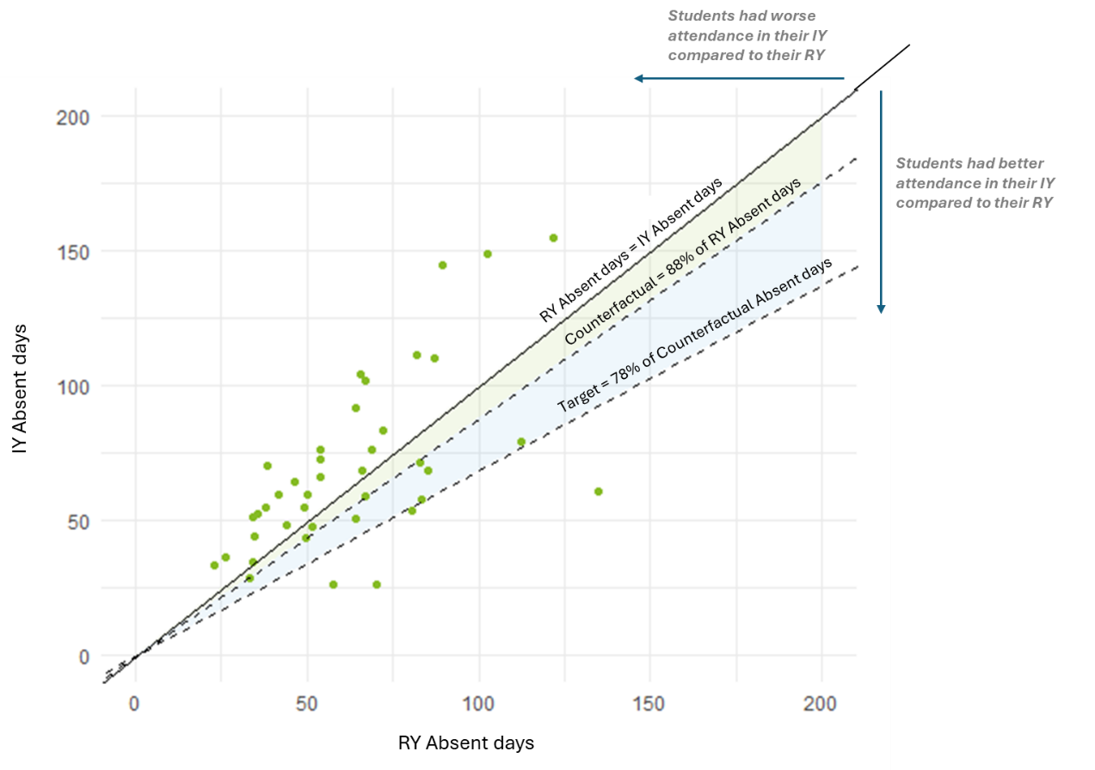
Note: Students between the ‘RY Absent days = IY absent days’ line and ‘Counterfactual = 88% of RY Absent days’ line had better performance in their IY compared to their RY but performed worse than the agreed counterfactual. Students between the ‘Counterfactual = 88% of RY Absent days’ line and the ‘Target = 78% of Counterfactual Absent days’ line performed better than the agreed counterfactual but below the 22% target. Students below the ‘Target = 78% of Counterfactual Absent days’ line exceeded the counterfactual by more than 22% and therefore exceeded the program’s target.
Source: Deloitte Access Economics (2024) using Department of Education data.
Wider schooling data and research continues to uncover how the COVID-19 pandemic had significant impacts on attendance patterns globally, in Australia and Victoria. Indeed, absences for other students not participating directly in the program increased for all Cluster 1 and Cluster 2 schools between 2021 to 2022. It is therefore difficult to isolate the effects of the Side by Side program on student attendance.
To unpack these trends further, this evaluation explored employing a difference-in-difference analysis approach, using a ‘matched’ comparison group, to estimate program effects:
- First, a group of control schools was selected (three control schools matched to each intervention school).
- Second, students with similar characteristics to Side by Side participants were identified within the 27 control schools to establish control groups.
- Two control groups were selected as comparisons. The first control group was defined by meeting the program selection and prioritisation criteria. For additional comparison purposes, a second control group was derived, limiting the sample further in an attempt to more closely match the average characteristics of Side by Side students.
It should be acknowledged that defining an appropriate control group for Side by Side students is extremely challenging due to the acute needs of the target cohort, data limitations, COVID-19 disruptions, and small sample sizes. The selection of the controls needs to balance the tensions of an appropriate sample size, with the precision of the match, while ensuring that the control constructs hold external validity for broader policy design.
The first control group, matched on the program selection and prioritisation criteria, has a large sample size (n=501) and is conceptually aligned with the original program design. However, it has less acute needs in comparison to Side by Side students (see Table ii):
- Lower average absent days (46, compared to 63 absent days for Side by Side students)
- Lower disadvantage levels (54% of Level 1 SFOE students, compared to 70% for Side by Side students)
- Lower rates of disability (28%, compared to 50% for Side by Side students)
- Lower rates of students in Out-of-Home Care (2%, compared to 8%for Side by Side students).
These findings are significant as they underscore that students ultimately selected to participate in the program are experiencing more disadvantage across a range of indicators compared to the general pool of eligible students.
The second control group has a more limited sample (n=140), but is more closely matching the characteristics of the Side by Side students (see Table ii):
- Closer average absent days (55, compared to 63 absent days for Side by Side students)
- Closer disadvantage levels (61% of Level 1 SFOE students, compared to 70% for Side by Side students)
- Closer rates of disability (34%, compared to 50% for Side by Side students)
- Closer rates of students in Out-of-Home Care (4%, compared to 8%for Side by Side students).
However, the second control group is showing significantly lower attainment using teacher judgement data than Side by Side students.
Future analysis as part of the Final Evaluation will explore utilising propensity score matching and synthetic control methods to develop control groups. These methods can result in even closer matching, however they also are more complex and sometimes difficult to interpret, particularly in the context of broader policy design considerations.
The comparison of characteristics across these groups, as well as the broader student population provided in the table below highlights the most significant discrepancies (in orange bold font).
  - Comparison of characteristics between student cohorts based on referral year data (noteworthy differences between control groups and Side by Side students displayed in bold orange font)
Student cohort | Side by Side students | Control group 1 | Control group 2 | Other students at Side by Side schools | All students at selected control schools
Sample size | 40 | 501 | 140 | 1,172 | 5,414
Program selection criteria
% of Aboriginal enrolments | 30% | 20% | 22% | 12% | 6%
Absent days | 63 | 46 | 55 | 22 | 19
Unexplained absent days | 46 | 24 | 36 | 11 | 5
Secondary program selection criteria – Teacher judgement (% below expected achievement in…)
Reading and viewing | 66% | 51% | 73% | 30% | 25%
Speaking and listening | 32% | 31% | 53% | 22% | 18%
Writing | 61% | 59% | 92% | 38% | 33%
Demographics
Gender (Female) | 50% | 49% | 42% | 49% | 50%
SFOE index (Level 1) | 70% | 54% | 61% | 48% | 34%
SFOE index (Level 2) | 20% | 20% | 22% | 19% | 19%
Refugee background | 3% | 4% | 2% | 5% | 7%
Disability (NCCD) | 50% | 28% | 34% | 22% | 18%
OOHC status | 8% | 2% | 4% | 3% | 2%
Note: The Student Family Occupation and Education (SFOE) index is a measure of students’ level of social disadvantage used by the Department of Education; the Nationally Consistent Collection of Data on School Students with Disability (NCCD) is an annual data collection of information about school students with disability; The Out-of-Home Care (OOHC) status reflects students who have been assessed to be at risk by Child Protection, or where their parents are unable to care for them for a period of time.
Source: Deloitte Access Economics (2024) using Department of Education data.
Overall, this evaluation finds limited evidence of systematic effects of the Side by Side program on reduced absent days for participating students across 2021-2022 intervention years. However, these results should be interpreted with caution given small sample sizes and the impacts of COVID-19.
As described previously, a slight increase in Side by Side student average absent days is observed between RY and IY. During the same period, both control groups display a slight decrease in the average number of absent days. As a result, the gap between Side by Side student and control group average absent days widened by (this change in the gap is referred to as a ‘Difference-in-Difference’ or ‘DiD’, see Table iii):
- 11.04 higher absent days in the IY compared to Control Group 1 (at 10% statistical significance level)
- 13.50 higher absent days in the IY compared to Control Group 2 (at 10% statistical significance level)

Differences in absent days in the MY are not statistically significant for both control groups, meaning that the result may be due to chance, rather than indicative of a true underlying effect.
There is some evidence of higher rates of unexplained absences for participating Side by Side students in the IY (at 5% statistical significance level).
No statistically significant effects on participants attainment, as measured through teacher judgement data, can be established at this time. Table iii reports results for writing, however, other domains of literacy were also examined and are reported on in Section 4.3.1. Several limitations of teacher judgement data are noted and future evaluation should explore the use of other datasets.
  - : Difference in Difference (DiD) results for Side by Side students - regression coefficients for treatment effects and significance levels
Control group | Outcome variable | DiD Intervention Year  (difference in change from referral year to intervention year; between intervention group and control groups) | DiD Monitoring Year  (difference in change from referral year to monitoring year; between intervention group and control groups)
Control Group 1 | Number of absent days | 11.04 ^ | 6.61
Control Group 1 | Number of unexplained absent days | 9.12 * | 14.24 ^
Control Group 1 | Writing (% below expected achievement) | -0.87 | -0.35
Control Group 2 | Number of absent days | 13.50 ^ | 7.04
Control Group 2 | Number of unexplained absent days | 12.52 * | 16.62
Control Group 2 | Writing (% below expected achievement) | -0.41 | -0.85
Notes: A decrease (i.e., a negative correlation coefficient) is associated with a more favourable outcome compared to the control group. Significance levels: 0.001***, 0.01**, 0.05*, 0.1^. Sample sizes for control group 1: IY- Side by Side students (n = 40), IY – Control students (445). MY – Side by Side students (n = 11), MY - Control students (n = 175). Sample sizes for control group 2: IY- Side by Side students (n = 40), IY – Control students (127). MY – Side by Side students (n = 11), MY - Control students (n = 49).
Source: Deloitte Access Economics (2024) using Department of Education data.
Broader patterns of attendance within participating schools matter. All five schools included in this analysis recorded trends of increasing absences for their broader student population throughout 2020-2022. While in two schools Side by Side students show relative improvements in attendance, others face challenges in mitigating absenteeism among Side by Side students, suggesting the program’s impact is highly dependent on individual school context. This underscores the complexity of addressing absenteeism and emphasises the need for targeted interventions conscious of the specific needs of each school community.
Although no 2023 data was available for a control group as part of the interim evaluation scope, program data (prepared for quarterly reporting) suggests that Side by Side students from IY 2023 exhibit improvements compared to RY. This is a promising result and will be explored further in future evaluations to understand how this trend compares to control groups.
Feedback from program staff, participating students, and schools anecdotally indicates that improvements in attendance have been observed on the ground. Three in four Side by Side families who provided feedback reported perceived improvements in attendance, with 33% reporting moderate and 42% high increase in attendance (based on 24 family feedback forms).

Key findings – Broader outcomes
Despite limited quantitative evidence on the effect of the program at this interim stage, qualitative evidence on the program’s broader outcomes underscores the value of this program to students, families and schools.
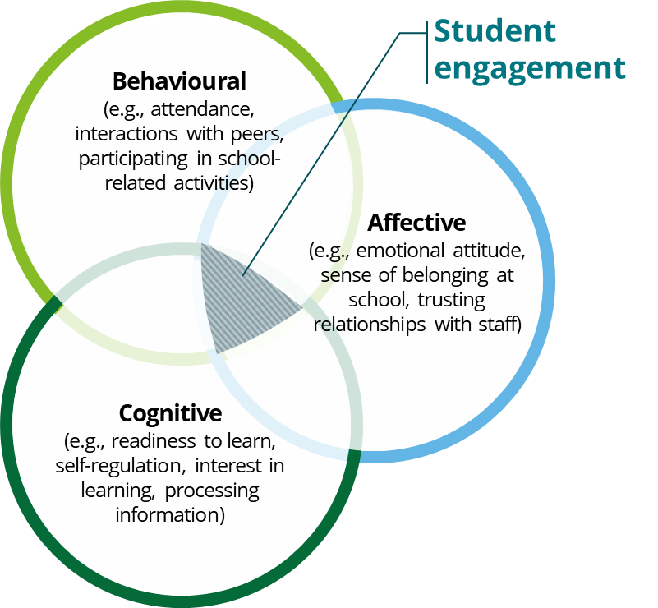
Qualitative evidence collected as part of this evaluation suggests that the Side by Side program is demonstrating a range of positive impacts on student outcomes, reflecting the holistic and multifaceted nature of the educational experience. Although attendance and engagement at school are related, it is helpful to draw out the differences between the two concepts. School engagement is often conceptualised as consisting of three elements: behavioural, affective, and cognitive. There is evidence of the Side by Side program contributing to all three types of engagement.
School staff reported notable improvements in student readiness to learn, and overall wellbeing, with perceptions of the program’s impact becoming more positive in 2023 compared to 2022. In 2023, of the 34 school staff surveyed who have a Side by Side student in their classroom, 100% agreed that the program has contributed to improvements in student capacity to engage (41% strongly agreed, 35% agreed, 24% somewhat agreed; no disagree responses recorded).
Source: Multidimensional model of engagement based on Eagly and Chaiken’s (1998) ABC model of attitude
Reported improvements appear to be less dependent on the specific program cluster team and more on the unique contexts of individual schools and their student cohorts.
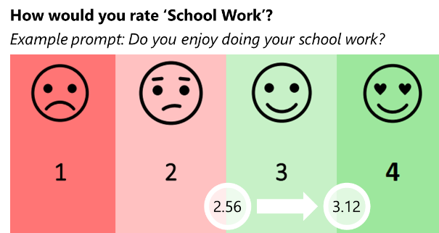
Year 2023 was the first year with a substantial sample of responses from students and families with 34 sets of pre- and post-program feedback responses for students and 15 for families. Students have reported enhanced attitudes towards multiple aspects of school, with the average rating for ‘school work’ improving the most from 2.56 to 3.12 (+0.56, see graphic on the right). Aboriginal and Torres Strait Islander students are reporting greater improvements in their perceptions of school (+1.14 on the average rating for ‘school work’).
Students report having positive experiences with Side-by-Side program staff, particularly appreciating the learning support during 1-on-1 sessions and the extra attention received by an adult. Qualitative evidence also points to students’ levels of confidence as an important marker of success and progress towards fuller engagement in school.
Source: Deloitte Access Economics (2024)
Results from 2023 pre- and post- student feedback forms
Families also report increased interest in school and learning, with 57% reporting that their child is ‘often interested’ in school and learning in post- feedback forms, compared to only 13% at the start (pre- feedback forms).
Program staff have described multiple examples of improvements in students’ emotional regulation and wellbeing, as well as their social skills and involvement with peers. Program staff also reflected on alternative ways in which the Side by Side program generates value – through connecting students to extracurricular activities, helping families navigate NDIS processes, providing financial assistance, and flexible support with whatever matters may constitute barriers to students’ school attendance (e.g., housing, medical, employment matters).
Successful implementation of whole-school transformation is rare, and it is early to expect to observe whole-school impacts of the program. Nevertheless, some early indicators of change can be observed.
As previously discussed, the whole-of-school component of the Side by Side program is designed to develop culturally responsive, and trauma-aware educational approaches that will support all students at the school, not just the Side by Side participants.
Recognising that whole-of-school transformation takes time, this evaluation does not expect to observe impacts of this nature for the participating schools at this point in time. Successful implementation of any practice change within a school takes time. Depending on the size and complexity of the school environment, school’s readiness for change, and the nature of the change desired, it can take between two to four years to implement a new initiative, and even longer for whole-of-school transformation.
In addition, measuring trauma-informed and cultural competency, as well as application of that in practice, is difficult for conceptual and practical reasons. These include challenges with defining specific competencies, consistency of self-assessment over time, inflated initial self-assessment due to limited awareness and other biases related to self-assessments more broadly.
Across the five schools that participated in the program for more than one year, three reportedly (according to assessments made by Side by Side staff) demonstrated positive shifts in trauma-informed practice and cultural competency from 2022 to 2023.
There is some emerging evidence that the Side by Side training is contributing to practice change with a variety of examples provided ranging from improved identification of student needs, to implementing better connections with local Aboriginal community. However, staff buy-in and appropriate authorising environments continue to be barriers to consistent to whole-of-school transformation. Where strong leadership buy-in exists, the Side by Side program’s impact can be visible in schools’ strategy, planning, policies, and procedures.
Future evaluation will continue to assess the degree to which whole-of-school development and transformation is occurring with more tangible impacts expected towards the end of the program’s implementation.

Next steps
The next phase of evaluation – with more than double the present amount of data and other evidence – will utilise similar techniques and lines of enquiry to provide a more rigorous assessment of program impact on student attendance and attainment.
This Interim Evaluation Report includes some interim opportunities for improving program and PAD implementation. These opportunities focus on areas such as enabling program staff to make timely and evidence-based decisions, and supporting flexibility in their responses (e.g., exploring in-home tutoring). The report also highlights limitations in VACCA’s ability to fulfill its intended leadership role, and it is notable that in this context, Aboriginal students are yet to see similar gains in attendance to non-Aboriginal participating students.
Further, the opportunities for improvement seek to ensure the final stage of the program creates the environment in which the relative benefits of the PAD arrangement, including the flexibility and responsiveness it is designed to engender, can be more deeply understood. While the program has primarily focused on supporting implementation within the school environment and establishing trusted relationships, there is an opportunity in the final years to develop an even more responsive and innovative program.
In the later years of the program, the evaluation will also focus on assessing the value for money of the Side by Side PAD. This is an intensive program, with a relatively high level of resources focused on a small number of students for the purpose of early intervention (where the potential gains are high). As the understanding of impact becomes clearer, the evaluation will consider whether – relative to other investments and funding arrangements – this program reflects an equitable, effective and efficient use of funds.
The following opportunities for improvement are noted throughout the report.
No. | Opportunities for improvement | Type | Section
1 | Berry Street should explore the potential for alternative delivery models of Side by Side teacher sessions to participating students with significant absences (e.g., home visits and tutoring). Consider defining an expectation for a minimum number of sessions for the program to be reasonably expected to translate to student attainment outcomes. | The Side by Side PAD | 3 – Implementation
2 | Berry Street, VACCA and DE should consider how the process for transitioning the relationships with the families after the Intervention Year (to the school and/or to the Area teams) can be further strengthened. | The Side by Side PAD | 3 – Implementation
3 | Berry Street and VACCA should consider the design of the program in the Monitoring Year, particularly whether there is scope for extending the individualised student and family supports if required. | The Side by Side PAD | 3 – Implementation
4 | Berry Street and VACCA should re-consider the design of the whole-of-school transformation component of the program. This may include being clearer on the aspirations for this component, the degree to which it is positioned as optional for schools, providing more targeted training to schools, and more opportunities for reflection and reinforcement of the training (e.g., via utilising the roles of cluster teams on the ground). | The Side by Side PAD | 3 – Implementation
5 | VACCA should explore where (and why) the cultural awareness training is well received and where it is less well received, as well as how the cultural improvement component of the program can most effectively link to the local school context and existing relationships with local First Nations groups. | The Side by Side PAD | 3 – Implementation
6 | Berry Street to explore whether adding further detail on the nature of family contact in their program data collection is viable (i.e., distinguishing contact types between in-person/phone call/SMS/attempted contact; estimated duration of contact). This would enhance the understanding of program dosage and therefore attribution of outcomes to the program. | The Side by Side PAD | 3 – Implementation
7 | DE to consider calibrating student eligibility criteria for any future programs of this nature, particularly for (1) students under the absent days threshold yet disengaged from school; and (2) students with absences significantly above the eligibility threshold who may not be able to benefit from the program in full due to complex home circumstances. | Future PADs or similar programs | 3 – Implementation
8 | Berry Street and VACCA to review the current resourcing model for VACCA at both management and FECM levels.  An alternative model could see the Side by Side program invest in VACCA’s resourcing at the middle-management level in a way that would not only build cultural capacity of teams, but also support flexible deployment to address short-term resourcing pressures in cluster teams. | The Side by Side PAD | 4 – Governance
9 | VACCA to consider strengthening the internal governance and support around the three Side by Side FECMs (noting that appropriate level of resourcing is a key enabler of that). | The Side by Side PAD | 4 – Governance
10 | Berry Street and VACCA to more deliberately define ‘flexibility’ within the program delivery, giving staff autonomy to problem-solve and make their own decisions within boundaries of non-negotiables. | The Side by Side PAD | 4 – Governance
11 | DE in collaboration with Berry Street and VACCA to explore ways to strengthen the program’s interface with area teams (and therefore regional buy-in) through the Cluster Steering Committees. | The Side by Side PAD | 4 – Governance
12 | DTF to collaborate with other government agencies to navigate and enable cross-governmental data sharing for the purposes of PADs while ensuring strong safeguards. This should ideally occur as much as possible before commissioning outcomes-based contracts. | Future PADs | 4 – Governance
13 | DTF to further invest in capacity and technical capabilities of providers (particularly understanding of financial implications and risk) to support ongoing operations. | Future PADs | 4 – Governance
14 | DE to take steps to improve data governance and quality assurance for the purposes of this program and future PADs. This could involve utilising existing monthly reporting process for a more formal reconciliation with knowledge on the ground. It is understood that DE has already made some changes to the process to mitigate the risk of future errors. | The Side by Side PAD and future PADs | 4 – Governance
15 | DE to consider whether providing access to schools’ student information management systems should be more explicitly encouraged with participating schools from the outset in future programs of this nature; and whether the DE could play a more proactive role to arrange this, including provision of guidance on how to manage access to personal (often sensitive) information for external service providers embedded within schools and working directly with students and families. | Future PADs or similar programs | 4 – Governance

A final Outcomes Evaluation Report is scheduled for delivery in 2027 and will provide a more summative view of the program and PAD effectiveness.
Deloitte Access Economics

Limitation of our work

General use restriction
This report is prepared solely for the internal use of the Victorian Department of Treasury and Finance. This report is not intended to and should not be used or relied upon by anyone else and we accept no duty of care to any other person or entity. The report has been prepared for the purpose of the interim evaluation of the Side by Side Partnership Addressing Disadvantage as set out in our Services Agreement. You should not refer to or use our name or the advice for any other purpose.

Deloitte Access Economics Pty Ltd
447 Collins Street
Melbourne, VIC, 3000
Australia
Phone: +61 3 9671 7000
www.deloitte.com.au

Deloitte Access Economics is Australia’s pre-eminent economics advisory practice and a member of Deloitte's global economics group. For more information, please visit our website: www.deloitte.com/au/deloitte-access-economics

Deloitte refers to one or more of Deloitte Touche Tohmatsu Limited (“DTTL”), its global network of member firms, and their related entities (collectively, the “Deloitte organisation”). DTTL (also referred to as “Deloitte Global”) and each of its member firms and related entities are legally separate and independent entities, which cannot obligate or bind each other in respect of third parties. DTTL and each DTTL member firm and related entity is liable only for its own acts and omissions, and not those of each other. DTTL does not provide services to clients. Please see www.deloitte.com/about to learn more.
Deloitte is a leading global provider of audit and assurance, consulting, financial advisory, risk advisory, tax and related services. Our global network of member firms and related entities in more than 150 countries and territories (collectively, the “Deloitte organisation” serves four out of five Fortune Global 500® companies. Learn how Deloitte’s approximately 415,000 people make an impact that matters at www.deloitte.com.
Deloitte Asia Pacific
Deloitte Asia Pacific Limited is a company limited by guarantee and a member firm of DTTL. Members of Deloitte Asia Pacific Limited and their related entities, each of which are separate and independent legal entities, provide services from more than 100 cities across the region, including Auckland, Bangkok, Beijing, Hanoi, Hong Kong, Jakarta, Kuala Lumpur, Manila, Melbourne, Mumbai, New Delhi, Osaka, Seoul, Shanghai, Singapore, Sydney, Taipei and Tokyo.
Deloitte Australia
The Australian partnership of Deloitte Touche Tohmatsu is a member of Deloitte Asia Pacific Limited and the Deloitte organisation. As one of Australia’s leading professional services firms, Deloitte Touche Tohmatsu and its affiliates provide audit, tax, consulting, risk advisory, and financial advisory services through approximately 8000 people across the country. Focused on the creation of value and growth, and known as an employer of choice for innovative human resources programs, we are dedicated to helping our clients and our people excel. For more information, please visit our web site at https://www2.deloitte.com/au/en.html.
Liability limited by a scheme approved under Professional Standards Legislation.
Member of Deloitte Asia Pacific Limited and the Deloitte organisation.
This communication contains general information only, and none of Deloitte Touche Tohmatsu Limited (“DTTL”), its global network of member firms or their related entities (collectively, the “Deloitte organisation”) is, by means of this communication, rendering professional advice or services. Before making any decision or taking any action that may affect your finances or your business, you should consult a qualified professional adviser. No representations, warranties or undertakings (express or implied) are given as to the accuracy or completeness of the information in this communication, and none of DTTL, its member firms, related entities, employees or agents shall be liable or responsible for any loss or damage whatsoever arising directly or indirectly in connection with any person relying on this communication.
© 2024 Deloitte Access Economics. Deloitte Touche Tohmatsu.

Particularly attendance/absence data in Victorian schools given the significant periods of remote learning during the pandemic and associated lockdowns.
This term is used to describe both – the role of FECM at Berry Street and the role of the Family Education Support Worker (FESW) at VACCA.
It was anticipated that the proportion of Aboriginal and Torres Strait Islander students participating in the program would be higher in the first years of program implementation as eligible Aboriginal and Torres Strait Islander students would be prioritised for enrolment.
Noting that some schools completed a version of this training in the past prior to commencing the Side by Side program.
Please refer to SVA investor reports for further commentary regarding deeming of results <https://www.socialventures.com.au/assets/Side-by-Side-Annual-Investor-Report-2023.pdf>
Over time, it would not be unreasonable for government to expect the maturity of the market to grow and service providers acquiring these capabilities.
Control schools were selected using Propensity Score Matching technique which considered a range of school characteristics – school location, size, level of disadvantage, proportion of students with high absenteeism (30+ or 20-29 days absent), proportion of Aboriginal and Torres Strait Islander students, proportion of students below expected achievements in various attainment domains.
High absent days (20+ days) AND one of: High unexplained absent days (15+ days); OR being an Aboriginal or Torres Strait Islander student; OR low attainment outcomes.
High absent days (20+ days) AND High unexplained absent days (15+ days) AND low attainment outcomes (defined using teacher judgement data).
At the time of conducting this analysis, 2023 data was not available.

